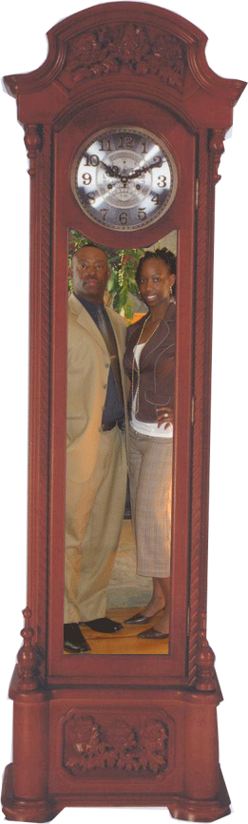
Tick Tock Time
Tick Tock Time. A baby is born on November 25th. A father realizes that this is reality now and not a myth. Tick Tock Time. The baby is beginning to walk and talk. A father has to get all the fairy tales read to her like Jack and the Bean Stalk. Tick Tock Time. The child is starting school. A father has to show her that she is a born leader and she to can rule. Tick Tock Time. The child finds that friends are not always going to be there. So as a father, he steps in and shows her that he truly cares. Tick Tock Time. She establishes the going out stage. Therefore, a father checks all the boy’s background by going on their myspace pages. Tick Tock Time. She is getting older and wants her privacy respected. One minute happy the next sad, these emotions are not easily detected. Tick Tock Time. She is begging for her first car. A father prays that she gets something small because these gas prices are so very bizarre. Tick Tock Time. The day of graduation is here. The next step is to choose a college and receive those tuition bills. Oh dear! Tick Tock Time. It is time for her to start a life of her own. A father realizes that she was your baby but now she is more beautiful and grown. Tick Tock Time. A father wants his child to be very independent and smart. As a father, you never want your close relationship that you have to grow apart.
Tick Tock Stop. You reflect back on that November 25th day that a father could never forget. Because this is the day, you felt your little baby girl that has now matured into a young lady was heaven sent.
~ Photo by: Tracy Adams
~ Poem by: Shanada

