“Once Upon a Dream.”
By: Kylee
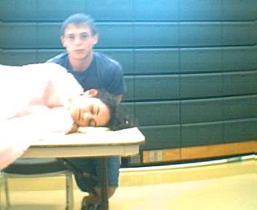
I awoke in a cold sweat at 1:17 am. The house was quiet; no one was awake at this hour. After a while, I finally got comfortable and tried to catnap. I awoke once again, but this time I was not in my room or in my house. I was in a very strange place. It looked like I was in Ireland, because there were rolling green hills and the ocean.
I was walking along the seashores of Ireland, when a strange man walked up to me and called me Princess Sophia of Ireland. I could not believe it, I was the “queen-to-be.” A big, weird, hairy man was my husband-to-be. How could I marry someone that I did not love? I already hated being in Ireland. First I get to marry someone like “King Hairy.” I was determined to have a talk with the Queen of this place.
I had to go on a big journey to find her. I found a man with a horse and carriage, and asked him to give me a ride to the Queen’s Palace. The Queen was even worse than I imagined. We had a long talk, and she told me that it was natural for young girls to marry in 864AD. A thought went through my head, “How could I have gotten to Ireland in the late 800s?”
Our conversation carried on, and I found out that I was being shipped off to the Saxons’ land. It would be a long trip. I was being put into hiding because of the war between the Saxons and Ireland. The best thing out of this whole deal was that I got my own personal handsome knight. He was tall, dark, and he had the most beautiful eyes ever. I felt as if I could fall asleep in his eyes. We sat and talked for a very long time. It was hard to say, but I thought I was falling in love with him. I thought to myself that it must be love at first sight. Every night after that, he came to see me. He told me that the only reason he came to see me was to tell me that everything was going to be all right.
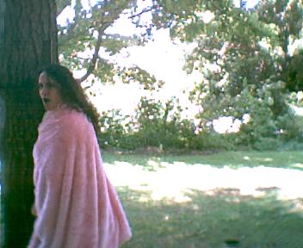
One night, he brought bad news. He told me that I had to go back to Ireland, and he could not go with me. Tears came to my eyes and we both finally said our goodbyes. As I grew closer to the seashores of Ireland, I saw four large battle ships. I was told that the war was over. Someone had lied to me; someone was trying to have me killed! I tried to get off the ship without anyone seeing me. I must not have tried hard enough, because a man with a sword came toward me. The next thing I knew the stranger had just cut my stomach open. My whole body had gone numb; I thought I had been killed.
I awoke again, but I was no longer on the ship. I was in a forgotten cave getting healed by this beautiful man. He was so hot, so muscular, so, so familiar. Suddenly, as he entered the cave, I knew who he was. He was the same knight that I had met in the Saxons’ land. I asked him how he got here and where I was. He told me I was still in Ireland in a forgotten, old, stinky cave. Then he told me that I had been poisoned. I quickly then asked him for his name, but he changed the subject. He acted as if it would be really bad to tell me his name. I thought I was falling in love with him at that very moment.
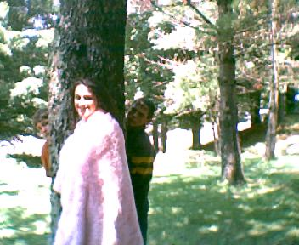
One day after the war was over, I was healed and ready to get out of the cave. I talked the knight into letting me go find the Queen of Ireland. When I arrived she was furious with me. The Queen was pushing my wedding date up to the very next day. I quickly stormed out of the castle in search of the knight who saved me. I told him the bad news and he told me the things I had longed to hear him say. The knight told me that he was not a knight. He was Lord James of the Saxons’ land, and the reason he had not told me that before was that he thought that I would not have liked him after that. He also told me that he thought that he was falling in love with me. It was the best news I had heard all day long.
The next day arrived way too soon. I had on a long, white, lacy dress, ready to marry a total stranger. I was being forced to do it. Each step I took shredded a piece of my heart away. I felt as if I was going to get sick. Just knowing I could no longer be with my true love. As I began walking down the aisle, I had not planned to look at him, but I did. When I raised my eyes to his face, I saw that it was my true love, Lord James. I was so excited that I practically ran down to the alter. The wedding went on, and we got to the best part. The pastor said, “I now pronounce you husband and wife. You may kiss the bride.”
As I leaned in to kiss him, I heard a strange noise. I turned my head quickly and then I woke up. My alarm clock was going off. It was time to wake up. Not only was that the best dream I have ever had, but it was also the adventure of a lifetime.

Photos taken and edited by: Kylee

