The Orange, and Its Peel

Sun-kissed caramel complexion
Almond shaped eyes, the color of soil after it has rained and rained
Thick lips that make my kiss linger on in the back of your mind
A small pug nose resembling a hill with two cannon balls shot through it
Wavy hair that of a deep black sea during a storm
Or am I ?..
Summer night colored
Beady eyes the color of the sand in the Caribbean
Thin lips that peck and leave only lipstick marks
A nose sharp as a shark fin
Hair straight as a blade of grass

Or am I isn’t the question, but who I am.
All that I am is how I define myself
So am I who I think I am?
Or am I ?..

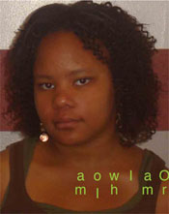

Author: Gabrielle UB @ Marquette University in Milwaukee, WI)
Category: creative writing
Work Cited:
Photograph created and owned by Gabrielle

