Da Creek

Created by: Bronson, Upward Bound, Leeward Community College, HI

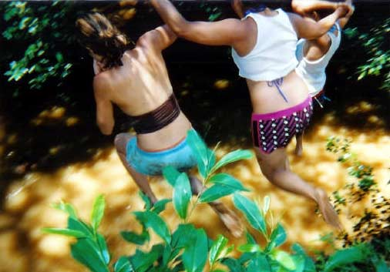

In Wahiawa, there is a place where you can go and forget all the problems you faced and all your worries from that day. This is a place that only few people know about. You’re very lucky, for I’ll tell you about this place that we all love. A place known to many as, “Da Creek”. Da Creek is not to far from anybody’s home. As a matter of fact, it’s in a huge valley. Just a short walk down and you end up in your own world. You’re isolated from everything else in the world. It becomes just you and your friends. Now, you can enjoy your stay here in beautiful Wahiawa. Da Creek is not only relaxing it’s a thrill. This is all thanks to a cliff in the forest called “Baby Waimea”. This is no kiddy jump; it’s a twenty-five foot drop in the water of the creek. The thrill and the screams all make for a great time with your friends. However, the first jump is always the scariest of them all. You stand there, above the water. Your mind is telling you “Yeah, you can do this, it’s nothing”. But your eyes see the drop and then tell your body and you “Don’t do it man, I can’t take this”. Then, the one thing that probably makes you jump is the voices of your friends in the background. You hear them screaming “Go, jump you chicken”. Then you jump, you try to close your eyes but you can’t. You look down and see the water getting closer, and closer, and closer, then SPLASH!!! You hit the water feet first, you pop your head back out of the water and you SCREAM your head off. Then all of a sudden, you want to jump again. So you climb back up, look around and jump one more time. What makes “Da Creek” and “Baby Waimea” fun is that it never gets old. It’s never the same, it’s always fun, and it’s right in your backyard. These some of the things I enjoy about Da Creek. Also what I went through when I first went to “Baby Waimea”. Everyone who goes always goes back again. As I said before, Da Creek is one of the best things about Wahiawa. And I love it. This picture was taken after it rained in Wahiawa, that’s why the water is brown.

Works Cited:
I took this photograph.

