Maunawili

Created by: Sally, Upward Bound, Leeward Community College, HI

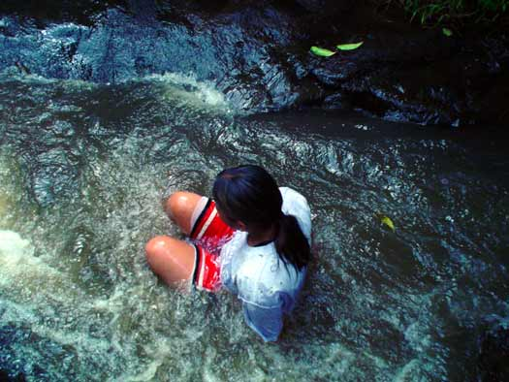

Pictures can speak a million words. It could represent the way you feel, the things you hear, the fragrance you smell, and the way you live. It could also represent your culture back around about your ancestors. It also captures the past. Pictures can remind you about the people and things you love or once loved. But most of all, pictures tell us stories. Unforgettable stories. Pictures make you laugh, they make you cry, but even through those happy and sad times, those stories are very hard to forget and makes you want to share your stories with other people. I would like to share a story with you. Slimy, dark green moss starts to tickle my feet and hands. The rush and pressure of cold, fresh water colliding with my back and flows to the bottom of the stream. The screaming and shouting of joy rushes through the trees, and the adrenaline rush starts to pump. All of a sudden, my whole body pushes forward and my hands fly up in the air. It’s like everything is anything at that time. The feeling was so incredible; it was like I was floating off a cloud. It felt like I was doing the impossible. When I slammed into the stored water below me, all I could think of was how fast I could run up the rocks to do it over and over again. This picture does not only remind me of that unforgettable experience, but it also reminded me of that one special day on Saturday, June 18, 2005. The day we went to an exotic natural place called Maunawili. Many of my friends from LCC had lots and lots of fun. We had the chance to help out with the taro patch. I still could feel my leg slide into the nasty, yucky mud. We had the chance to play in the fresh water that smelled so sweet, and we also had the chance to pound and taste our own taro. Me and my fellow LCC classmates that attended this outrageous activity would all agree that we had a wonderful learning experience that day.

Works Cited:
This photograph of me was taken by Justin.

