A Different Kind of Hunt

by: Helen Nash

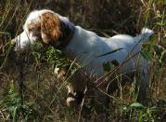Occasionally a miracle happens. When it does, don't question why, just grab on gladly before it gets away. That's exactly what I did that day in the field.
Gunner – photo by Helen Nash

My mind is racing. I don't have time to think about the briars and honeysuckles tearing around my ankles, or the stabbing branches I'm ducking under as I quickly yet stealthily move in closer with single-minded focus toward the beautiful animal targeted in my sight. We'd been out all day and were ready to give it up and go home empty-handed, when my companion called to me softly and said, “I think we've got something!”

Looking quickly to the direction of the pointing hand, I’d spotted the reason for his excited whisper. Like a gift from heaven, standing statue-like in a small clearing at the wood’s edge, a shaft of sun hitting him square in the face, my ‘miracle’ had appeared! Advancing carefully, I see every muscle quivering in eager anticipation with his perfect stance frozen in time, coming down through eons of breeding for this single moment. My hunting partner waits quietly with his weapon at the ready as I find my position, my heart racing in anticipation of capturing this lovely sight before me. I can't remember when I've seen such a gorgeous head, with eagerly arched ears and sunlight piercing the eyes, setting them a-glow with amber fire, so large in my lense and full of life as to seem surreal. This is perfect—exactly what I'd come for: a great-looking point with a clear shot, no tall grasses or corn stalks hiding the face...even the lighting angle is perfect. “I couldn't have planned it better…that's fantastic!...if I breathe it may be gone....!!” My finger touches the trigger once, twice, and a couple more for good measure. “That's it—I’ve got it!"

Exhaling slowly and with an excited smile I turned to my partner who then moved in closer. His excellent marksmanship quickly brought down the single Bobwhite on flushing, and the gorgeous white Setter relaxed his point, marking the perfect ending to this event I'd planned, hoped and traveled here for. We were all pretty proud of ourselves, especially Gunner, the Setter who was our 'main event’ in this brief episode. We are all three hunters, and today, we'd each gotten our quarry, the difference being the objective and the equipment; in this case—cameras, guns and noses!

This hadn't been our only find that day, as there'd been several—just none that would work for my purposes. With nearly 200 images logged to my memory card, there had been no shortage of shots of both Tee and Gunner, the two English Setters belonging to my client who’d commissioned a painting of them in the field. A few weeks prior, we’d set out early, spending the day walking the rolling fields of thick cover. That first full day’s session brought home the perfect close-up picture of our featured attraction and trusty veteran of the fields—lovely Miss Tee—white with black head and ticking. She has a bit of crouch when she points, looking rather like a famous Edmond Osthaus painting ‘come to life’, complete with her staunch, old-world majesty, intensity and pride. That’s the fun part of this business; you never know what you’re going to get when you set out, but like the kid in the candy store, you know it’s going to be something good! That first great shot would be the basis for my layout for the painting and now all I’d needed was a good pose of Gunner to go with it….‘piece of cake’, right?

"Ok, Gunner, step right over here, please…no, no--turn more that-a-way, into the sun better. Also, when you’re on point, make sure you’re not in the weeds so I can see your face...ok?" Yeah, RIGHT! If it were as simple as just giving instructions, it wouldn't be nearly so fun.

There's a lot more to this business of good hunting dogs than I'll ever know, so I’ll leave that to the owners, trainers and hunters and stick with what I know best, which is painting them. I'm just glad and honored by the privilege a few good hunters have extended me, for the opportunity of honing my own skills for this ‘different kind of hunt’.
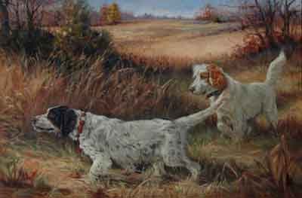
‘Tee & Gunner’ - oil - artist: Helen Nash

