Among the Hidden
Poem by Ayron
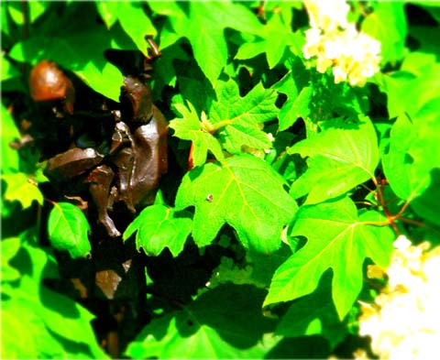

Photo by Ayron

I sit, and watch the world pass by.
Staying hidden, with no one by my side.
Wondering when I’ll be accepted.
Because these kids keep rejecting.
Days turn to nights.
I’m ready for our friendships to take flight.
I keep some good friends, close and near.
But making new friends, I do fear.
I stay behind the scenes,
But on a shoulder I need to lean.
With no one to trust,
My emotions are about to bust.
It seems as if society has changed so much,
And I’ve been left behind in a pile of mush.
It’s like an epidemic that’s swept the nation.
But my confidence is not as high as inflation.
I’ve always wondered who was real and who was fake.
As people start to flake.
But know I know who to trust.
And that success is a must.

