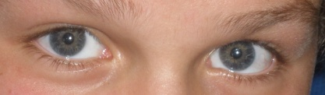
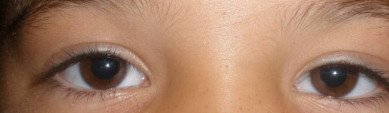
Eyes

Everyone has an eye or two,
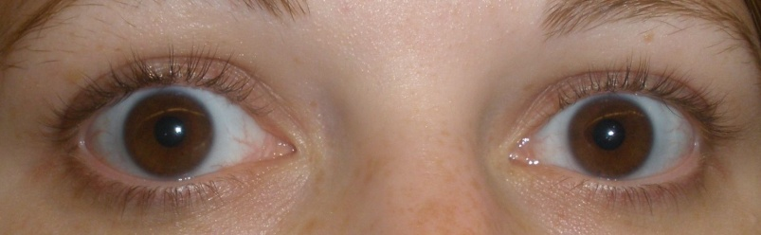
No one can tell who’s really who.
The emotions we hide,
We keep inside,
Never to show the truth.
Eyes are like a passage way,
A light that people can look into.
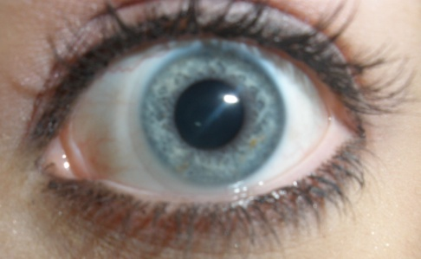
Eyes are like a secret door,
For the ones who want to know more.
We cannot reveal what we hide inside,
I It would be like committing suicide.

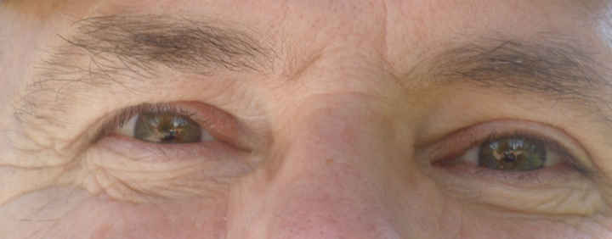
We all have different eyes,
They all connect to who we are.
The way you see life through your eyes,
Is a different way than mine.
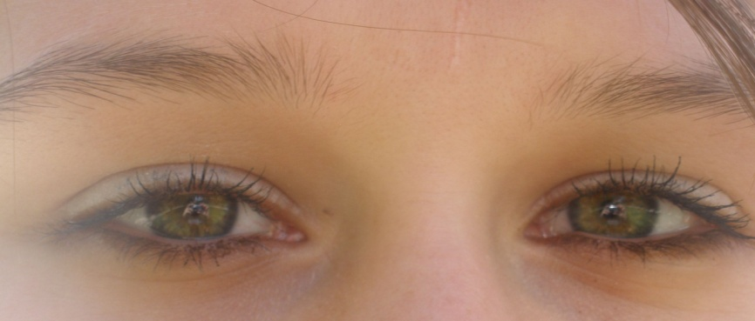
The world is such a pretty place,
Full of wonder, beauty and grace.
To comprehend all we know,
We will have to show,
Or else the light inside our eyes
Is surely going to go.
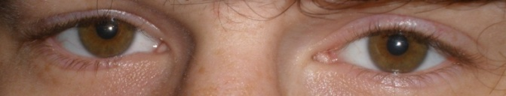
Poem and Pictures By: Kimberly Dixon

