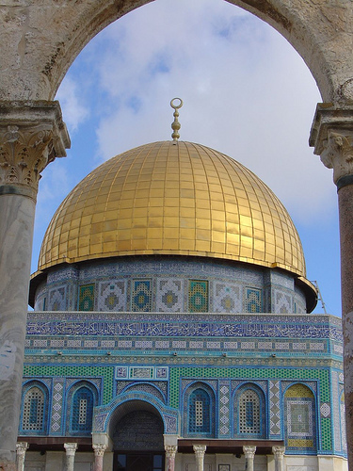
Home
By: Deemah Saadeh
Home is the place that I like to go to
Makes me feel important and very proud
I forget everything that matters too
Makes me remember the important ground
I just wish I could see it one more time
Even though it is very far away
I’m just going to have to deal with every crime
And see every beautiful thing in May
I like to remember every moment
Which will remind me of all the sadness
And the things I did in every movement
But the end did remind me of madness
I will remember my childhood now
And will ask myself what caused this and how
Where I’m from;
I am from falafel and humus
I am from a big family
From the smell of sweet pastry filling the air and dairy products
From olive trees and mountains
I am from the sound of sheep, cows and roosters in the morning
From a small population to a large population
From uniforms and private schools
I am from mosques and praying
From Muslims and Christians
To Catholics, Jews, and Buddhists
From lack of differences to diversity
From fire to ice
From confinement to freedom
From children living on the streets
To children living in villas and castles
I am from the holy land to the golden state
From the Mediterranean Sea to the Pacific Ocean
From one side of the world to the other
I am from war to peace

Thanks to amanderson2 for the flickr image.
Attribution-Noncommercial 2.0 Generic.
Photo edited using Microsoft Office 2007.

