I’m Hooked
By: Ivan
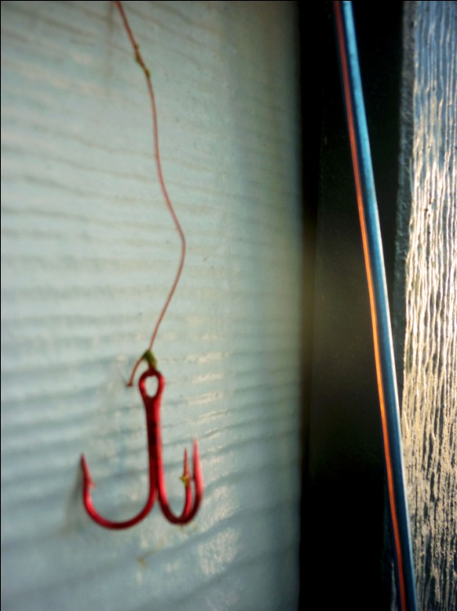
I am not asleep, although my body would wish otherwise. Rolling with restlessness and blended with insomnia for what seems an eternity. I glance towards the window in wonder. Wide eyed, I stare at the silver moon. The dark blue sky is filled with the swirls of the stars, with an eerie layer of silence.
The silence amplifies my thoughts in my head. No one can hear me scream in space but I can definitely hear my thoughts. These thoughts are pounding harder and louder and for a moment I felt that the moon heard it too. Then things become clearer.
Photo taken and manipulated by Ivan
My mind wonders off into the sky…
I feel a tug. I’m hooked. It’s an idea within my mind. A dream, dormant in my subconscious that every once in a while gets reeled back onto the surface.
This tug is the “What If?” questions.
What if…
I took a risk?... I had applied myself?... I chose a different career?... I told her how I truly felt?...
These are ideas bound to me with an invisible string. Hardly noticeable at times, yet they tug and pull with might. As I feel the tug, an impulse of emotions filters through me. There is anxiety of what I didn’t do and regret of what I did.
I am a fisherman of the night and my mind is the rod. My mind persists to question everything. I sail through the night sky far and wide through the chandelier skies and another tug is made.
My mind wonders off into the sky again…
The craters of the moon arrange themselves into a smile and greet me. I see my adventures taken with my friends and see the joy in their eyes. The stars are filled with an ember of happiness. I am that ember! As I come to this realization my ship nears land.
I rise from my bed drowsy and pale. As I pour myself my third cup of coffee for the night a small grin forms on my face. I stare at the window one last time only to see the radiance of the sun peeking through the sky. A new day has begun. It is a new day to make memories of ember.

