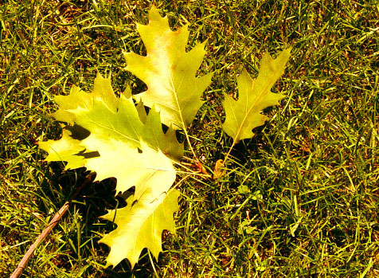

Photo by: Joseph 07-07-10

Photo Manipulation by: Joseph

Joy

By: Joseph

When I was little, I always went to the park during the springtime. Each time I saw this girl. She was about medium height and had long brunette hair. She was about the same age as me, around twelve. She seemed quiet, and shy. At that age, I just wanted to have fun, so I really didn’t notice her; but as years went by I got older and I started to notice her more.

One day I went back to the park. It was a normal spring day; everything felt right. At the time, I wondered if she was even at the park anymore, but of course she was there. Out of all these years I didn’t know anything about her. I didn’t even know her name. I didn’t know what it was about her, but I was going to find out.

“Hey, what’s your name?”

She seemed to hesitate for a moment. She didn’t know whether to trust me or not, which was just fine. I thought she was just going to get up and walk away, and I was pretty scared of that. She kind of surprised me when she said, “ You can just call me Joy.” I didn’t know if that was really her name or not, but I didn’t care as long as she was talking to me.

We talked a little more. Then she asked me a random question: “Do you like climbing trees?” Of course I said yes. So then I ended up climbing this humongous tree. I wasn’t scared or anything like that; I’ve climbed trees before. But when we started climbing the tree, it was harder than I thought. The tree was angled in a strange position; it looked as if two trees were joined together, almost like a heart.

I decided to check on her and see how she was doing. When I saw her, she was already halfway up the tree. I was amazed how fast she was climbing. She must have climbed that tree a hundred times. I was extremely impressed.

After I finally got up on the branch that supported both Joy and I, we just sort of sat there. It was a beautiful view, the view of a gigantic city just waiting for us to join the thousands of people there already. Then she asked, “What do you want to do when you’re older?” I didn’t really know how to answer her question, so I said “I never really thought about my future. I’ve always just gone with the flow.” It was the honest truth.

For a minute I thought she was going to say I was a slacker and needed to do something with my life, but instead she said, “You’re kind of like a leaf, huh?”

At first, I didn’t know what to think. “What do you mean by that?”

“Well, you just go with the flow, right? So basically, you’re a leaf because you just want to do whatever. You don’t really care what people want from you, or why they even talk to you. You just let them. Am I right?”

I was speechless. She had just described me. Most people would just say, “Yeah, that’s cool,” or “that’s good,” but she really understood me.

I really wanted to know if she was like me. She must have been the same if she knew me so well. “So, what about you? What is your personality like? Like mine?” As I waited for an answer, I couldn’t help but notice that she was sad.

“I guess, but I kind of don’t like it.”

“Why?”

“Well, I guess you can say that I go with the flow a little too much. You see, me and my parents move a lot.”

“Why is that such a bad thing?”

“Well, I don’t really know how to talk to people unless they talk to me, and even if they did, we won’t be friends for long because I move too much.”

When I heard her tell me that, I wanted to tell her “I know how you feel,” but the reality was that I had know idea how she felt. I had lived at the same place all my life so far; I had made plenty of friends, and she had nothing, really. “Why do you have to move so much?”

“Well, my Dad changes his jobs so much that he can never really keep one. I don’t blame him, though. He’s just trying his best to keep a job.”

I felt so depressed now. I wished I could help her, but I couldn’t do anything. I was only a kid.

After hearing this, I knew she didn’t really want to think about it or she just might cry. So I said, “I’m sorry that you travel so much, but look on the bright side: you just made a friend.” After she heard those words, she seemed to feel better. I was glad that I could help her out a little.

“Thanks,” she said, “you’re really nice guy.”

“Yeah, I try.”

She laughed a little.

“I guess we can be leaves together then,” I said.

She smiled at me. “Yeah, we sure can.”