Life: The Pursuit of Happiness
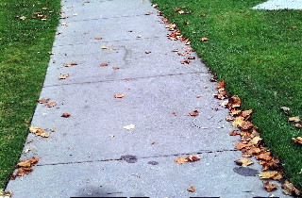
Photo taken and edited by: Josue

For centuries, humans have asked the same question: what is the purpose of life? By nature, humans are curious so we set out to answer these questions of the universe with one goal: happiness.
As you go through your daily routine, do you ever stop and ponder why you make the decisions you make? Most people are in the pursuit of happiness. This euphoric sensation we call happiness, comes in several different forms, from financial wealth, to harmonious relationships with others, to freedom. We all go through life persevering through daily activities, hoping for that shimmer of light over the mountain peak. We go through life hoping that our actions will pay off and that we will be happy.
In my life, things never go as planned. When I fail a math test or let someone down happiness seems far-fetched, yet I go to school to receive an education. I receive an education to follow a career, to someday make money (to be happy), and eventually retire. I get involved in relationships in search of friends and the right one. I do this all in the pursuit of happiness, yet this is when I stop to consider that the possibility of happiness could be only a pursuit.
I realize I am the pursuer. I follow this path we call life in an everlasting obstacle course to achieve bliss. Some individuals nonchalantly go with the flow, while others work hard to become someone of significance on this path. Whether you chose the path of partying or working hard is your decision.
I have chosen the path of working hard, but happiness acts like a mirage. It is a goal that is only in my grasp for mere seconds before it is whisked away by nature. Happiness comes and goes like a fistful of sand: you have it one moment and the next it is gone. For example, a happy couple can be having the time of their life one moment and the next they are arguing senselessly over insignificant matters. They are the pursuers of “happiness.”
Since I can only pursue happiness, it becomes very difficult to stay motivated in life. But after reflection, I stumbled upon a loop hole. I realized that happiness is instantaneous. This seems like an overwhelming idea, but if we can make these instantaneous moments constant, we can achieve ultimate bliss.
As stated earlier, happiness means different things to different people. Whether it is financial glory or a healthy family relationship, we all find happiness in one thing or another. As pointless as life may seem sometimes we spend our lives in the pursuit of happiness. Our purpose may be obscured, but we are the sculptors of our path. In the end, is happiness merely a pursuit or a goal we can successfully achieve? That is up to you to decide.

