Love Song

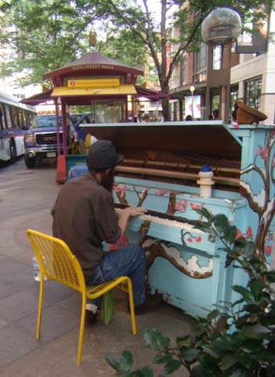
This summer, I visited Denver, Colorado for the first time in my life. While in Denver, I went to the 16th Street Mall. When I first heard about the mall, I thought it was going to be three stories high; but I was amazed to discover that it was a street and there were pianos on the street, a lot of different people and works of art. I was taking pictures like crazy; but what really got my attention was this man sitting at a piano playing “Love Song” by Sara Bareilles. I was walking by and when I heard the song, I stopped to look at the man who was playing it. I was speechless and so was everyone else.
This man inspired me to think about how everybody has a talent and how nothing should stop us from using it. He made me reflect on my own talent and capabilities.
I would have liked to know his name. This man was playing a piano in the street and this impressed me. I passed him, came back an hour later, and he was still playing. Much to my astonishment, he was still in the middle of a crowd that was taking videos and pictures. It would have been great to have had the opportunity to ask him who taught him to play the piano, what inspires him to continue to play, and so many more things.
The experience that I had this summer in Denver and this specific memory of a man in the street playing a song that I love inspired a feeling that I want to keep with me for the rest of my life. The sound of his notes and the power of his talent transformed everyone on that street. This is the gift of his talent, but we each need to discover our own and make our own contribution.

“Play Me, I’m Yours”¹ photo was taken by Rosie in Denver, Colorado on July 23rd, 2010.
Reference^{: 1} www.streetpianos.com

