My Hometown

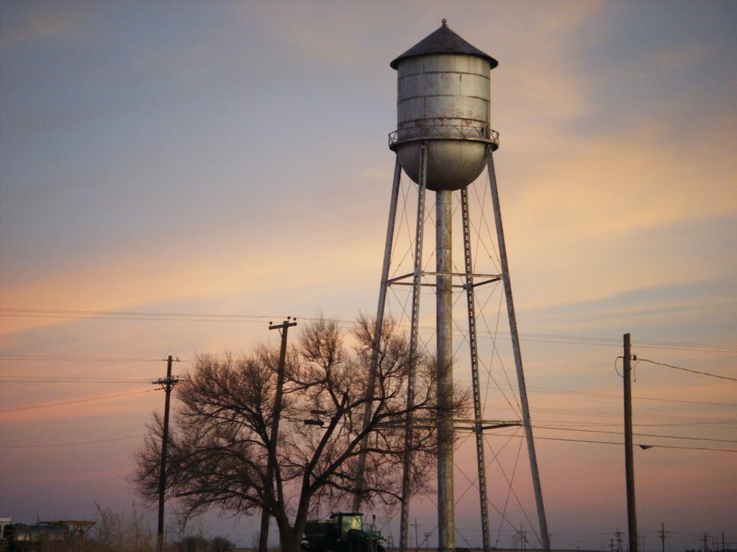By RaeAnn

*Photo by RaeAnn*

Imagine, living in a town with a population of about 450 people. Can you picture it? Can you picture a town with only one gas station/convenient store, a school, a city hall, 2 churches, and, of course, a water tower all within a 2 mile radius? If you live in a big city then it may seem unlikely. If you live in a town of with a population of a couple of thousand people it may seem real to you. But for me, this is my everyday life. I live in a town that takes about 5 seconds to drive by it. Welcome to my world.

You may be thinking, “How can you stand to be in a place that small?” Well it is really simple, I don’t have a choice. I could run away but where would I go? The closest town is 12 miles away and I wouldn’t want to walk that far carrying a suitcase. Plus, my parents would know that I was running away before I even got outside city limits because where I live, everybody knows everybody. But it really is not that bad. Like I said, everyone knows everyone. I can go for a walk and run into 10 or more people I can talk to. If I really want to socialize I can go to the store and talk to anybody I know who is hanging out there. Even though there is really no place to go, I can always find something to do.

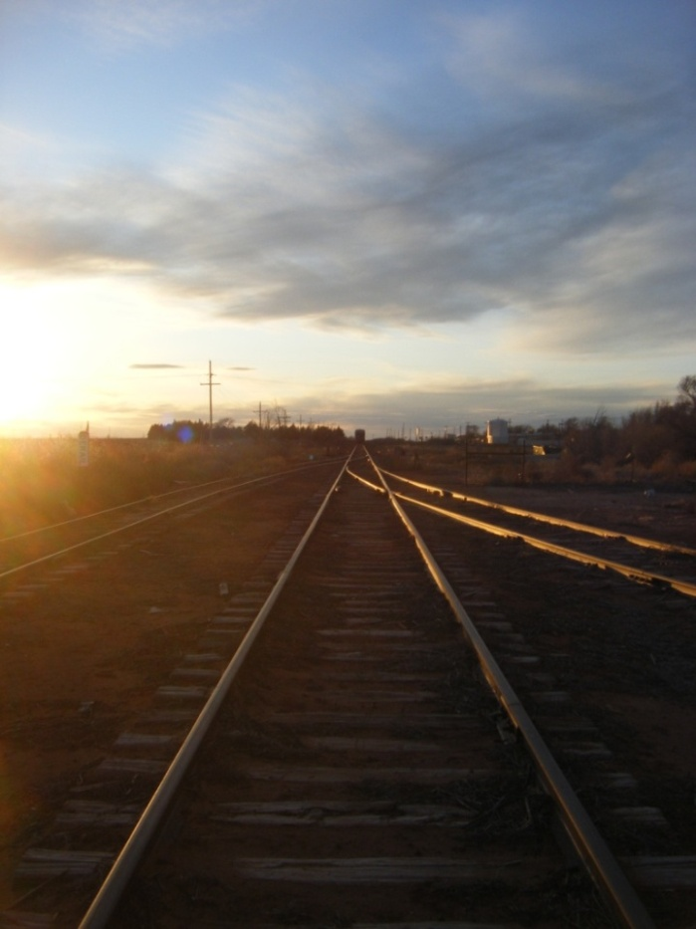“So,” you may ask, “What do you do for fun?” Well, where else in the world, besides a small town, can you pull a boat down the highway without a trailer? Can you go mudding after it rains in the city? Have you ever snowboarded off the roof of you house after it snowed? Have you ever sledded down the street after it snowed by pulling a mattress or a car hood behind a pickup? If you and your friends want to ride a horse to the convenient store, you can! If you want to learn how to shoot a gun all you have to do is go outside city limits. That is the beauty of living in a small town. You can do almost anything.

*Photo by RaeAnn*

However, sometimes I feel trapped. I feel like I will never be able to get away from my small town. There are days when I hate living where I do because I want to go somewhere exciting. I think that if I lived in a city, I could go eat out almost everyday, or get to know a variety of different people, spend an afternoon riding the city bus, or just go hang out in the Wal-Mart with my friends. But then I go outside and I see one of those west Texas sunsets that have so many vibrant colors in them. If you lived in a big city it’s not like you can’t go outside and see a sunset. What I am saying is that when I step outside my back door I get to look beyond a farmer’s field and truly see the sun setting.

Living in a small town has taught me to be a better person. If a friend or neighbor is going through a difficult time, my family takes food over to their house to show that we are there for them. We know that they would turn around and do the same for us. I have also learned to enjoy the simple things in life. Sure, sometimes I wish I could live in a busy city where there is a lot going on, always somewhere to go, and always something to do, but then I step outside and realize I am right where I want to be.