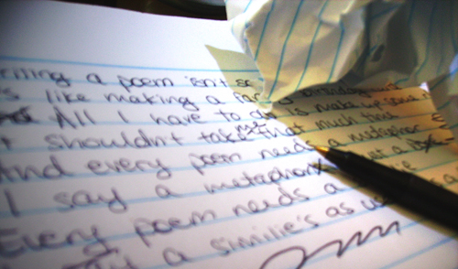

Photograph by: Katie

A Poetic Satire
By Katie

Writing a poem is not so hard
It’s like making a fancy birthday card

All I have to do is make up some rhymes
It shouldn’t take too much of my time
A metaphor is a snore
Thinking of one is no chore

A simile, worthless like a bee
To think of one, is not hard for me
Alliterations are always needed
They don’t make my mind depleted

Syllables don’t have my attention
They naturally flow in the right direction

I wrote this poem on the spot
Revising it, I did not

