Reflection of my Life
Essay by EJ
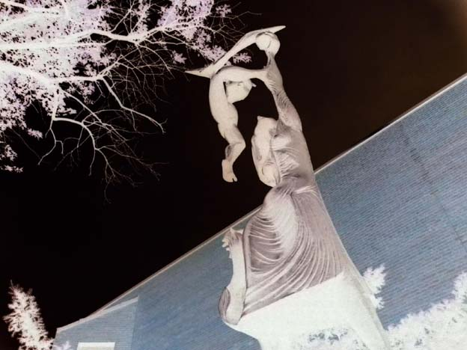
Picture by EJ
This picture reminds me a lot of my life and what I like to do in life. I like to hang out with friends and family, and play basketball. You may be thinking, “How does that remind me of my life?”I will explain.
In the picture there’s a dark side and a bright side. The bright shows me how basketball, and my friends and family affect me. Without them I would most likely be on the dark side.
On the other hand, dark side reminds me of all the things that could happen to me if I didn’t have basketball or friends and family in my life. I could be caught up in things such as gang violence, drugs and other bad things.
So now when you look at a picture don’t just look at it for the details. Try to figure out how the picture reminds you of your life.

