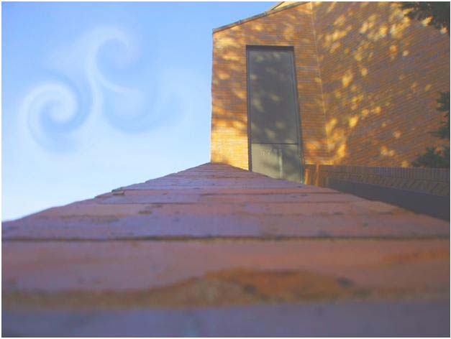

Photo by Ashton

The Brick Mountain

Essay by Ashton

Climbing up the mountain made up of bricks where a little girl lives. She loves to play and sing. Her friends love to play and like the colorful mountain. They love to play tag games and the house is the base. Her home is far, not short, but she says it is where her little house stays right above the mountain. This mountain she calls to herself the stairs up to her mom and dad It does not have much, but a little wind and color when she climbs. There are butterflies and bees flying happily in the breeze. All that she worries is her little home will fall off the mountain and the little mountain will fall. That won’t happen as long as she feels safe at her little house above the brick mountain. This is goodbye from the little girl whose house is above the brick mountain.