The Fragrant Taste of Rain
Sushen

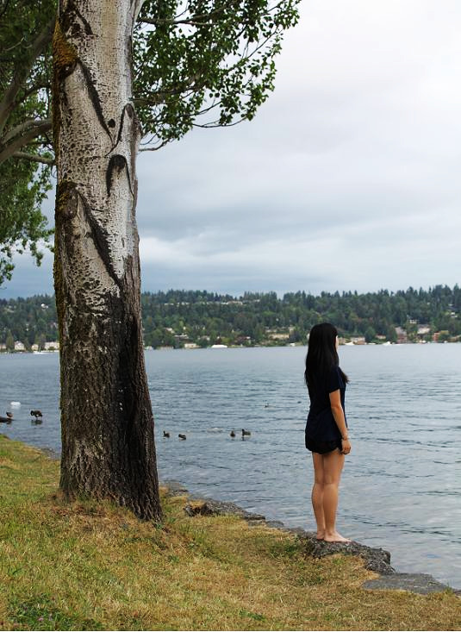
Photograph and edit by Sushen. Taken July 30, 2010.

Inhale. Exhale. Inhale. Exhale. Droplets of the drizzly, summer morning rain delicately skims down my face as I squint my eyes to get a better view of Mt. Rainier. I stood at the edge of the jagged rocks and sniffed the Lake Washington water, a mixture of seaweed infestation and duck odor. Still, the smell felt familiar and safe and the scenery made my soul feel heaven-bound.
For every family argument, friendship dispute and stress from school, I found myself standing at this exact spot. Every time, it felt cold, lonely and painful yet somehow reassuring. I rested my head against the sappy tree, slowly closed my eyes and remembered the day I first encountered this area…

It was Christmas 2007. My large family celebrates Christmas together annually at my Cousin Kathy’s house. This Christmas by Donny Hathaway blared through the surround sound speakers as the atmosphere of the holiday season grew cheery. I looked down at my phone, expecting a call from my dad. My parents divorced seven months ago. My mom was on another business trip for work and my dad had a gig at a casino, so they were not at the party to celebrate Christmas with me. Both of them are never around to take care of me and my two brothers anymore. I imagined my dad drinking beside my uncles and my mom sitting next to her sisters, laughing cheerfully, right where they’re supposed to be.
Before the divorce, I crawled into bed with my parents on Christmas night, happy with the gifts they wrapped for me. I hugged both of them tightly for ten seconds each, before I fell asleep between them. My dad counted with me, “one, two, three, four, five, six, seven, eight, nine, ten...” I secretly held onto my dad longer. His gifts were always thoughtful and something he made himself. I used to be Daddy’s little girl. This year, I had not received a gift from him. This year, I have to spend the night at this house because my mom isn’t home to take care of us.
Around eleven o’clock, my relatives slowly trickled home, all except Uncle Johnny. He was extremely drunk and stumbled into a table beside him, shattering a glass of wine. I caught his eye. Afraid, I looked away and pretended to pick up some garbage. Since he was too drunk to drive home, Cousin Kathy offered him a room for the night. My brothers and I slept in the living room on the creaky wooden floorboards. For one last time, I looked at my phone, as if my dad would call any minute. Heartbroken, I curled into my sleeping bag and fell asleep.
I felt a big tug on my blanket. Annoyed, I dug my head deep into my sleeping bag. I felt a hand creep on my skin. Startled, I pushed it away, lifting my blanket, revealing my uncle’s face shadowed in the dark. Shocked, I pretended not to notice and plumped back down to sleep. I felt the hand again. Frozen stiff from shock, I couldn’t move. I moved my mouth to speak, but nothing came out. Tears filled my eyes as I squeezed them shut. I remembered that if my parents had not divorced, I would be sleeping beside them instead of here. I counted, “one, two, three, four, five, six, seven, eight, nine, ten”.
At dawn, Cousin Kathy found me in her closet. I told her everything but she did nothing. My mom came to pick us up that morning. By then, my uncle was gone.
At home, I found a card in the mailbox for me. I stuffed it into my pocket along with one other item. Still troubled, I put on my running shoes and sprinted out the door to Lake Washington. I stopped running when the beautiful, breathtaking scenery of the Mt. Rainier caught my attention. The misty winter morning breeze brushed my hair out of my face. I stood at the edge of the uneven rocks and cried until I ran out of tears. I looked down to the lake water and thought, “Too shallow.” I reached in my pocket for the item. I pressed the lever and out sprung a blade as sharp as a snake’s piercing eyes. I looked at my wrist, and then I looked at the blade. At that moment, the idea seemed so convincing, so right.
“Daddy! I found it! I found it!”
I turned around to find a little girl and her father taking a morning walk. A resentful feeling felt like an anchor in my chest. I wondered why my dad hadn’t called yet. I glanced at the blade. The wind-chill brushed my skin. Inhale. Exhale. Inhale. Exhale. The fragrant taste of lake rain cleared my head. I released the blade.
The card from the mailbox that I dropped from my pocket caught my eye. I brushed off the grass dew and opened the card. Money flew out of the fold with a message scribbled, “Merry Christmas Victoria, here is $300, hope you’re doing well – Dad”. A teardrop trickled down my face and fell onto the word “Dad.” Smeared, the word is merely a blotch of ink, barely legible, clouded and faded. Below the short message, the printed text read, “Enjoy all the Gifts of the Season.” But I knew, the gift I received this Christmas, I would never enjoy…

My vision blurred as tears flood my eyes. I hate remembering this event, but some things are difficult, nearly impossible to forget. After four years, my family became more shattered, disoriented. As each piece of the family falls apart, I bring it here to throw away and forget. This is my safe haven. As usual, I stand on the same jagged rock, next to the same sappy tree. At each breath I take, the atmosphere lifts my soul out of my body, cleanses the dire thoughts and flushes them away into the green lake. Each breath I take, feels like my first breath alive. Inhale. Exhale. Inhale. Exhale.

