John F.
The Last 300 Miles
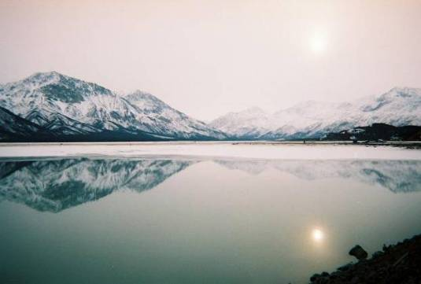
Photo By John Anderson Fields
The Alaska Highway is one of the most beautiful stretches of road I have ever travelled. The highway starts in the dirty little industrial town of Dawson Creek, British Columbia, and runs all the way into Fairbanks, Alaska. The 1700 miles of rugged wilderness road are no wider than a typical suburban street. The first 1200 miles or so I shared with the diesel behemoths that supply this barren landscape through its one vital artery. The most impressive and dangerous portion lies in the three hundred miles between Destruction Bay, Yukon Territory and Mt. Wrangell/St. Elias National Forest.
When I first saw the sign for the town of Destruction Bay, I thought it was quite funny. There had been no sign of an ocean, lake, or any substantial body of water for the last two days. About ten miles outside of town I was stopped at a crudely made road block. I pulled behind a battered blue Volkswagen Rabbit and waited while a man wearing a Canadian tuxedo (denim jacket and pants) radioed to a not yet visible outpost. The man in the tux informed the other driver and me that the road was under construction and that we would need to wait for an escort. That is when I noticed the road leading up the hill in front of us was completely unpaved. To be truthful, the road was made of mud. There was no gravel, sand, or small rocks - just good old-fashioned mud. I asked the man with the radio if this was a new section of the road. He laughed and replied,” Nope, the road here won’t take. So every couple a years it slides off into the bay. When that happens, we pave it and come back when it slides off again. Ya see, it’s the tundra. Everything out here is subject to the whim of the frost. When winter comes, it freezes everything solid and the road rises. When it warms up, everything thaws and the road sinks. See, the problem is that we’re building on top of water that never stops moving.” Satisfied with the answer, but still skeptical, I got in my truck and awaited the escort. The escort came in the form of a dirty white Isuzu Pup with dingy orange flags on the roof. We followed our escort up the hill much like Sancho Panza and his mule followed Don Quixote.
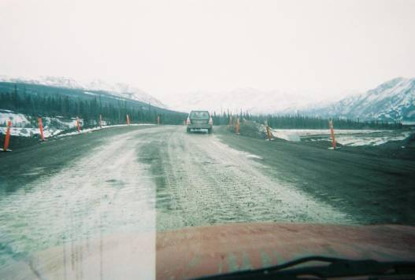
Photo by John Anderson Fields
What I saw next as we crested the muddy hill took my breath away. I was looking down into a tract of black mud about fifty yards wide snaking the edge of an enormous clear lake ringed with white-capped jagged mountains. The tract was being dozed by the biggest earth moving equipment I have ever seen. My dog was going crazy in the seat next to me every time one of the giants lumbered past us. About two miles into the mud tract, I saw the other outpost. This one sat at the mouth of a small road built upon stilts over the expanse of the bay. “So this is Destruction Bay,” I said to myself. I traversed the bay on the tiny bridge. On the other side I pulled over and got out. The entire bay was encircled with mountains. The mountains reflected themselves in the cool blue water. I watched as three Dahl sheep nimbly walked up a steep slope behind me. It struck me that maybe man was not supposed to build his roads up here. Maybe that was why this arcane lake kept devouring the foolish toil of her would-be tamers. I pressed onward toward the town. If I had sneezed, I would have driven right past the little town and never would have known I missed it.
I stopped and bought expensive fuel and a package of terrible cigarettes with a picture of a cancerous lung on the front of the box. Before I pulled out of the station, I took a long look at the road ahead. It appeared to wind its way up into the high points of the northern Rockies. The road into the Wrangell mountain range was extremely dangerous and slow going. I did not encounter a single tractor trailer until I was stateside. I think the bigger rigs abandoned this route due to the tundra that the road was built on. The road dips and rises every couple hundred feet. This is pretty predictable because the cracks in the asphalt that signal the rises and falls are very clear. The biggest problem is the frustration of not being able to go more than thirty miles an hour for about 150 miles. It is almost impossible to take in the scenery with the road in this condition. To break down out here, alone, means to become part of the food chain. To me, this is pretty scary. This is a land where wolves still run in packs, and survival of the fittest is the only way of life. These doleful doldrums give way to one of the most taxing mountain drives around. The Mt. Wrangell National Forest is full of caribou, musk oxen, and rockslides. The entire time the road takes me, in a windy roundabout downhill slalom of semi trucks, large rocks, and random wildlife, down to the Parks highway. My eyes danced from mountain to road with some of the most amazing sights nature has to offer.
I would love to travel this road a third or even fourth time. I feel the most perilous aspect of the journey down the last three hundred miles of the highway is so dangerous because of the raw beauty. I kept getting the feeling that I was seeing what was never meant for a man to see. I felt as if I was an invader from another world. All in all, I felt that at some places the road took me I could leave my vehicle and instantly be transported to the Stone Age.

