Victoria Who
After Sandra Cisneros’ “Abuelito Who”
By Vivian

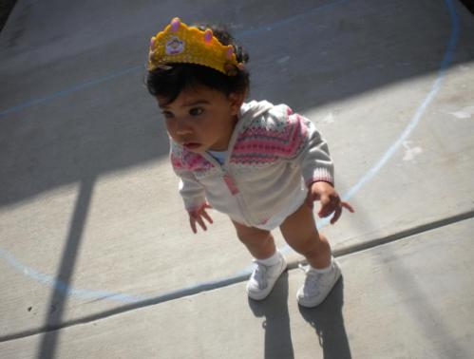
Victoria who throws tantrums when she doesn’t get her way
Who struggles with everything she needs to say
Who is small and wobbley
Who is very distractible
Whose hair is soft and curly
She is still just learning
Who loves exploring outside
Who points at the car to go for a ride
She hasn’t yet reached her terrible-twos
But trust me when I say they are coming soon
Who smiles more than anyone I know
Who has only eight teeth to show
Who pulls hair and throws everything in sight
When she sees strangers she always says hi
She loves Spongebob and Winnie the Pooh
Who calls me Bubba and loves me too
Who knows I’ll never leave her Photo Credit: Vivian
But holds me tighter just to be sure
Who follows me around because she doesn’t know
Who’s still so little and has a long way to go

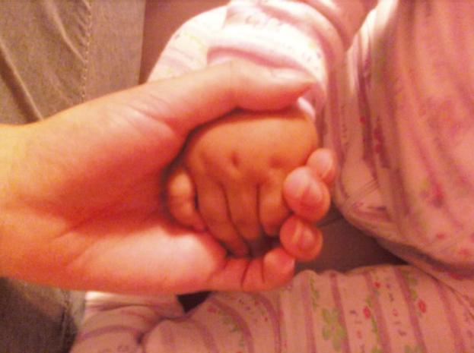

Photo Credit: Vivian

