Tiara

The Reality of Autism: Living With It
What is Autism? I know that if you ask anyone what it is they will tell you that it is a mental disorder. But does anyone know the exact definition of Autism? Well let me tell you. Autism is a disorder of neural (nervous system) development. It is mainly characterized by impaired social interactions and communication and by restricted and repetitive behavior. This is a disorder that millions of children get diagnosed with every year. And, even though that one child might have autism it could affect a whole household in many ways.
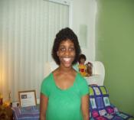
Being around a person with autism is one thing, but living with one is a whole different story. I live with someone who has autism. My twin sister Ciara has autism so I have a first hand experience of how it is to live with a person with autism. This is a situation that can get very frustrating sometimes. At times it seem like this is something that I will have to deal with forever. Other times I feel that my sister will be able to overcome this. It’s the many things she can’t do though that makes it hard for the family sometimes.
With my sister, one of the main ways that her autism affects the household is that she cannot talk. Since she can’t talk, it is hard for my family to know what she wants or needs or if something is wrong with her. Instead of showing us what she wants she sometimes acts like a baby and starts crying or whining until someone sees what she wants. That is frustrating for us because none of us in the house feel like hearing her make all that noise. Most of the time we are watching TV and that can get pretty aggravating. Another thing about her that affects the family is that there are plenty of things that she is not capable of doing by herself. Regular daily things like brushing her teeth, getting dressed, tying her shoes, and bathing herself are things that she can’t do on her own. That means that one of us, usually my mother and I, have to take time out of our personal time to help her get those things done.

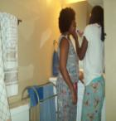
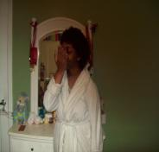
One way that my sister’s autism personally affects me is that it makes me want to teach her a lot of new things. Seeing how fast she learns certain things makes me want to teach her a whole lot more. One specific thing that I teach her every once in a while is sign language. Since she can’t talk I teach her different signs that make it a little bit easier for her to communicate with us. It might take her a little while to do the signs but it is worth teaching it to her. Another way that it affects me personally is that I look at people with disabilities a little different than other people. What I mean by that is I have a lot more compassion for people with disabilities than other people do. Since my sister has autism I choose not to laugh or make fun of people like her or with any disability because it would be like me laughing at my sister. That’s why I get angry when I see people do that. I feel that if they can laugh at any person with a mental disorder or a disability they could easily make fun of or talk about my sister. That’s why I feel that if the people who do that put themselves in my sister’s shoes or any person with autism’s shoes they will think twice about laughing because they wouldn’t want anyone laughing or talking about them. 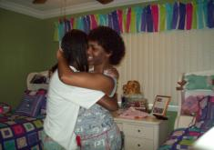
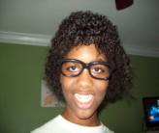
Having a sister with autism can be a hard task. We have to constantly see to her needs. Also, since my sister is non-verbal she chooses to make noises whenever she wants something. She knows some of the signs like eat and drink but she chooses not to use them. She also can’t do things by herself so we have to help her with those things. There are many things that I could complain about, but that wouldn’t show how I feel about the situation. Even though she makes it hard for the family sometimes we are taking it one day at a time. My parents could have easily given her away when they found out she had autism. They chose to handle this situation. It is only a bump in the road and it can only get better. So I am grateful that she is with us and we are able to help her and take care of her. Living with autism is no joke but she along with us can make it through.
-All original photos by Tiara

