The Genetics of Tyrosinemia Type I

Where does tyrosinemia come from?

Tyrosinemia is a genetic, inherited condition. When a condition is called ‘genetic’, it means that the genes are involved. Genes are recipes that determine traits such as eye color and height. The cells in our bodies contain thousands of genes that are arranged in pairs. One gene of every pair is inherited from each of our parents. The gene involved in tyrosinemia type 1 is one that makes a type of protein called an enzyme. The enzyme involved in tyrosinemia type 1 is fumarylacetoacetic acid hydrolase, or FAH.

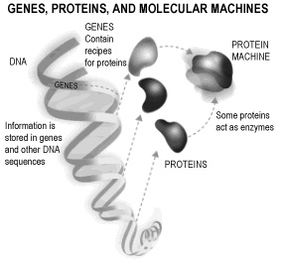
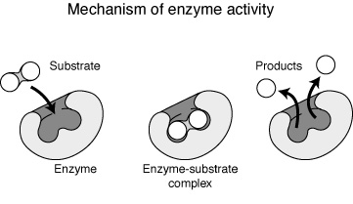
A mutation is a change in a gene that disrupts its function. It’s like a spelling mistake in the recipe to make that enzyme. If the message is incorrect, the enzyme isn’t made properly. For someone to have tyrosinemia, they must have inherited two changed (mutated) copies of the FAH gene. Neither copy is functioning the way it’s supposed to.

(U.S. Department of Energy Genomes to Life Program http://www.ornl.gov/hgmis).

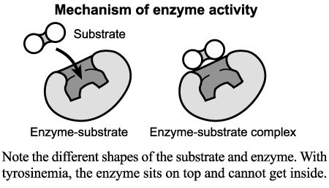
People who have just one mutated FAH gene produce less of this enzyme, but their body still makes enough that they will not have tyrosinemia. The other copy of the gene makes up for the one with the mutation. These people are carriers because they carry one mutated copy of the gene, which can be passed on to their children. This means, that as a parent of a child with tyrosinemia, both you and your child’s other parent are carriers of a mutation in the FAH gene.

Tyrosinemia type 1 is a rare disorder in most parts of the world. In the general population, approximately 1/110, 000 is born with tyrosinemia. That means that about 1/150 people in the general population are carriers for tyrosinemia type 1. In the Saquenay-Lac St-Jean region of Quebec, Canada, it is much more common, and occurs in approximately 1/2000 people. Among individuals descended from this region, 1/18 is a carrier.

How did my child get tyrosinemia if I don’t have it?

When both parents are carriers, there is a 1/4 or 25% chance with each pregnancy that both changed copies of the gene will be passed on to the child and cause tyrosinemia. There is also a 1/2 or 50% chance that only one parent will pass on the changed gene, and the child will be a carrier just like both of the parents. Finally, there is a 1 in 4 or 25% chance that neither parent will pass on the changed gene. This child will neither be affected with tyrosinemia, nor be a carrier.

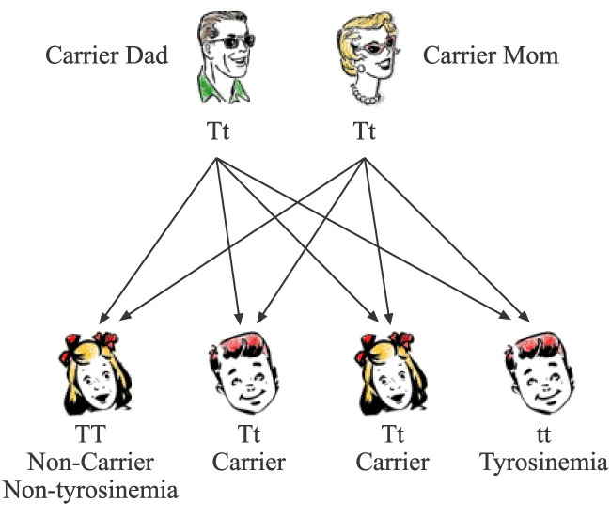

A research protocol is in place through the University of Washington Biochemical Genetics Clinic to determine the specific mutations that are responsible for tyrosinemia in your family. This information is not required to make the diagnosis, and will not benefit your child directly, but may contribute to our understanding of tyrosinemia from a genetic perspective. The doctor who manages your child’s tyrosinemia can give you more information about this.

Genetic counseling is available to you and to other family members who are interested in discussing their chances of having a child with tyrosinemia type 1. You may be already connected to a genetics department, but if not, you may contact Lisa Sniderman King at lcsk@u.washington.edu or go to www.nsgc.org and click on Resource Link to search for a genetic counselor in your area.

