The Visually Impaired: Differently-Abled, not Disabled

Akiera
Donna Bolima, Instructor
Language Arts 12A
January 30, 2007
INTRODUCTION
Not too many people know much about the culture of blindness. It is hard for people to understand this way of life and what blind people go through on a daily basis. The blind face discrimination and abuse living life day to day with tough obstacles to overcome. Many don’t realize that people with disabilities are normal human beings too, regardless of what their disability is. People who are differently-abled, need love and companionship in their lives, as everyone does. There are a lot of visually impaired people in our society and it’s good for people to be aware of the special struggles they go through.
MYTHS AND FACTS
There are a number of myths about the visually impaired. The first big myth is that blind people can’t see anything. CNIB claims that the “most common myth” is that the blind reside in “total darkness” when in reality, only “18%” of blind people can’t see at all. CNIB claims that most visually impaired people can “distinguish between light and dark.” Most people who are labeled as blind, are not even blind--people who have a visually impairment just automatically get labeled and stereotyped as non-seeing (CNIB; Vision health Vision hope).
Another myth is that all blind people read Braille. As quoted in CNIB; Vision health Vision hope:
“The numbers of blind and partially sighted people able to read Braille fluently are quite small, ie 13,000. To read Braille it is necessary to develop a good sense of touch and this is often difficult for older people. Many visually impaired people therefore use large print and tape instead of Braille” (qtd. in CNIB; Vision health Vision hope).
For those who can read, it is advised to label things using Braille.
The idea that blind children must attend a school for the blind is another myth. If a child needs special therapy or training for their disability, then that’s when it is best for a child to go to a school for the blind. It is claimed, however, that most children are capable of attending regular school and in fact, have a “right to attend school in their own communities” (CNIB; Vision health Vision hope).
Following these myths there is the idea that blind people feel other people’s faces to see what they look like. As mentioned previously, most visually impaired people are not totally blind. As stated “77%” of people with impaired vision retain enough sight to be able to recognize friends up close. In fact, if you are not recognizable, a blind person will just ask who a person is and feeling a person’s face “won't help!” Although some people do use strategies such as touch to recognize objects, they do so because they are unable to communicate with words (CNIB; Vision health Vision hope).
TYPES OF IMPAIRMENT
There are many types of visual impairment. When you hear the words ‘visually impaired’ it can also refer to eye disease. “Oculocutaneous Albinism, Ocular Albinism, Cataracts, Diabetic Retinopathy, Glaucoma, Macular Degeneration, Nystagmus, Optic Atrophy, and Retinitis Pigmentosa” are all different types of visual impairment. “Oculocutaneous Albinism” and “Ocular Albinism” have to do with a lack of pigmentation in the eyes. “Oculocutaneous Albinism” also affects the hair and skin. “Cataracts” are when the eye has a “clouded lens” which scatters light onto the retina and leads to a reduction in sight. It can happen at birth or as you get older. Cataracts can also cause a person to experience double vision when looking at a bright object that is against a dark background. “Nystagmus” is when “both eyes begin to flicker, causing vision to be like a ‘blurred photograph.” Stress, anxiety, or fatigue will make the disorder worse (University of Westminster; see Appendix B).
HELPING THE VISUALLY IMPAIRED
It’s understood that when one goes blind they don’t know how to live life without their eyesight. They are uncomfortable doings things that require sight but when it comes to other things i.e. sleeping or eating they are comfortable doing it. Visually impaired people usually try to stay close to home and not leave their comfort zone. They become afraid that they will not be accepted by others with the ability to see (Bennett 17).
A technique that Bennett found helpful in accepting blindness is to “reduce the importance of vision in life” (13). She claims that the eye is more a passive organ than something we just can not live without. Eyes don’t “open doors, put on our clothing, or transport us from place to place” (14). The visually impaired use their hearing to find objects like escalators. They use their nose to figure out where the food court is if they’re in the mall. For the blind that weren’t born blind, they will use what they remember from when they were able to see (17).
Bennett was able to cope with blindness and still pursue her hobby. She loves to write and she did this by recording her thoughts onto a tape recorder and developed a “habit of dictating a short story or comment on tape each day.” Soon it took the place of writing for her. As she says “I could express myself and feel creative as well as productive” (Bennett 18).
According to Lisa M. Petsche “Twenty-one percent of Americans ages 65 and over report some degree of visual impairment.” (Petsche 22 ). The American Foundation for the blind defines visual impairment as “any vision problem that is severe enough to affect an individual’s ability to carry out the tasks of everyday living” (2). Visual impairment can have different affects on people, such as the ability to read, write, and be independent. It’s normal for someone in this matter to go through stages like being frustrated, irritated, and feeling lonely. If you have a loved one who is visually impaired you should be there to talk to them. Learn about the disease and don’t think about what they can not do, but what they can do. Just be there when they need you. There are also several things you can do to make their everyday lives better. Depending on the severity of the blindness, you can re-label things around the house and put larger print labels on them. When you take them out in public let them hang on to your elbow and let them know where they’re at and whose around. You should also look for organizations in your community that assist the visually impaired (42:43; see Appendix C).
TECHNOLOGY TO AID THE VISUALLY IMPAIRED
According to Leslie Bennett there are tools out there in the world to help the blind and visually impaired transition normally with blindness. Bennett was once able to see then she went blind and she claims that practicing using these tools could help improve the daily lives of the blind. She also says “But we don’t have to learn these techniques on our own. Help is there for the asking” (qtd. in Bennett 12 ). People who go blind often ask themselves "how do I reclaim the life I once had?" (17).
Some technology to help the blind includes the new Braille key pad that allows the blind the opportunity to vote. As stated in Rocky Mountain News, “McGeorge,” who is 76years old “listened to the choices and punched in his candidate picks using a Braille key pad” (see Appendix A). In past elections, he had to depend on friends, relatives or an election commission worker” to help with voting tasks. This machine reads back all the voters choices to a visually impaired voter through a pair of headphones. Therefore the voter can go back and change any of their mistakes using a hand held key pad with Braille (News Rocky Mountain News.com).
VISUALLY IMPAIRMENT AND SOCIAL RELATIONSHIPS
How does a visual impairment affect relationships? When someone looks you in the eye you usually look at them back. When someone makes a certain facial expression you respond with either words or another face expression. As stated in Frame, “Someone makes eye contact and smiles at you; you chose to return the smile and gaze or to ignore it. Someone who never sees the initial smile or gaze has no choice but not to respond” (qtd. in Frame). So all of the body language and cues that we use visually are not an option or limited for people who cannot see well. A visually impaired person usually will date only someone that is known by someone who is close to them. Frame quotes Halloran as stating that “a spouse has power in the relationship to the extent that he or she uses resources, wealth, or physical strength to influence the other towards the achievement of certain ends” (23). If a person who is blind in a relationship feels that they have no control, it can lead to dissatisfaction and depression. In some cases, the blind partner may use their disability to gain more power, which is not a healthy way of sustaining a good relationship (63:70).
CONCLUSION
Overall, the Visually Impaired may be ‘differently-abled,’ but they are not ‘DIS-abled.’ There are different types of technology to help the visually impaired through their obstacles and consequently to lead a normal life. The blind vote, read, and carry on normal relationships. Those who are visually impaired face some difficult challenges and it is not easy for them when it comes to locating objects, finding food, or figuring out where they are, so they use the senses they do have to determine these things. There are little things that you can do to help the visually impaired such as letting them hang on your arm while you’re out in public and let them know where they are and who is around. There are also myths that people have made about the blind and it is up to us to understand what is real and what is not. It helps to understand that many people, including those who wear glasses, have a visual impairment and this category covers many types of disease or situations. When it comes to a visual impairment there are many different stages. We all have problems in our relationships with family and loved ones, whether we have perfect vision or not. One who is visually may face more unique difficulties, but relationships are possible. Despite their impairment, blind people, like everyone have kind hearts, are sweet, and are still normal human beings.
Works Cited

Beckman, Mary "Medicine; Light at the tunnel's end; In a future where being blind won't mean a person can't see, a sunset may sound quite beautiful, and a joystick could be more than just a toy. 03 Jul 2006,F.3. Los Angeles Times. ProQuest. . 22 Sep. 2006 http://www.proquest.com/
Bennett, Leslie "EMBRACING BLINDNESS. " Braille Forum 1 Jul 2006: 17-22. Alt-Press Watch (APW). ProQuest. 22 Sep. 2006 <http://www.proquest.com/>
Chung, Juliet "Reading at Their Fingertips; National Braille contest draws blind and visually impaired youth from throughout the country. Organizers say learning it is key to employment. 25 Jun 2006,B.5. Los Angeles Times. ProQuest. . 22 Sep 2006 http://www.proquest.com/
"Disiabilty Services." Types of Visual Impairment. University of Westminster. 31 Oct 2006 <http://www.wmin.ac.uk/page-9546>.
Frame, Melissa. Blind Spots: The Communicative Performance of Visually Impairment
in Relationships and Social Interaction. Springfield: Charles C. Thomas
Publisher LTD., 200
"Information Technology; HumanWare launches Maestro 2.0, the new generation of PDA for the visually impaired. " Science Letter 1 Aug. 2006: 813. Discovery. ProQuest. 22 Sep. 2006 <http://www.proquest.com/>
Ramirez, Rosa. "Blind people have a new ally in voting booth - technology." News Rocky Mountain News.com. November 3, 2006. 8 Nov 2006 <http://www.rockymountainnews.com/drmn/local/article/0,1299,DRMN_15_5114786,00.html>.
Stevick, Eric "Helping the blind to see success. " The Herald [Everett, Wash.] 27 Jun 2005,1. Washington Newsstand (6). ProQuest. . 22 Sep. 2006 <http://www.proquest.com/>
Vascellaro, Jessica "Web Sites Improve Service for Blind People Boosting Compatibility With Screen-Reading Aids. " Wall Street Journal, 20 Jul 2006, ProQuest 22 Sep. 2006 <http://www.proquest.com/>
Wood, Lamont "Giving Eyes To The Unsighted -- Three Windows apps can help the visually impaired. " VARbusiness 15 May 2006: 50. ABI/INFORM Trade & Industry. ProQuest. 22 Sep. 2006 <http://www.proquest.com/>

Appendix A

Braile Chart

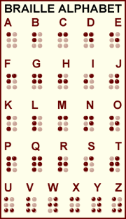

Color Braile Chart

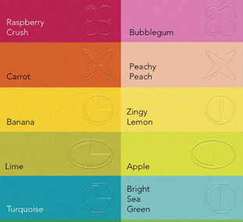
Appendix B

Types of Visual Impairment

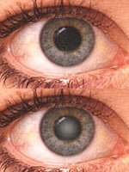  CATARACTS | 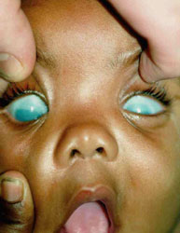  CONGENITAL GLAUCOMA
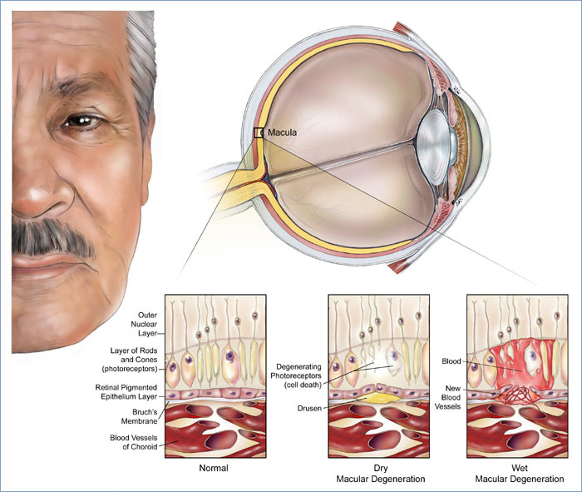

MACULAR DEGENERATION
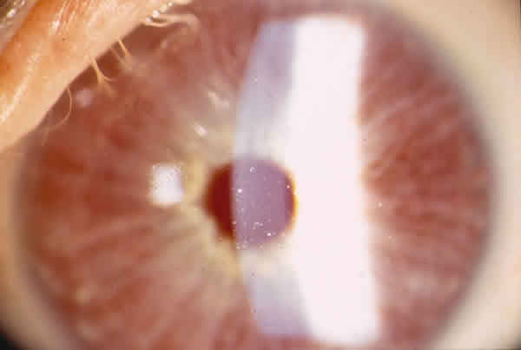  Oculocutaneous Albinism | 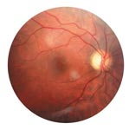  Optic Atrophy
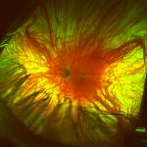

Nystagmu

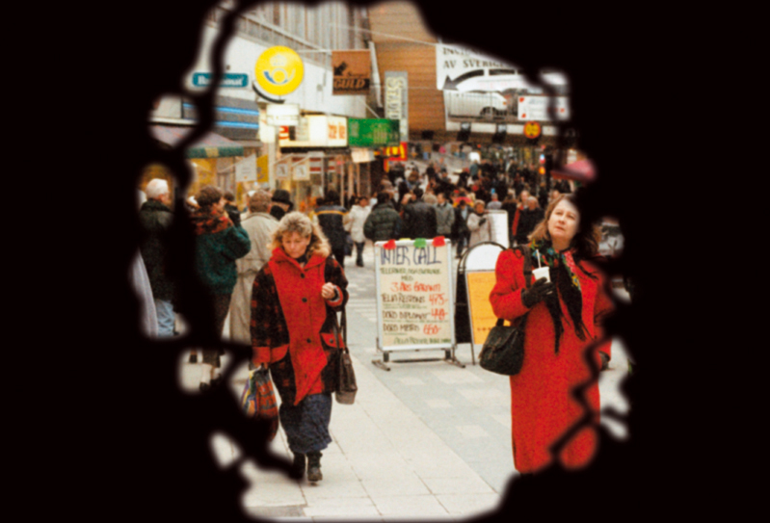  Two views of what a person with “Retinis Pigmentosa” sees | 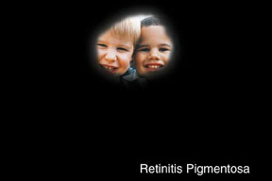

Appendix C

ORGANIZATIONS

Washington State Department of Services for the Blind (DSB)
3411 S Alaska Street, Seattle, WA 98118-1631
Phone: 206-721-4422
1-800-552-7103 (Toll free state-wide)
Fax: 206-721-4103
URL: http://www.wa.gov/dsb
Offices also in Olympia, Tacoma, Vancouver, Yakima, and Spokane.

The Lighthouse for the Blind, Inc.
2501 S Plum Street, Seattle, WA 98144-4711
PO Box 14959, Seattle, WA 98114-0959
Phone: 206-322-4200
1-800-799-0402 (Toll free)
Fax: 206-322-4419

*The Seattle Lighthouse, a local nonprofit organization, is a diversified industrial manufacturing company. It provides employment and on-the-job training for people who are blind or deaf-blind, as well as vocationally related rehabilitation services. The Service, Office & Systems (SOS) Training is a vocational educational program designed to help people who are blind enter careers in customer service, clerical support, and related fields.

LINKS

- http://helpinghands4theblind.com/

- http://www.myflorida.com/dbs/braille/braille_alphabet.shtml

- http://www.viguide.com/

