MINUTES of AAUP Executive Board meeting
Monday 11 May 2020, 3:30-5:20pm
https://washington.zoom.us/j/94257455155

Three priorities in the current AAUP strategic plan:
1. the escalating division of insecure academic labor
2. reductions and restructuring of public funding and budgeting processes
3. the increasingly hostile environment affecting students and faculty

On Zoom: Eva Cherniavsky, Charlie Collins, Abraham Flaxman, Jim Gregory, Amy Hagopian, Dan Jacoby, Jay Johnson, Diane Morrison, Duane Storti

Guests: Julie Schmid (national AAUP) <jschmid@aaup.org>, Bill Lyne (WWU, United Faculty of Washington) <William.Lyne@wwu.edu>, Chris Newfield (UCSB, Remaking the University) <cnewf@ucsb.edu>, Jim Bakken (AAUP regional) <jbakken@aaup.org>,

Absent: Nora Kenworthy, Rob Wood

Resigned, but acting in treasurer capacity in the interim: Bert Stover

Absent as usual (resigned?): Ann Mescher, Theo Myhre

Agenda:
The topic of our meeting on Monday is how do we get from principles to strategy: what would it look to mobilize in the coming months (and years) for large-scale, state reinvestment in higher ed?
Some readings:
Newfield's Chronicle piece: https://bit.ly/2JWfX7C
Change.org petition:http://chng.it/TPLsHWzs8b
New Yorker piece: https://www.newyorker.com/culture/cultural-comment/the-pandemic-is-the-time-to-resurrect-the-public-university?utm_source=onsite-share&utm_medium=email&utm_campaign=onsite-share&utm_brand=the-new-yorker
Labor Notes Public Higher Ed Group principles: our principles.
Chris Newfield’s important article: https://www.chronicle.com/article/Only-Free-College-Can-Save-Us/248468

Minutes

How will higher education survive and even thrive as we pick up the pieces after COVID-19?

Eva started us off. UW AAUP chapter crafted a letter to our UW President asking for protections for students, academic student employees, staff and faculty. The response from the Senate and the president were as expected – concerns and shared values, no commitments (a la “thoughts and prayers”).

AAUP has a 2000-person list server, where we posted this letter, and there was a bit of a dialogue.

We anticipate a barrage of austerity. We can respond by protesting various cuts, but as UW faculty are not unionized and our Faculty Senate is rather powerless, we anticipate few results. Instead of meekly asking for fewer cuts, we could join a national movement to make a bold claim for centering higher education as a reconstruction strategy. The new higher education could be newly accessible to all, eradicate the need for debt, and be centered as central to the nation’s recovery. Could we launch a campaign for centering higher ed as a proactive strategy?

Bill Lyne, representing the public colleges in Washington State, spoke about the state-level scene. The legislature will doubtless reconvene in special session to cut the budget in the fall.

This is a very different situation than 2008—the legislature can't just cut our state support and say, “Go raise tuition.” Polling is showing students won’t pay increased tuition for on-line education, and we may even lose enrollment. After the last downturn, we raised tuition (a lot), sending our students into debt. Curiously, we also funded new auxiliary perks with bond debt—dorms, new buildings—and those bills are now coming due. We are seeing the fruits of neoliberal higher ed.

In good news, Governor Inslee has already said he wants to keep the Washington College Grant entitlement program that passed last year. And there remains some momentum for taxing the big rich corporations in our state. Still, it’s likely that student and bond debt will be the foundation of our higher ed financing plan, unless there’s a national plan along the lines of what Chris Newfield talked about. What’s happening in Washington in the short term won’t be as important as the national effort to make public education public again.

Eva: It’s clear enough what we want, but how do we get there? Could take multiple years. Need to build momentum.

Can we connect to the Biden campaign to center this issue? We could build on the progress of the Sanders campaign, turning free college into genuine public college.

Julie Schmid, Ex Dir of national AAUP, talked about the multiple national educational organizations with a stake in this. Remarkably, there has not yet been a conversation about this kind of campaign among the key players, but there could be one. AAUP internally has been discussing, but hasn’t reached out to national peer organizations. AFT at the national level could be interested in this topic, but they’re still in the mode of the immediate crises. NEA could be in the same boat.

For AAUP, any kind of national campaign would have to focus on the idea that higher ed must by its necessity include job security in the field, because that is the only way of ensuring the public good of academic freedom and a democratic society, the creation of knowledge that isn’t subject to the winds of corporatism and political intrusion. That can’t be built on the cheap.

Do we have a way into the Biden campaign? NEA and AFT have endorsed him. Moving higher ed up the ladder of NEA and AFT priorities is an uphill battle, but that would be the way in. Bill Cooper, Mike Bostick, Daren Nedrow at AFT. Barbara Mandeloni, formerly with NEA?

Could the next stimulus bill have a higher ed focus, with a requirement to keep people employed? The last CARES Act didn’t have many strings. There’s interest in a different bill. Senator Murray is interested in an education stabilization fund, but it will be direct grants to the institution. Lyne’s goal is to include stipulations for maintenance of efforts. But NY Governor Cuomo and Senate minority leader Schumer don’t want those restrictions. We’re likely to see another round of that kind of funding.

Important fact: University administrators want to pay their bond debt first, before salaries. CFOs are happy to protect the creditors before the people with lower salaries.

Chris Newfield asked us to think about how much money is needed to fund the model we want. California might need $9.7 billion, he thinks. One of the essential services is to keep employment. An important talking point is saving jobs, a base to restart the economy. California should strive to stay 100% whole. The state universities’ $40 billion budget is projected to suffer 70% losses, largely from medical care hit. They project 18% cut, or worse. Senior managers just want to avoid talking about it.

Hagopian noted that across America, public hospitals and universities are intrinsically tied through their medical schools. A large part of our national medical care safety net for millions of uninsured is right there in the public university hospitals, where medical residents provide the bulk of care. This is why the U.S. has 25% more capacity in our medical residency training programs than we have graduates of our own medical schools—to provide the capacity to admit graduates from schools abroad. There’s no firewall between universities and these public hospitals. The pandemic created a serious financial crises for the hospitals, and therefore for the universities.

Lyne says higher ed budgets in Washington actually went up over the recession. But we can’t do that this time; we survived the 2008 recession on the backs of students, so tuition is maxed out.

Public hospitals and universities provide the resilience our society needs to survive the crisis. It doesn’t make sense to kill off the institutions that can save us.

The Washington legislature’s special session seems likely to cut higher ed, as it did in September 2011. You’ll recall K-12 teachers responded with Occupy type demonstrations in Olymia, and even staged a citizens’ arrest of the legislature. See the fun video here: https://www.youtube.com/watch?v=ODBNCYRQdyk

There are legal implications of furloughs and salary freezes and pension benefits. Mitch McConnell wanted state to declare bankruptcy to get out from under the pension commitments.

Ambitious college administrators will want to start closing programs, especially in non-unionized campuses, where our only protection is the faculty code. They’ll close non-profitable programs first.

Bill noted Central Washington Univ was quick to declare financial exigency; they’ve had a dysfunctional administration and board for a long time. The president had hoped for authority to renegotiate bond debt, the board responded by declaring the exigency; that had to be walked back. The board seems eager to fire people. The governor’s office has responded by leaning on some of those governor-appointed board members.

Charlie was in grad school during the 2008 downturn. What do we see if states continue to gut ed funding, what will this look like?

Diane noted we’ve already seen program shut down, with the IELP. The level of response from the faculty was mild. They can pick off programs one by one if we don’t defend each other.

Eva suggested the decisions will come down all at once, as we’re starting fall quarter, without much opportunity for intervention. This has to be a national campaign. There’s a moment now where it seems possible to start to do the work of building protections, but we need to plug into something. The point is to emphasize how crucial higher ed is to recovery, with phase one as remaining whole and phase two to reconstruct around quality.

Chris noted there are corporate systems lined up to offer on-line, low-quality, pablum-packaged material.

What would the “being whole” amount be in Washington? The hospital books are very secret, so how would we calculate that.

What’s the scenario at UW? Summer surprise is traditional. Dirty rearrangements are announced then, when Faculty Senate isn’t meeting. Our governance is especially weak now, with Sandison running the Senate Committee on Planning and Budgeting.

AAUP could coach the Senate leaders so they aren’t complete dishrags when the hits start to come. There seems to be no instinct to support each other’s programs, no sense of sticking together under shared governance. We have to work on that using the list serve, create the atmosphere of activism that we need.

Diane suggested we call on the Senate to continue to operate over the summer. There was agreement about that.

Jim said we should call out Sandison on its failure to employ the “Reorganization, consolidation, and elimination procedures (RCEP) in relation to the English Language program, on the list server. Get Senate leadership worried that we’re watching. As more programs come up for elimination, this will be key.

Jim circled us back to the bond issue, as we can’t let administration make paying back the bonds be the top priority.

Bill: All the universities are scurrying off to their debt consultants. “Municipal Liquidity Functioning” was part of the bailout, Federal Reserve allotting $.5 trillion to states and municipalities to get federal bonds stretched out. States need to get that fed money to universities to cover the bonds they took out for housing and food service construction, stadiums. The more we can make public that kind of crisis, the better. What are the consequences of bond default? At UW the football stadium was internally funded, no bonds.

Duane noted people coming up for tenure are a critical group, at risk for denial. The President’s office/provost might ask to review tenure at the central level, as it did in the 1990s. Jim recalled the talk of freezing tenure in the last downturn. Administration didn’t do it then. Jim recalled even back to the great depression when faculty salaries were cut 30-40%, but that predated the ruling that salaries were a property right.

Next steps:
- Calculate the “made whole” number—who’s crunching those numbers at UW?
- The work of a national public ed campaign needs to unfold in coming months. We can build a counter-narrative about the possibilities: A project of public education is possible. All the rules are up in the air! We have to show the vision the administration should be demonstrating.
- AAUP could join a national campaign, and roll out the role of its chapters. The campaign needs to have facts and figures about costs and possibilities. Could AAUP supply a toolkit?
- At UW level, engage the Faculty Senate—ask them to meet over the summer, call them out on the failure to push back on program closure. Jim could craft the ask?
- Our national level affiliates to engage with the U.S. presidential and Senate campaigns, to bring political pressure.
- We all must engage student groups, helping them notice what happened in 2008.
- Focus on the precarious faculty issue, which accelerated the dominant nature of adjunct faculty status to a normative situation in 2008.
- Figure out how to uncover the information required to answer these questions. Unions have capacity to request it, but may need FOIA. Can AAUP put together a tool to help chapters calculate its figures.
- It will be key to address the medical center and UW Physician components of the fiscal disaster. Unfortunatey, UW Physicians data are not subject to FOIA and are held secret.
- RCEP procedures require time (a quarter, typically) to review. Faculty rights are in the balance. As usual, in an “emergency,” the Faculty Code goes out the window and the Board of Regents supersedes.
- AAUP national will do a webinar on shared governance that we can promote.
- Bill, Julie and Jim were encouraged to work with national organizations to make a united bid to the Biden campaign and some key Senate campaigns.
- We need to get out front of some bad things we anticipate at UW: program closure, tenure pauses, salary cuts, furloughs, layoffs.
- Note that AAUP national leadership elections are in June, which may change up some things.
- It will be important to prompt a list server conversation on program elimination and the history of how program privatization worked after the last downturn. Even before that, in the early 1990s downturn, there was an attempt to wipe out Slavic languages, applied math, others--Galya Diment may be able to fill us in on this history.
- Bill will monitor the budget situation in the legislature, in the absence of any meaningful Senate lobbying staff.
NEXT MEETING: June 1, 3:30 pm

Recording with the integrated audio transcript:
https://washington.zoom.us/rec/share/yMpMaPL1921LHKvSxHjeZv8qOqrHaaa813dP-aILz0jMs1mODLYjPOVrFUDkTZHC

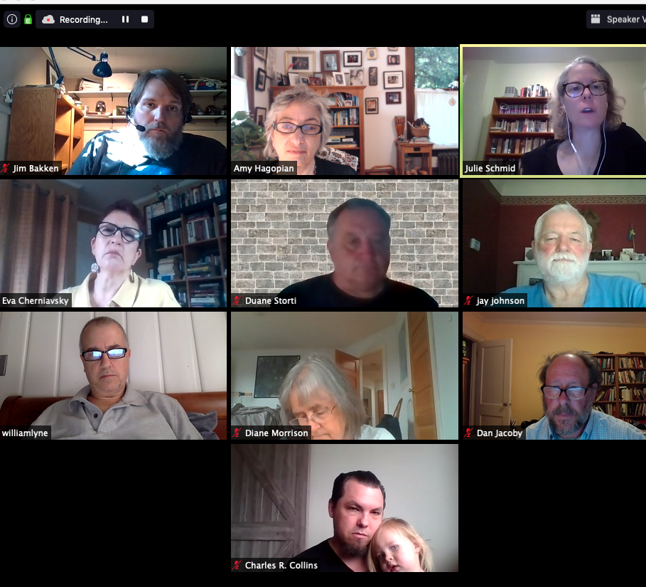

NOTE:
Diane has been participating in the Public Higher Education Workers organizing group last week, run by Barbara Madeloni, education coordinator, 413- 695 6658, barbara@labornotes.org. They are developing a set of principles to follow as decisions are made about responses to the COVID crisis. Also, Rutgers has put out a statement on how decisions should be made about CARES Act funding.

To consider (from our last meeting):
- Who else needs to be in the discussion?
- Why is there no public conversation on UW budgeting?
- Adjunct lecturers are awaiting their fate, with no guidance. What are the principles and priorities, and why is the UW not making that conversation public? What happens to people on grant funding?
- What are support mechanisms can we organize?
- What is the data gathering for people’s experience?
- How will the Faculty Senate be engaged? Any Senator can propose a Class C Resolution.
- Are Senate meetings being broadcast?
- What is the university sharing about enrollments?
- No information shared about fall off in spring 2020, we noticed.
- We’ll need a significant campaign in Olympia to push against the defunding we experienced in 2008. If cuts and austerity are the rule, then it’s the wrong agenda.

