Amy’s notes from AAUP forum dated 6 February 2020
New Titles for UW lecturers? Parity for lecturers will require more than a name change, but it’s a start…
4:30 pm to 6 pm, Odegaard Library
Sponsored by AAUP and Faculty Forward

Panel:
Linda Hurley Ishem, urban studies (UW-Tacoma)
Aaron Katz, public health (UW-Seattle)
Carrie Lanza, social work (UW-Seattle)
Annie Nguyen, interdisciplinary A&S (UW-Tacoma)
Moderator: James Rush Daniel, Dept of English (UW-Seattle)
Eva Cherniavsky, host on behalf of AAUP & Faculty Forward

Aaron Katz started the conversation by describing his career at the University of Washington. He started as professional staff in the 1980s. The then-department chair in Health Services appointed him as a lecturer as a matter of convenience, to allow him to teach classes. Two years after being appointed as lecturer, he was appointed as senior lecturer. It was considered a “title of convenience.” His appointment was renewed annually, although he later became aware that full-time senior lecturers were supposed to be appointed to multiple-year terms. He was lucky there were no career-limiting consequences for this oversight.

Many lecturers suffer serial quarterly appointments for teaching obligations that are, in practice, permanent. Each unit at the UW treats these positions differently, with different pay scales, different lengths of appointment and different senses of security.

The Faculty Senate approved giving voting rights to senior lecturers with appointments of at least .5 FTE. The Senate (in 2018) also put an end to allowing Assistant Professors voting on the faculty status of lecturers.

The Faculty Senate is now considering legislation to transform lecturer titles to “teaching professor” titles. [I couldn’t find any on-line text of this legislation, by the way—does it exist?]

Linda Ishem described her experience at UW Tacoma, where she was recruited to teach when she was working for the Department of Community Services in Pierce County. While they wanted her for her practice expertise, that background wasn’t recognized in the promotion or advancement criteria. She was an “opportunity hire” at UWT and then got her PhD in social work while teaching. While a student, her title was predoctoral researcher, while enrolled for the PhD. Then she was appointed Assistant Professor, but fairly quickly was asked to teach full time (inhibiting her capacity to advance a research portfolio so she could succeed on the professor track). Eventually she converted to lecturer.

Linda was routinely showcased as the “community engagement” person on faculty UWT was being praised for having practice faculty, while in the background her career was suffering for the time she spent on practice and teaching, which crowded out research. There were also subtle hierarchical issues around scheduling and other practical matters.

Carrie Lanza previously taught at UW Bothell, but the program there ended and so now she is full time lecturer in UW Seattle’s School of Social Work.

Carrie had been a pre-doctoral lecturer in the School of Education during her PhD program, and took a pay cut of $1200 (per month?) when she left the UAW union to join the faculty.

She views herself as a part time lecturer, working full time, with time spent on new course preps while also juggling mentorship responsibilities and being assigned no office. She teaches elaborate community-engaged courses, hybrid online/in-person classes, study abroad (last summer she was in 2 countries).

After 8 years of experience, her position was given to someone without teaching experience because teaching wasn’t in the hiring rubric. Now she’s been hired competitively, with lots of internal confusion about her voting status.

Annie Nguyen began her career in community college, where all the faculty were on the same track. Once she paid her dues there, she felt her career was allowed to develop and flourish.

At UW she finds she has little creative license to develop new courses. For lecturers, there’s no credit for research and publications, which is puzzling: why is that unrecognized? More intellectual freedom is needed.

In the Q&A section, some ideas were floated:
- Some of the differences observed across the panel are generational. Aaron, who is at retirement, enjoyed a healthier career trajectory did the younger people on the panel.
- There is huge variation across departments, with lots of power in the hands of the chairs. There are issues beyond salary and security that pertain, too: course assignments, sabbatical opportunities, research projects.
- The variability across units and campuses is unconscionable. The differences represent a failure of accountability. Why are appointments on such a short-term basis, when there is consistent need for teaching faculty?
- Does the UW value teaching? Is there evidence to support this value? Why isn’t the teaching line a tenured line?
- These precarious arrangements for faculty threaten academic freedom. The whole austerity financial model for higher ed is a threat to the important value that “institutions of higher education are conducted for the common good, not to further the interest of either the individual teacher or the institution. The common good depends upon the free search for truth and its free exposition.” [I added that definition from the AAUP website.]
- The use of student course ratings to value teaching performance is highly problematic.
- There is no common or consistent definition or set of guidelines for the use of the lecturer title. We are creating a faculty underclass.
- Promises made to improve the lives of lecturer faculty aren’t being kept.
- We are forgetting the primary role of faculty in making these decisions, leaving many decisions to administrators, chairs and academic HR. “Competitively hired” is an Academic HR invention.
- Other university systems’ lessons in this area could be valuable, but aren’t being investigated.
- Symbolism matters. Changing the titles may appear to be symbolism at first.

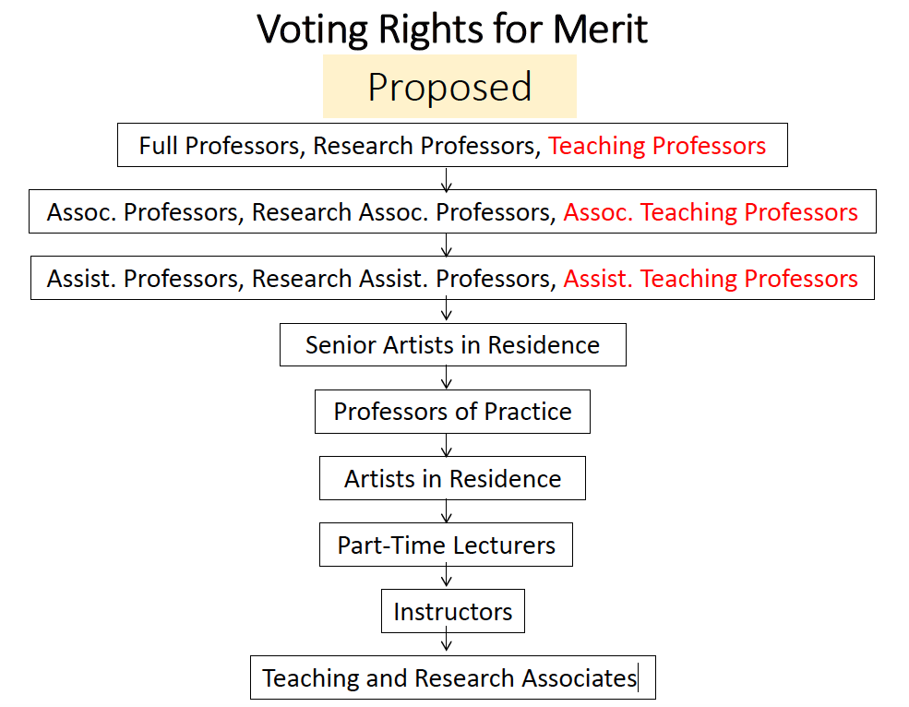

Pursuant to the Provost’s Guidelines for the Appointment of Full-Time and Part-Time Lecturers, individuals appointed since September 2013 are limited to annual appointments for up to three consecutive years.

The University has established minimum full-time monthly rates of pay for faculty, librarians, and other academic personnel. These salary minimums apply to all titles, ranks, and tracks listed below regardless of funding source or length of appointment. Salary minimums also apply to persons appointed as acting, affiliate, clinical, temporary, and visiting in any of the applicable ranks and titles below. Note: these salary rates are minimums. In determining an appropriate salary, there are likely to be factors which justify a unit exceeding the salary minimums. Note: Nine month lecturers must earn a minimum of $4490 per month.

From: AAUP <aaup-bounces@mailman12.u.washington.edu> On Behalf Of Jack Lee
Sent: Sunday, April 14, 2019 10:16 PM
To: Faculty Issues and Concerns <aaup@u.washington.edu>
Subject: [AAUP] "Teaching Professor" proposal

Dear colleagues,

Apologies in advance for the length of this email. I'm writing to alert you to an important proposal that's being considered by the Faculty Council on Faculty Affairs (which I currently chair). We won't be officially presenting it to the Faculty Senate until next fall, but I want to let everyone know that we're thinking about it, so the faculty has time for a serious discussion before it comes up for a vote.

As many of you know, the Faculty Senate and the administration have taken a number of steps in recent years designed to improve and strengthen the working conditions of the teaching faculty at UW. The next step now being considered by FCFA is somewhat bigger.

TL;DR: The Faculty Council on Faculty Affairs is considering a proposal to change the titles of Full-Time Lecturers, Senior Lecturers, and Principal Lecturers to "Teaching Professor" titles.

More specifically, the proposal would make the following title changes in the Faculty Code:
- Lecturer Full-Time (competitive recruitment) -> Assistant Teaching Professor
- Senior Lecturer (part-time or full-time) -> Associate Teaching Professor
- Principal Lecturer -> Teaching Professor
We are contemplating that these will be non-tenure-track positions, with essentially the same code language regarding qualifications, appointments, merit evaluations, reappointments, and promotions as now apply to the corresponding lecturer titles. We want to ease the transition by not requiring colleges to commit any more financial resources or contract length than they are doing under the current code (although we hope this change willencourage colleges to treat teaching faculty more like other categories of professorial faculty).

Why are we considering this change? Here are a bunch of reasons that many members of FCFA find compelling:
- It's a National Trend: More and more universities are conferring professorial titles on teaching faculty. We've found 29 such universities (see attached list), a much higher number than just a few years ago
- Recruitment and Retention: We will be more likely to recruit and retain excellent teaching faculty if we can offer professorial titles, especially if we're competing against other universities that offer such titles
- Morale: Because our teaching faculty are carrying an ever-increasing portion of the teaching load in this university, they should have titles that demonstrate clearly that they are respected and valued, not “second-class faculty”
- Equity: Most lecturers are women, and a higher percentage are people of color than in the professorial ranks. Can we really justify relegating this population to titles with markedly lower status?
- Transparency: The proposed titles are a clearer reflection of the qualifications and duties of teaching faculty
- Professionalism: Professorial titles are likely to encourage departments that hire teaching faculty to consider them as career professionals
- Parity: There are other categories of non-tenure-track faculty at UW, with no higher qualifications than our lecturers, who carry professorial titles, such as Research Professor, Clinical Professor. and Professor of Practice
- Respect: Professorial titles are likely to command more respect from students, and letters of recommendation & grant applications will carry more weight
- Commitment to Undergraduate Teaching: Professorial titles will demonstrate to students, parents, legislators, and donors that our courses are taught by “real” faculty on a career path, not just fill-ins, thus raising the stature of UW
Other than the title change, the one category of significant substantive changes that this will entail is in voting rights. The faculty code links voting rights to academic rank, and professorial titles will automatically boost some teaching faculty members higher in the voting hierarchy. The proposal we are considering would stipulate that faculty on the Teaching Professor track would not vote on promotion or tenure of tenure-track or research-track faculty, just as faculty on the Research Professor track do not vote on promotion or tenure of tenure-track or teaching-track faculty. But for merit and reappointment, faculty on the Teaching Professor track would vote on the cases of everyone of lower rank, just like Research Professors.

The main changes to voting rights that would result are summarized graphically in the attached PDF. As you'll see, the only change for promotion and tenure voting rights is that tenure-track Associate Professors, who now vote on the promotion of Senior Lecturers to Principal Lecturers, would no longer vote on the corresponding promotion of Associate Teaching Professors to Teaching Professors. But the changes in voting on merit and reappointment would be more extensive.

There are many open questions that will need to be settled before this proposal is ready to go to the senate. Here are some of the questions we're thinking about:
- Are these the right titles? Many different teaching professorial titles are used at other universities (see the attached document). After extensive informal discussions with many colleagues (especially with lecturers of various ranks), we found a strong consensus in favor of the titles proposed above. Many people dislike "Instructional" as an adjective because it sounds too much like "instructors," and many dislike "Teaching Assistant Professor," etc. (despite its obvious parallel with "Research Assistant Professor"), because it sounds too much like "Teaching Assistant."

- Is a title change just "window dressing," without substantive changes in the terms and conditions of employment? This is a somewhat controversial question, but the general consensus on FCFA, and the near-unanimous judgment of the many lecturers we've spoken with, seems to be that the title change is likely to bring significant real advantages, for all the reasons listed above. In any case, even if we do wish to make substantive changes to the terms and conditions of employment, the title change in itself is a big step, and maybe we should take one step at a time. But see the next question.
- Are there some substantive changes that might be made to the code that could offer the possibility of enhancing the job security of teaching faculty without undue disruption? One such change that we've talked about is extending the maximum contract length for associate & full teaching professors -- say, to 7 years for associate and 10 years for full. This would not require any college or department to give longer contracts, but it might offer the possibility for some teaching faculty to obtain more job security and more robust academic freedom.
- Should we be offering tenure to teaching-track faculty? The AAUP's 1940 Statement of Principles on Academic Freedom and Tenure, on which almost all US universities' tenure policies are based, clearly envisions tenure as a requirement for both teaching and research faculty. But with one partial exception, none of the universities we know about offer tenure to teaching-track faculty, so our feeling is that it would be too radical a change to propose now. (The partial exception is the UC system, which offers a tenure-like status called "Security of Employment.")
- If not tenure, should we at least be considering a six-year up-or-out requirement for Assistant Teaching Professors, like the one now in place for Research Assistant Professors? This might have the advantage of forcing departments to make a timely decision whether to make a long-term investment into the career of a teaching faculty member. But other than UC, none of the other universities we studied have such a requirement, and we decided not to propose it at this time.
- Is this change likely to encourage colleges to appoint more non-tenure-track faculty, thus further eroding tenure? Some worry that the title change will provide deans with "cover" for replacing more and more of the tenured faculty with non-tenure-track faculty. Others counter that the economics of higher education have already made it necessary to have a nontrivial portion of the faculty with higher teaching and lower research loads, and we need to ensure that they are recognized and respected as professionals. In any case, it's a good bet that most departments, concerned with their status in the world of academic research, will argue strongly for maintaining a critical mass of tenure-track faculty.
- Are there structural changes that could help to slow or stop the undermining of tenure? USC, for example, requires each college to establish an upper bound on the ratio of teaching-track to tenure-track faculty. UW could do something like that, either through the faculty code or at the direction of the provost, allowing for variations in custom and needs from college to college.
- What should happen with part-time lecturers? As a separate project, the FCFA is considering whether changes need to be made to the code language regarding appointment and reappointment of part-time lecturers. For the time being, we are assuming that the title Part-Time Lecturer will remain in the code, and not be converted to a professorial title. There might also need to be some title corresponding to HR's "Lecturer Full-Time Temporary," for short-term lecturers hired without a competitive search.
- How should the transition be handled? Our inclination is to immediately convert all existing competitively hired lecturers (except Part-Time Lecturers) to the corresponding professorial titles, as described at the beginning of this letter.
Thanks to those of you who have read this far. This could be an important step in the evolution of UW's faculty, and it deserves some serious discussion.

Jack Lee
Chair, Faculty Council on Faculty Affairs
_______________________________________________
John M Lee, Professor of Mathematics
Box 354350, University of Washington
Seattle, WA 98195-4350
johnmlee@uw.edu, 206-543-1735

