MINUTES of AAUP & Faculty Forward meeting
2 February 2022, 11:00 am to 12:30 pm

Three priorities in the current AAUP strategic plan:
1. the escalating division of insecure academic labor
2. reductions and restructuring of public funding and budgeting processes
3. the increasingly hostile environment affecting students and faculty
Our mantra is “refuse austerity.”

Via zoom https://washington.zoom.us/j/93610086550 or One tap mobile

+12063379723,,93610086550# (Seattle)

AAUP Board members present: Eva Cherniavsky (president), Abraham Flaxman (VP), Amy Hagopian (Secretary), Diane Morrison (treasurer), Rachel Chapman, Louisa Mackenzie

Missing: Aaron Katz, Jay Johnson, Rob Wood, Ann Mescher, Nora Kenworthy, Duane Storti, Annie Nguyen (membership secretary), Charlie Collins, Jim Gregory

Guests: From Faculty Senate: Zoe Barsness, Mike Townsend, Amanda Paye

AGENDA
Review the recommendations of the Faculty Senate’s disciplinary task force

MINUTES
The task force was set up back when Thaisa Way was Senate chair. See membership and structure in appendix, below. The Senate endorsed the principles, and then the drafting committee was asked to proceed. Members felt they were following the Senate’s directive, not that of administration, nor were they negotiating.

Mike emphasized the principles and values included: accountability (all members of the community should be held accountable to their responsibilities and obligations), the value of education (informing members of the community about the expected behaviors, and allow mistakes without outsized consequences). Accountability and education sometimes get twisted into punishment and rehabilitation.

Mike hopes this will be viewed as “conduct legislation,” not misconduct legislation. The code had swung too far to punishment. Certain aspects of the current code are likely illegal, such as the “suspension with reduced salary,” which can be implemented without any peer faculty review or hearing involvement. That’s likely illegal under current court cases. Also, accuracy matters, with a burden of proof on the person making charges. The Washington Administrative Code has a role.

There’s no requirement that a faculty member be found to have done something wrong in the informal intervention part of the diagram at the top (where feedback and support are the interventions).

Behavior can prompt feedback without punishment—these behaviors can include inclusiveness errors, microaggressions, or falling short of meeting responsibilities and obligations to respect dignity, or act in a civil manner. Informal interventions can result in a written warning, but that could be appealed. Under the current situation, the local administrator can impose written warnings without recourse. Warnings aren’t considered discipline.

In this new approach, there are new opportunity to appeal to a faculty body for review. A Faculty Rights and Responsibilities panel would be established. Our system now requires volunteers serve as adjudicators, that wouldn’t change.

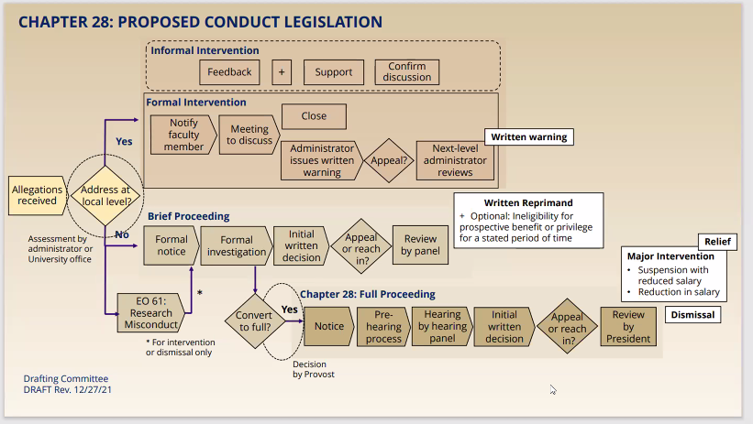

Where are the areas of contention with regard to this proposal? Mike took a stab at these:
- Administration worries about cost. Training of chairs will be required. Of course, that’s already a need. No costing estimates exist.

- Administration is not keen to eliminate the capacity to reduce salary without a hearing or proceeding. Ana Mari believes there must be capacity at the unit level to punish.

- The additional list of interventions available adds complexity administration believes will be hard to understand.

- Faculty worry about how the written warning may be used.

- Some wonder who gets to decide from the very beginning whether the problem can be addressed at the local level.

Mike noted all concerns stem from mistrust. Administration doesn’t trust faculty to police itself. Faculty doesn’t trust administration to be evenhanded. Mike suggested the alternative mechanism is a union. Rachel later noted we allow the administration to police itself, but not the faculty. Abie noted if trust was a prerequisite then we wouldn’t need a system at all; the whole point of this mechanism is provide procedures in the absence of trust.

It was reported that Bob Stacey makes the point that the 25-71 process doesn’t work. He views the adjudication panel as a useful way to bring solutions.

Louisa noted the local level can be the source of a lot of problems. She noted the case of a serial sexual abuser on the faculty on her campus, who is now gone. Under the current system, he was allowed to stay at UW (for decades!!) because he made technical arguments about the authority of people at the unit level to decide things. Under the proposed model, she believes the person would have left sooner.

The UW maintains terrible records of its disciplinary processes and decisions, and when asked for records produces a hodgepodge of local unit text files that are inconsistent and can’t be searched in any systematic way.

A chair’s power, acting alone, in the new proposal is limited to a written warning. A chair could no longer unilaterally declare someone non-meritorious, remove administrative assignments beyond “at will” EO-20 appointments, or impose coaching. A panel of 3 members of the faculty rights and responsibilities pool can be made available to the faculty member for a consultation before they agree to settle.

Separately, the provost has a task force working on faculty evaluation and merit reviews. AAUP members expressed some alarm at the products of this task force to date. Note: merit criteria haven’t typically included civility. FCFA will have to look at that.

Mike reiterated 4 aims for the new approach: clearer grounds for intervention, procedural safeguards, training, and monitoring mechanisms. He supports the proposal and hopes we do too. It’s not perfect.

Rachel expressed her regard for the intense care and concern to push the system to do less harm. She expressed the importance of a vision for a restored, just and thriving community. No matter what we do, though, there will still be abuse. She noted the system is legalistic in nature, and uses policing as a default approach to punish rather than build relationships of trust. If disrupting the peace is criminalized, the one who defines the peace is who owns the power in the system. Is gaslighting the UW’s institutional strategy?

As she asked during the last meeting with Faculty Senate representatives on this topic, she asked the same questions:

- Were there any BIPOC folks on the committee that designed this reform?
- Was anyone who’s been on the receiving end of punishment involved in the drafting?
- Does the president still have veto power?

Amy asked how Rachel’s critique was addressed when she delivered it last year. Zoe noted the committee did more consultations. Rachel noted the assumptions about the bounds of civility are projected by the folks who serve on the committee. The current committee is comfortable with its processes and power. It works for them, the folks on it are rewarded by the current system.

Withholding merit is used to punish people, scar people, and in a long-lasting way. The papering of your file is forever.

Some specific questions: How does one arrive at the "re-education" box? What is the process for evaluating allegations that don't reproduce the current hierarchy of value? Why are there question marks in the appeal boxes?

Where is UCIRO in here, and does it include any BIPOC people? We worry about all white juries, but isn’t that what’s happening here?

Diane was shocked at the reluctance of administration to train people in these systems (either before or after reform). It’s inviting costly mistakes.

Eva noted the composition of the many bodies who work on important governance issues are hand-picked by administration and poorly represent the range of voices in our community.

We discussed the adjudication of tenure disputes. The faculty panel that hears tenure problems has no power to confer tenure, only to refer it back to the unit that made the flawed tenure decision in the first place. The best outcome is the redress will be assigned to the same people who committed the original violation. Mike noted the revised approach had that case in mind, but they were constrained by the limits of what administration would tolerate.

Mike acknowledged the composition of the committee was based on who had influence in the system, and that Rachel expertly deconstructed the system. Does our approach here solidify a certain approach to friction?

Meeting ended at noon, with no next steps.

APPENDIX
Structure of the Faculty Senate Task Force
For this complex project, a tri-part committee structure was established.
List of Committee members.
Steering Committee
The Steering Committee is charged with overseeing the review and proposed revisions of the relevant Faculty Code provisions and oversees two work groups: Values and Principles Committee and Legal and Regulations. In summary, the Steering Committee, made up of a mix of representatives of faculty and administrative leadership is responsible for reviewing all recommendations by the workgroups and ensuring that all appropriate University constituencies have been consulted with and engaged in the development of the proposals.
Co-chairs: Zoe Barsness, former Chair of the Faculty Senate, and Mike Townsend, Secretary of the Faculty.
Values and Principles Work Group
The Values and Principles Work Group, made up of a majority of faculty, many of whom have served in roles within the current system, was charged with identifying and clearly articulating the values and guiding principles that would serve as the foundational framework for the revisions to the Faculty Code and related policies. It was also charged with assessing the landscape of discipline and dispute resolution processes, including reviewing peer institutions.
Chair: Zoe Barsness, former Chair of the Faculty Senate.
Legal and Regulations Work Group
The Legal and Regulations Work Group (aka the Drafting Committee) has been tasked with developing Class A Legislation consistent with the draft models developed through the work of the Task Force. The work group, made up of a small group of individuals with experience in policy development and relevant state and federal laws and other legal frameworks relating to discipline and dispute resolution, is also responsible for identifying and raising legal and compliance issues relating to the draft models.
Chair: Mike Townsend, Secretary of the Faculty.

