

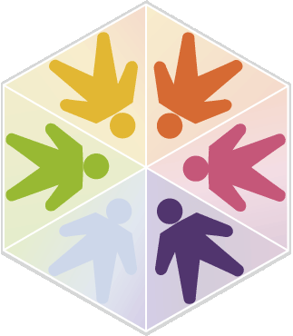
Local and Online Resources for Young Adults and Youth in Transition:

Created by an adult with ASD, Wrong Planet is a web community designed for individuals (and parents / professionals of those) with Autism, Asperger’s Syndrome, ADHD, PDDs, and other neurological differences. They provide a discussion forum, where members communicate with each other, an article section with exclusive articles and how-to guides, a blogging feature, and more (http://wrongplanet.net).

The Division of Vocational Rehabilitation (DVR) is a division of the Washington State Department of Social and Health Services and helps individuals to participate fully in their communities and become employed. They offer services designed to help prepare for, get, and keep a job. The services are tailored to the needs and circumstances of the individual (https://www.dshs.wa/gov/ra/division-vocational-rehabilitation).

“Welcome to the Autistic Community!” (https://tinyurl.com/WelcomeAdolescent) provides developmentally appropriate information about autism and self-advocacy.

“Spoon Theory” is a way of talking about energy and stress management in the disability community. An introduction to the concept can be found at https://tinyurl.com/understandingspoons, and a discussion specific to autism can be found at https://tinyurl.com/autismspoons.

Information about autism acceptance and neurodiversity can be found at https://www.autismacceptancemonth.com/ and the resource library at https://autisticadvocacy.org/resources. A helpful analogy for neurodiverse brains can be found at https://tinyurl.com/AutismAnalogy.

Support Groups:
- http://www.meetup.com/squarepegs/ Seattle
- https://www.eventbrite.com/e/square-pegs-tacoma-adult-autism-support-group-tickets-38790723097 Tacoma
Adult Resources/Info
- https://www.nwesd.org/aop/transition-adulthood
- http://www.seattlechildrens.org/contact/alyssa-burnett-adult-life-center/
- http://www.metroparkstacoma.org/
- UW Adult Autism Clinic – medical care for individuals with ASD
  - http://www.uwmedicine.org/locations/adult-autism
- Autism Self Advocacy Network:
  - www.autisticadvocacy.org
- AASPIRE Healthcare Toolkit
  - https://www.autismandhealth.org/
  - Primary Care Resources for Adults on the Autism Spectrum and their Primary Care Providers
- Adult Developmental Clinic​
  - https://www.multicare.org/adult-developmental-clinic/​
  - Located at East Pierce Family Medicine by Good Samaritan Hospital​​
  - 1st & 3rd Thursday afternoons each month​
  - 253-697-1435​

College Resources:
- Academic Support for students with ASD at Seattle Central College
http://www.sailsforstudents.org/
- Bellevue Community College Navigator’s Program
https://www.bellevuecollege.edu/autismspectrumnavigators/

