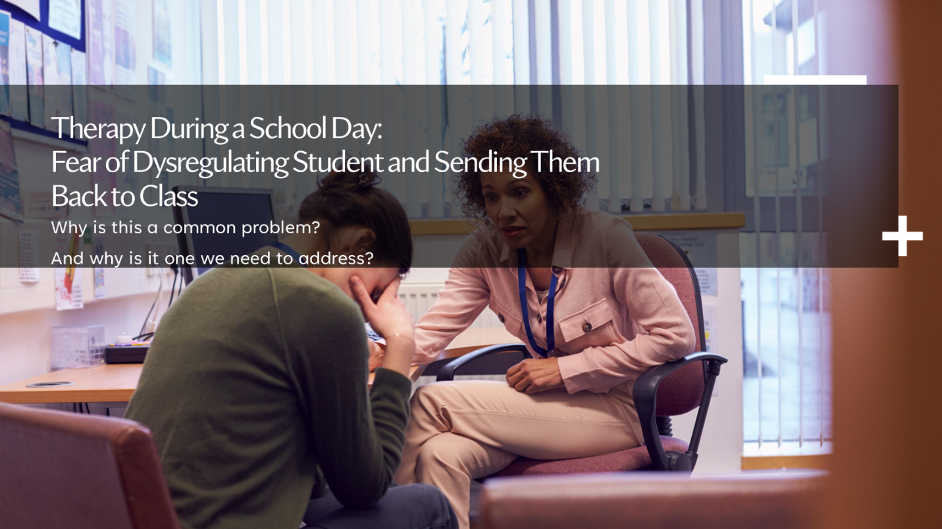

Preparation and Prevention Strategies
- Set clear expectations with students, including expectations to engage appropriately during breaks.
- Be intentional about scheduling sessions and pacing trauma-related content.
- Plan time at the end of sessions for grounding or choice-based activities.
- Practice "coping ahead" and collaboratively build a coping skills toolbox.
- Incorporate somatic and mindfulness-based practices throughout sessions.

Strategies to Support Dysregulation During Sessions
- When a student begins to show signs of dysregulation, consider using one or more of the following:
- Taking brief walks
- Throwing a ball or engaging in light physical movement outdoors
- Offering snacks, fruit, or water (when appropriate and permitted)
- Playing structured, low-stress games (e.g., Uno)
- Using essential oils or calming scents if allowed
- Accessing a calm or sensory-reduced space

Therapist Reminders
- If a student is willing and ready to talk about their trauma, do not shy away from the conversation.
- Dysregulation may be directly connected to trauma; avoiding the trauma content can prolong emotional distress rather than resolve it.

Session Closure Tips
- End sessions with lighter or grounding activities, such as mindfulness.
- Transition to neutral or positive topics the student enjoys.
- Normalize emotional responses by preparing students ahead of time that strong emotions can arise.
- Review available supports and resources, including the option to rest with the school nurse if needed.

