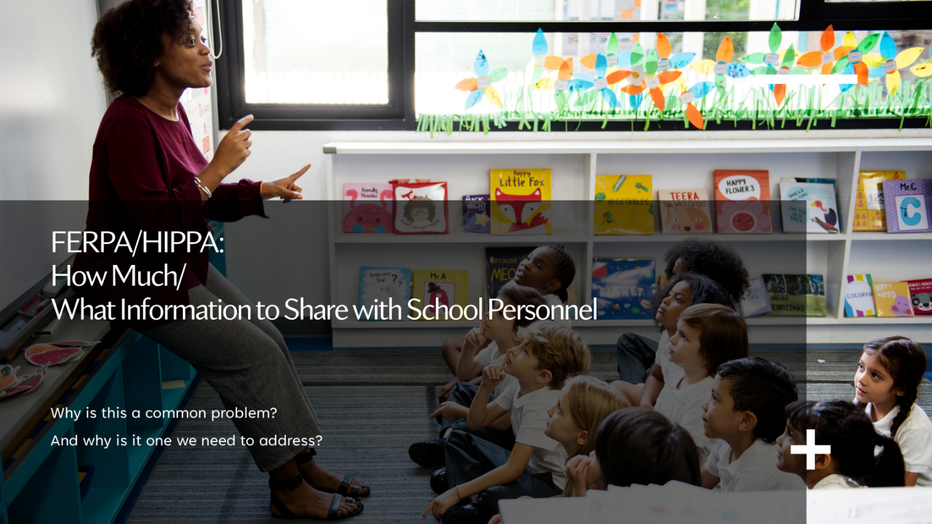
Common Challenges
- Staff uncertainty about who information can be shared with (teachers vs. counselors vs. administrators).
- Discomfort sharing information even with a valid Release of Information (ROI).
- Difficulty tracking individual ROIs for each student.
- Concerns about how shared information may be used or discussed by school staff.
- Lack of communication when students exit or terminate services.

What Information Is Commonly Appropriate to Share
- When allowed under FERPA/HIPAA and any applicable ROI:
- Confirmation of scheduling or service status (e.g., in services or exited services)
- Safety plans and safety-relevant information
- Information necessary for IEP/504 planning
- Attendance passes or excuses
- General observations related to school functioning (e.g., credits, credit recovery)
- Notification that a student needs additional monitoring or support (without clinical details)
- Clarifying longer session times due to regulation needs (no clinical content)

Who to Share With
- Primarily share information with school counselors or designated student support staff.
- Limit sharing with teachers and other staff to what is educationally relevant.
- Avoid sharing clinical details unless explicitly permitted and necessary.

Best Practices for Collaboration
- Educate school staff on confidentiality laws and boundaries.
- Be proactive: schedule brief, intentional check-ins with teachers or school teams to share logistics and non-confidential information.
- Attend all-staff meetings or hold regular coordination meetings with mental health providers and school teams.
- Communicate when a student exits, completes, or terminates services, when possible.
- Focus information sharing on the function and purpose—why the information is helpful for the school.

Youth and Family Involvement
- Involve youth in decisions about what information is shared and with whom.
- Do not assume a student wants no information shared.
- Encourage youth to use school counselors as additional supports between sessions.
- When appropriate, let parents and students guide information sharing decisions.

Programs and Special Considerations
- Handle With Care: Emergency personnel notify school districts following exposure to crisis events; counselors may ask youth before requesting notification.

