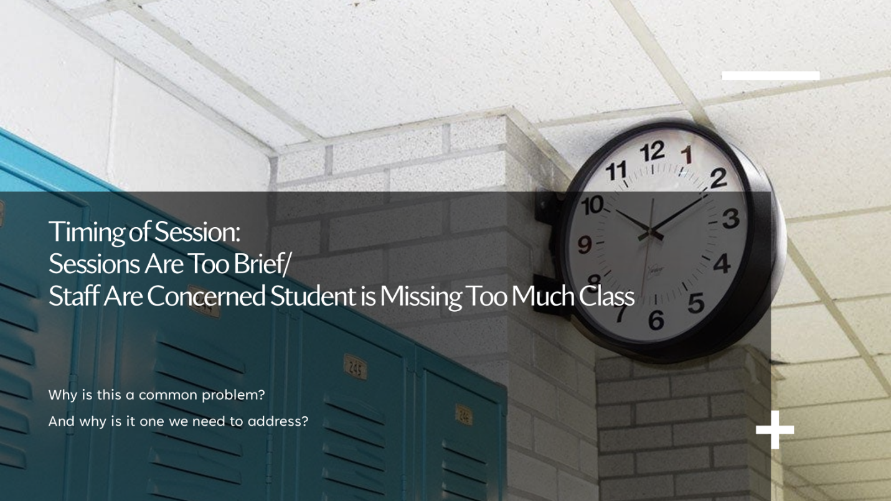

Communication & Relationship-Building
- Educate teachers and administrators on the academic benefits of mental health services.
- Be responsive when teachers raise concerns and adjust timing when possible.
- Use valid Releases of Information (ROIs) to support appropriate communication.
- Coordinate with teachers regarding missed notes or homework when students are pulled.

Scheduling Strategies to Minimize Disruption
- Vary session times to avoid students missing the same class repeatedly.
- Meet during electives, lunch, or before/after school when appropriate.
- Split sessions into two shorter meetings within a week when beneficial.
- Use briefer meetings during high-impact academic periods.
- Avoid sessions during testing or other critical instructional days.
- Alternate classes missed when ongoing services are needed.

Operational Tools & Supports
- Send call slips earlier in the day so students can arrive during passing periods.
- Utilize excused absences when allowed.
- Access school schedules to avoid reinforcing class avoidance (e.g., consistently missing math).
- Offer out-of-school session options (office-based or telehealth) when needed.

Clinical Efficiency & Structure
- Use structured agendas to ensure sessions are purposeful and efficient.
- Prioritize core evidence-based components of treatment.
- Use approaches such as FAST to make full use of session time and keep treatment courses brief.
- Incorporate CBT-based workbooks to support focused, skills-based sessions.
- Increase frequency only when clinically indicated by severity or impairment.

