Challenges

The health messages associated with the Air Quality Index (AQI) for particulate, both PM₁₀ and PM_{2.5} are ascribed to 24 hour averages. For cases like those graphed below, are there heath impacts for the shorter term impacts? May 28, 1998, a continuous PM₁₀ monitor recorded a 24 hour concentration of 93 μg/m³. During that 24 hours, it recorded a maximum one hour concentration of 1156 μg/m³.

Figure 1. 24 Hour PM₁₀ Concentrations
Figure 2. 24 Hour PM₁₀ Maximum One Hour Concentrations
In 1998, it was generally true that the large wildfires were on private property in rural areas. The government owned land in Florida is involved in an aggressive prescribed burning program. The urban areas are the benefit of many more people to notice and report fires, as well as a greater density of fire response resources to respond quickly to the fires.

Unfortunately, the wealth of monitoring resources are also concentrated in the high population urban areas, not where the fires are likely to be out of control. In 1998, levels of PM10 as high as 514 were recorded in Daytona from a nearby fire. The monitor was only 2 blocks from the evacuation zone. However, the largest out of control fire was in Flagler county were there was no monitoring. The plume from this fire impacted most of the peninsula.

Again with the most recent large wildfire fire in Florida, the Mallory Swamp fire on the Lafayette-Dixie county fire, the nature of plume activity in Florida was demonstrated. From evening through the morning hours, the plume direction was inland, toward Jacksonville, as seen in Figure 3 below. The image was taken 5/23/01 at 5:25PM EST.

Figure 3. Satellite Image of the Mallory Swamp Fire Plume Moving Onshore 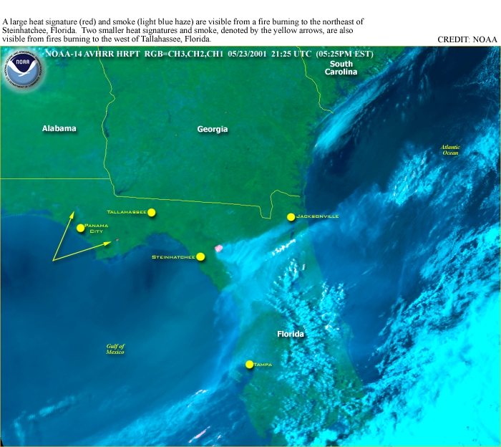

Figure 4. Satellite Image of the Mallory Swamp Fire Plume Headed to Sea

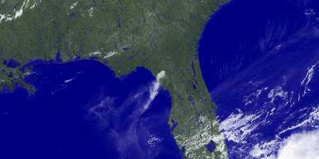

This image was taken at noon on May 24, 2001. Follow there plume offshore and notice that it wraps around in the Gulf of Mexico to head into the west coast of the state, heavily impacted Tampa, St. Petersburg, Bradenton and Sarasota. For a few hours in St. Petersburg and surrounding areas, visibility and air quality were greatly reduced. Figure 5 is from the St. Pete Times. The story described the impact from a fire 150 miles away. As the satellite image portrays, the trip was longer than that.

Figure 5 . Image of the smoke plume in St. Petersburg

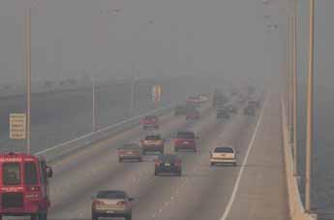

The 24 hour levels of both PM₁₀ and PM_{2.5} were below the health standards of 150 and 65 μg/m³ respectively. In this case, the hourly values of PM₁₀ stayed below the 150 μg/m³ concentration, while PM_{2.5} was measured on an hourly basis as high as 110 μg/m³.

Elevated ozone was associated with this plume. It can be created in the fire plume and from the influx of additional precursors. There were ozone levels over the 8-hour standard from Pasco county (north of Tampa), south through Hillsborough (Tampa) and Pinellas (St. Petersburg-Clearwater), inland to Polk county (Lakeland) and continuing south along the coast through Manatee (Bradenton) and Sarasota counties. The events of large wildfire and elevated ozone are inextricably tied. The impacts of the confounding parameters must be considered.

