Label the parts of the heart on the diagram (as labeled on the overhead). Use the words from the following word bank. Trace the flow of blood using the red and blue pencils. Do both of these things before you begin to explore the heart.

Word bank:
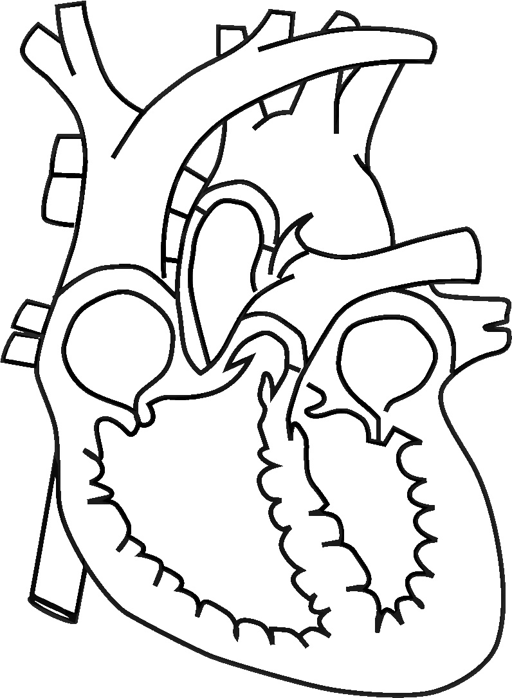
- Aorta
- Superior Vena Cava
- Inferior Vena Cava
- Right Atrium
- Left Atrium
- Right Ventricle
- Left Ventricle
- Tricuspid Valve
- Mitral Valve
- Apex
- Right Pulmonary Artery
- Right Pulmonary Veins
- Left Pulmonary Artery
- Left Pulmonary Veins

