|  |
| --- |
| AFYA BORA CONSORTIUM GLOBAL HEALTH LEADERSHIP FELLOWSHIP PROGRAM |
| GLOBAL HEALTH POLICY AND GOVERNANCE |
|  |

|  |
| --- |
|  |

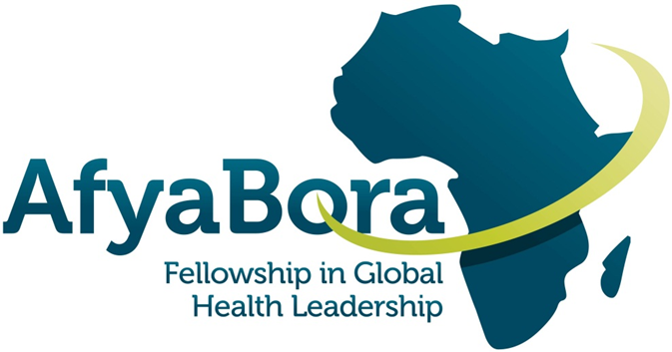

|  |
| --- |
|  |

**AFYA BORA CONSORTIUM**

**GLOBAL HEALTH POLICY AND GOVERNANCE**

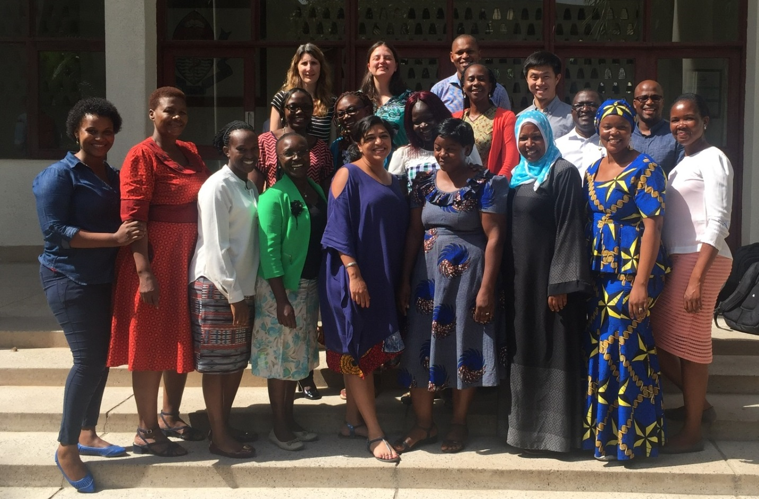

Afya Bora Policy Module and Fellows – Tanzania 2017

**Guide for Fellows and Instructors**

Table of Contents

BACKGROUND/CONTEXT 5

Overall Learning Goals 5

Global Health Policy and Governance 8

Day 1: 9

DAY 2: 11

DAY 3: 13

Appendix 1: 16

Health Policy Brief 16

Appendix 2: 19

References (located on your dropbox folder) 19

**Global Health Policy and Governance Module**

**Afya Bora Fellowship Agenda**

# BACKGROUND/CONTEXT

What drives health and healthcare inequalities? What are the underlying policies that help determine these inequalities? Who has the power to change these inequalities? Why are some health issues prioritized over others? Each of these critical questions can be considered through the lens of health policy. This module will provide an introduction to health policy through a series of lectures by experts in the field, case studies, and a student-produced presentation. The course will cover some of the basics of health policy including health financing, global health actors and health workforce. It will also examine how other disciplines, including the law and economics, interact with health to create governing health policy.

## Overall Learning Goals

1. Define global health policy and the special circumstances that may influence health policy in low- and middle-income countries
2. Identify the major actors in global health policy and describe their influence on global health policy and relation to each other
3. Become familiar with concepts around how global health policy is made
4. Utilize their concepts to analyze specific health policies
5. Critically examine key issues in global health policy

**Module Assignment**

Fellows will be engaged and dialogue with the guest speakers and will be active participants in the module. One ongoing activity throughout the week will be the development and presentation of a policy brief.

**Group Work: Policy Brief Exercise**

Overview: The week will provide introductory exposure to components of policy development and implementation. In this exercise, fellows will be provided with the opportunity to explore the nuances of policy development and effective presentation to policy-makers. Groups will work together during the week to develop a cogent policy plan and present this plan to the rest of the fellows.

Goals:

1. Work in a team-oriented environment on a single topic with the focus on a single health policy issue to be presented on the final day of the policy module.
2. Understand how to construct a policy brief
3. Capacity to understand the assortment of priorities amongst all stakeholders in the process of policy development including front-line workers, Ministers and citizens
4. Communicate verbally various positions and points of debate in an organized, professional, and comprehensive fashion

Conduct: Fellows will be placed into groups of four. On day one, they will be tasked to come up with a subject that they will advocate for. They will brainstorm on the following:

1. Subject matter-What are they most passionate about? What constitutes a real public health need? What background information from the course can they incorporate in their preparation?
2. Game plan-there will need to be the development of a strategic plan. What has been done on the subject? What still is necessary and what are the priorities? What are the financial implications? What is the landscape of the issue? Set up for the strategic planning that needs to occur the rest of the week.

On the morning of Day 2, facilitators should be provided with the topics each team selected. Throughout the day facilitators will go over subject matter with the teams to assess feasibility and make suggestions as to alternative subject matter if appropriate.

Day 2 and 3: Create the brief and explore the potential positions of other stakeholders.

1. Based on thorough landscaping and the importance of the issue, the team will put together a comprehensive presentation for dignitaries to consider. Aspects of the argument will include financial ramifications, effect on population health if proposal is adopted or not adopted, feasibility and plan for implementation.
2. The team will also explore the potential angles and priorities of other stakeholders. This includes: Police, Ministers of Finance and Health, community leaders, scientists, and individuals effected by the issue. This is critical for making a strong argument AND members of the team should be ready to PLAY these roles.
3. The day prior to presentation (afternoon of Day 3), individuals on the team will draw straws as to what “role” they will play. Facilitators will have already mentioned to the group, based on the subject matter, who the stakeholders might be. This *may* include:
   1. Frontline workers - This person will likely present the case
   2. Minister of Finance - This person will focus on the monetary effect of implementation of the proposal
   3. Minister of Health - This person will focus on the level of priority this issue seems to have (based on the argument presented and other issues in the country) on population health
   4. A citizen directly affected by this issue - They will serve as an advocate, and give heart-felt testimony regarding the issue and how it has affected their lives
   5. Hospital Administrator - Similar role as a combination of Finance and Health Ministers
   6. A scientist with data to support the cause - This person will present, when appropriate, studies that have been conducted to make the argument for advocacy stronger
   7. WHO representative - This person will provide a vantage point of overall goals for health care worldwide priority items. They will either end up advocating for the presenter, or asking tough questions along with the Ministers and the Hospital Admin person.

All of these individuals are suggestions except the frontline worker is the key person who will be presenting the issue at hand. Other potential stakeholders may be possible based on the subject chosen.

**Evaluation:** The course instructors will provide evaluation of the policy brief delivered on the last day. Feedback will be given based upon performance of each individual, and how well they understood their role realistically. Weight will be particularly given towards the strength of the frontline individual’s presentation given that this reflects the culmination of the work of the group during the week.

Appendix 1 has more information on how to write a policy brief, but note that this will be an oral presentation. No PowerPoint presentation will be available. However, your group may provide a short handout to evaluators.

MODULE SCHEDULE

# Global Health Policy and Governance

|  |  |  |  |  |
| --- | --- | --- | --- | --- |
|  | **DAY 1** | **DAY 2** | **DAY 3** | **DAY 4** |
| 8:30am | Module Objectives and Introductions | Features of a Strong Policy Proposal and How to Deliver it | Stakeholder Analysis | The Role of Parliament and How to Work with Parliamentarians for Effective Policy Change |
| 9:45am | Introduction to Global Health Workforce | Media Advocacy and Importance of Working with the Media | Leadership and Policy |
| 11am | **Tea** | **Tea** | **Tea** | **Tea** |
| 11:30 | Introduction to the Policy Process and Policy Brief | Press Release | Policy Brief Wrap-Up | Presentation of Policy Briefs! |
| 12:30 | Global Health Policy Actors | Role of Healthcare Providers in Advocacy | Case on Healthcare Advocacy (if time allows) |
| 1:30pm | **Lunch** | **Lunch** | **Lunch** | **Lunch** |
| 2:30pm | Split into groups (2-3) to decide topics; no more than 5 people per group. | Groupwork | Finalize group projects and have any printed material to Margaret | Group Winners announced  Leadership and Policy Wrap-Up |
| 3:30pm | Complete Evaluation of Policy Module |

# 

# Day 1:

Introduction Lecture

Global Health Workforce Universal Healthcare Coverage

In this session, course instructors and participants will introduce themselves. This session will then launch into a discussion about universal healthcare coverage. There is a global shortage of skilled health professionals. This talk will outline the etiologies of this critical issue as well as examine several ways to address the problem and fill the global gap.

By the end of this session, fellows will:

1. Be introduced to the course and know the course objectives
2. Explain several factors driving the global health workforce shortage
3. Analyze potential solutions or ways to address this issue.

Lecture and Discussion

Introduction to the Policy Process and How to Frame a Policy Brief

A policy brief is a tool used for communicating to government policymakers on recommendations for formulating or influencing policy. This session will introduce you to the varied and complex features of a policy and policy processes and how policy analysis can help us understand what drives and influences policy processes and their consequences. It will additionally provide an overview of how to write a policy brief.

By the end of this session, fellows will:

1. Recognize the role of a policy brief and obtain basics on how to write a policy brief.
2. Distinguish between policy as intent and policy as understanding and practice
3. Describe different forms of policy analysis

Lecture and Discussion

Global Health Actors

Key players influence health policy on the global, regional and national level. This session will review some of the main global health actors and their roles in setting health policy. You will discover that there are different actors and that their actions are influenced by beliefs and value systems. You will also be introduced to some key theoretical concepts relating to actors and their roles in the policy process.

By the end of this session, fellows will:

1. Identify key categories of actors in the global health policy process.
2. Recognize the role and reach of key actors including the WHO, the Global Fund to Fight AIDS, TB and Malaria, the Gates Foundation among others
3. Identify several ways to access these global players
4. Recognize their practices and sources of power
5. Identify factors influencing actors’ behaviors and roles in the policy process.

Group Work

Divide into groups of 4 and identify a policy brief topic.

# DAY 2:

Lecture and Discussion

Strategy to Policy Change and Features of a Strong Policy Proposal

This session explains how understanding actors’ interests, values, beliefs and ideas can inform strategies to build support for and/or reduce opposition to a proposed policy. You will be introduced to some of the concepts and ideas about managing actors.

By the end of this session you should be able to:

1. Recognize the importance of strategy to policy change and development
2. Apply a framework in identifying actor management strategies
3. Identify other types and forms of strategies
4. Recognize key factors influencing the processes used in policy development and implementation
5. Understand the relevance of policy analysis to managing policy change processes and people.
6. Understand what a strong policy should like.

Lecture and Discussion

Media Advocacy and Importance of Working with the Media

This session will discuss the role of healthcare workers in media advocacy. An health advocate who also doubles as a journalist will discuss his work and the importance of working with the media.

By the end of this session, fellows will:

1. Recognize media allies
2. Discuss how to work with the media to advocate for the profession

Lecture and Discussion

Role of Healthcare Providers in Advocacy

This session will discuss the role of healthcare workers in advocacy. A healthcare provider will discuss key issues when advocating and acting as mediator between health professions and the government.

By the end of this session, fellows will:

1. Recognize allies and how to work with them to advocate for the profession
2. Describe some examples of how healthcare workers and advocate

Group Work

Work in your groups on your policy brief.

# 

# DAY 3:

Lecture and Activity

Stakeholder Analysis

This session will cover basic information on how to complete a stakeholder analysis. A stakeholder analysis is an analytical tool that can help to assess the political feasibility of a policy and its implementation, either prospectively or retrospectively.

By the end of this session, fellows will:

1. Identify potential stakeholders
2. Determine level of support from identified stakeholders
3. Understand the purpose and approach of stakeholder analysis
4. Conduct a stakeholder analysis
5. Assess the strengths and weaknesses of stakeholder analysis

Policy Brief Final Review

Discuss what makes an efficient policy brief. Fellows will get the opportunity to write a policy brief in groups based on their group topic.

By the end of the session, fellows will:

1. Determine their audience for a policy brief
2. Craft their own policy brief

Group Work

Work in your groups on your policy brief.

**DAY 4:**

Lecture

The Role of Parliament and How to Work with Parliamentarians

Oscar is the Chair of the HIV Parliamentary Committee in Tanzania, and he will talk about his own experience working in parliament.

By the end of the session fellows will:

1. Learn from an experienced and successful leader strategies to work with parliamentarians.

Lecture

Leadership and Policy

Leadership in policy is key in motivating stakeholders and policy makers to implement change. You as a global health leader can influence policy, whether this is through leading by example or empowering, motivating, and inspiring others. Fellows will have the opportunity to hear from a global health leader and activist in health and women’s rights.

By the end of the session fellows will:

1. Learn from an experienced and successful leader in global health
2. Reflect on their own leadership style and how they can impact policy

Activity

Fellow Presentations

During the first day, the class will divide into groups to prepare for fellow presentations at the end of the week. In these presentations, fellows will be able to demonstrate their analysis of health policy issue and present the potential viewpoints of various key stakeholders. Each group will develop a policy brief on a topic of their choosing, and will be able to defend this topic from the viewpoints they selected.

Course Instructors will evaluate and announce the winning group and a prize will be awarded.

Discussion

Wrap-Up and Ethos of Afya Bora and your Leadership Pathway

This discussion will serve as a wrap-up of the global health policy module.

By the end of the session fellows will:

1. Articulate one policy issue they wish to change in the next 5-10 years and how they might do it
2. Provide feedback on what they learned this week, and what policy areas they would have liked more information about.
3. Consider how they can stay connected to impact change in the region through South-South collaboration.

M&E Specialist will distribute the anonymous evaluation of the Policy Module following this discussion. Please fill out so we can improve upon this module for next year!

## Appendix 1:

## Health Policy Brief

Health policy briefs are short documents that present a clear, accessible overview of timely and important health policy topics or research findings and recommendations to a particular audience. Writing of a policy brief must be informed by extensive research, deep analysis and synthesis of both primary and secondary sources of information. In general, it should be a stand-alone document that is focused on a single topic. For this exercise, plan on writing no more than 2-4 pages. Often, policy briefs are written to be persuasive to a particular audience. For this reason, we are asking that you consider each issue from the point of view of policymakers, service providers and community members.

**Executive Summary:**

Consider a text box that gives snapshot information of the key recommendations or most effective evidence.

* Keep each point short—the detail is given in the body of the brief
* Each point should encourage the reader to read on

Distill the essence of the brief and provide a 1-paragraph overview for the busy reader. Ensure there is a sentence indicating the audience for whom the brief is intended. Pull the reader in so they are encouraged to read further. This should be written at the end (like the abstract of a paper) and summarize your main recommendation points in the more detailed sections to follow.

**Introduction:**

What is the central issue being addressed? Why is it significant? What is the urgency? **State the problem or objective – you could phrase it as a question for which a decision must be made.**

What is the relevant background? Include data whenever possible to highlight the problem. Be sure to include only essential facts that the decision maker needs to know.

Relevant research or if this is a brief for a particular study: present the objectives, overview of the findings, and conclusions

**Summary of approaches and results:**

What is the proposal? If this is a research policy brief, summarize the facts and interpret the results in an ‘easy to understand manner’, excluding all research and scientific jargon – remember the decision maker is most cases is neither a researcher nor a scientist and yet they must clearly understand what you are communicating.

Describe what has been piloted, researched or implemented (how the study was conducted, who conducted the study, where the study was conducted and methodology) and the outcome (what did we learn?).

Your interpretation, analysis, and synthesis: What are the issues? What is the debate? Highlight benefits, opportunities.

**Implications:** Include both what could happen and what should happen. The implications must be supported in the sections above and flow logically from what has already been presented. Depending on your audience, you may want to soft-pedal this section so that readers can draw their own conclusions.

**Pre-existing policies and guidelines:** Summarize what has ever been done about your research topic, especially if it is not the first of its kind. This helps inform the reader of policy options that have already been pursued, if any. The absence of no action may be a policy decision in itself that you may want to challenge in your recommendations.

**Recommendations:** What should happen on the basis of your interpretation of the implications of the background and data provided. What is next? Focus on relevance (to the audience), credibility on the basis of what was presented and feasible for the setting. Please sieve out and provide the main possible courses of action or inaction. Please limit these to a feasible number and avoid overwhelming the policy maker with so many options. The end result may be total inaction.

**Concluding paragraph**

**Resources:** (provided)

**Authors:** (state who wrote, constructed and contributed to the brief)

Finally, think about formatting. Make bolded titles and break up the text for reader interest and ease of use. Consider using sidebars to hook the reader and should be short, descriptive, stimulating and focused on action. Callouts where sentences or sentence fragments or quotes are printed in larger font and placed in the margins or in a box. Bulleted list of <5-7 items can be considered if thoughts are multi-part of complex. Charts, photos, graphics make visual interest.

Check your work. Make sure you have completed the following: proofread, edit, and spell check. Does a message clearly stand out? Don’t use too many statistics. Is it persuasive?

**PS:** Please remember that in writing this policy brief, you want to win a policy issue in line with what your findings were. Be succinct, specific, and persuasive in your presentation. You may not want to have your policy brief shelved just like any other.

NOTE: There is an example of a bad policy brief and a good policy brief in your dropbox folder.

|  |  |  |  |
| --- | --- | --- | --- |
|  | **Policy makers** | **Community members** | **Service Providers** |
| What is the aim of the policy brief? |  |  |  |
| What do you know about the audience? |  |  |  |
| What is the best hook for the audience? |  |  |  |
| What background information is necessary? |  |  |  |
| What data will you include? How will you present it? |  |  |  |
| What policy options are there (if appropriate)? |  |  |  |
| What recommendations will you make? |  |  |  |
| Can you come up with a catchy title? |  |  |  |

## Appendix 2:

## References (located on your dropbox folder)

Jamison DT, Summers LH, Alleyne G, et al. [Global health 2035: a world converging within a generation](http://www.globalhealth2035.org/sites/default/files/report/global-health-2035.pdf). 2013. *The Lancet*.

Summers LH and 267 signatories. [Economists’ declaration on universal health coverage.](http://globalhealth2035.org/sites/default/files/resources/lancet-economists-declaration-on-uhc.pdf) 2015. *The Lancet*.

G Yamey, R Feachem. [Evidence-based policymaking in global health – the payoffs and pitfalls](http://globalhealthsciences.ucsf.edu/sites/default/files/content/ghg/e2pi-evidence-based-policymaking-in-global-health-the-payoffs.pdf). 2011. *Evidence-Based Medicine*.

Yamey G, Fewer S, Beyeler N. [Achieving a “Grand Convergence” in Global Health by 2035: Rwanda Shows the Way](http://globalhealth2035.org/sites/default/files/journal-articles/rwanda-shows-the-way.pdf). 2015. *Int J Health Policy Manag.*

**Additional Suggested Readings:**

Piot P, Abdool Karim SS, Hecht R, Legido-Quigley H, Buse K, Stover J, Resch S, Ryckman T, Møgedal S, Dybul M, Goosby E, Watts C, Kilonzo N, McManus J, Sidibé M. [Defeating AIDS--advancing global health](http://www.sciencedirect.com/science/article/pii/S0140673615606584). 2015.

Afnan-Holmes H, Magoma M, John T,…Lawn JE, for the Tanzanian Countdown Country Case Study Group. [Tanzania's Countdown to 2015: an analysis of two decades of progress and gaps for reproductive, maternal, newborn, and child health, to inform priorities for post-2015. 2015](http://www.sciencedirect.com/science/article/pii/S2214109X15000595). *The Lancet* *Global Health.*

Kruk M. Mbarukub G. [Public health successes and frail health systems in Tanzania](http://www.sciencedirect.com/science/article/pii/S2214109X15000364). 2015. *The Lancet Global Health*.

J Shiffman, S Smith. [Generation of political priority for global health initiatives: a framework and case study of maternal mortality](http://www.sciencedirect.com/science/article/pii/S0140673607615797). 2007. *The Lancet*.

J Shiffman. [Issue attention in global health: the case of newborn survival](http://www.sciencedirect.com/science/article/pii/S0140673610607106). 2010. *The Lancet*.

J Shiffman. [Generating political will for safe motherhood in Indonesia](http://www.sciencedirect.com/science/article/pii/S0277953602001193). 2003. *Social Science & Medicine*.

Powell RA, Mwangi-Powell FN, Radbruch L, Yamey G, Krakauer EL, Spence D, Ali Z, Baxter S, De Lima L, Xhixha A, Rajagopal MR, Knaul F. [Putting palliative care on the global health agenda](http://globalhealth2035.org/sites/default/files/journal-articles/powell-putting-palliative-care-on-the-global-health-agenda.pdf). 2015. *The Lancet Oncology.*

Moran M. [The Grand Convergence: Closing the Divide between Public Health Funding and Global Health Needs](http://journals.plos.org/plosbiology/article?id=10.1371/journal.pbio.1002363). 2015. *PLOS Biology.*

Kruk ME, Yamey G, Angell S, Beith A, Cotlear D, Guanais F, Jacobs L, Saxenian H, Victora C, Goosby E. [Transforming Global Health by Improving the Science of Scale-Up](http://journals.plos.org/plosbiology/article?id=10.1371/journal.pbio.1002360). 2016. *PLOS Biology.*

Goosby E. [Out of the shadows: shining a light on children with tuberculosis](http://www.tballiance.org/sites/default/files/child-resources/out_of_the_shadows.pdf). 2015. *Int J Tuberc Lung Dis*.

Sustainable Development Goals:

Horton R. Offline: [Why the Sustainable Development Goals will fail](http://www.sciencedirect.com/science/article/pii/S0140673614610461). 2014. *The Lancet*.

The Economist. [The 169 commandments](http://www.economist.com/news/leaders/21647286-proposed-sustainable-development-goals-would-be-worse-useless-169-commandments). 2015.

McArthur J, Zhang C. [Who pays attention to global development goals?](http://www.brookings.edu/blogs/future-development/posts/2015/10/09-global-development-goals-mcarthur) 2015. Brookings blog. -🡪 full paper [Who talked (and thought) about the Millennium Development Goals?](http://www.brookings.edu/research/papers/2015/09/24-millennium-develoment-goals-mcarthur)

Commision on Investing in Health:

Jamison DT, Summers LH, Alleyne G, Arrow KJ, Berkley S, Binagwaho S….Yamey G. [Global health 2035: a world converging within a generation](http://www.globalhealth2035.org/sites/default/files/report/global-health-2035.pdf). 2013. *The Lancet*.

Policy Brief. [Global Health 2035 Report Overview](http://globalhealth2035.org/sites/default/files/policy-briefs/overview-english.pdf)

Donor Financing:

Schäferhoff M, Fewer S, Kraus J, Richter E, Summers LH, Sundewall J, Yamey G, Jamison DT. [How much donor financing for health is channelled to global versus country-specific aid functions?](http://globalhealth2035.org/sites/default/files/journal-articles/donor-financing-for-health-is-channelled-to-global-versus-country-specific-aid-functions.pdf) 2015. *The Lancet*.

GH2035 Policy Brief. [Opportunities for the International Community](http://globalhealth2035.org/sites/default/files/policy-briefs/policy-brief-5-english.pdf).

Dieleman JL, Schneider MT, Haakenstad A, Singh L, Sadat N…Murray CJL. [Development assistance for health: past trends, associations, and the future of international financial flows for health](http://www.thelancet.com/journals/lancet/article/PIIS0140-6736(16)30168-4/abstract). 2016. *The Lancet.*

Domestic Financing:

Evans T, Pablos-Mendez A. [Shaping of a new era for health financing](http://www.sciencedirect.com/science/article/pii/S0140673616302380). 2016. *The Lancet*.

GH2035 Policy Brief. [Opportunities for Low and Middle Income Countries](http://globalhealth2035.org/sites/default/files/policy-briefs/policy-brief-4-english.pdf).

Dieleman JL, Templin T, Sadat N, Reidy P, Chapin A…Kurowski C. [National spending on health by source for 184 countries between 2013 and 2040](http://thelancet.com/journals/lancet/article/PIIS0140-6736(16)30167-2/abstract). 2016. *The Lancet.*

Universal Health Coverage:

Bump J, Cashin C, Chalkidou K, Evans D, González-Pier E, Guo Y…Yamey G. [Implementing pro-poor universal health coverage](http://globalhealth2035.org/sites/default/files/bellagio/statement-implementing-pro-poor-hc.pdf). 2015. *Lancet Global Health.*

Summers LH and 267 signatories. [Economists’ declaration on universal health coverage.](http://globalhealth2035.org/sites/default/files/resources/lancet-economists-declaration-on-uhc.pdf) 2015. *The Lancet*.

Sen A. [Universal healthcare: the affordable dream](http://www.theguardian.com/society/2015/jan/06/-sp-universal-healthcare-the-affordable-dream-amartya-sen). 2015. *The Guardian.*

Policy Implementation:

First Global ministerial Conference on Health Lifestyles and Noncommunicable Disease Control. [Discussion Paper. Intersectoral Action on Health: A Path for Policymakers to Implement Effective and Sustainable Intersectoral Action on Health](http://www.who.int/nmh/publications/ncds_policy_makers_to_implement_intersectoral_action.pdf). 2011. WHO.

USAID Health Policy Initiative. [Taking the Pulse of Policy: The Policy Implementation Assessment Tool – Summary](http://www.healthpolicyinitiative.com/policyimplementation/files/1086_1_PIAT_Summary_Taking_the_Pulse_of_Policy_acc.pdf).

* + - * There is a full guide that participants could explore: <http://www.healthpolicyinitiative.com/policyimplementation>
      * Also [country case studies](http://www.healthpolicyinitiative.com/policyimplementation/files/15_materials.html) from this tool.

Walker L, Gilson L. [We are bitter but we are satisfied’: nurses as street-level bureaucrats in South Africa](http://www.sciencedirect.com/science/article/pii/S0277953603007081). 2004. *Social Science & Medicine. 🡨 I think this could provoke a lot of discussion!*

Erasmus E. [The use of street-level bureaucracy theory in health policy analysis in low- and middle-income countries: a meta-ethnographic synthesis](http://heapol.oxfordjournals.org/content/29/suppl_3/iii70.full). 2014. *Health Policy Plan*.

**Acknowledgments**

Content developed by:

**Dr. Kristen N. Hosey**

**Email:** [khosey@uw.edu](mailto:khosey@uw.edu)

**Alice Kayongo**

**Email:** [alkayongo@gmail.com](mailto:alkayongo@gmail.com)

*This project was made possible by the Afya Bora Consortium Fellowship, which is supported by the U.S. President’s Emergency Plan for AIDS Relief (PEPFAR) through funding to the University of Washington’s International AIDS Education and Training Center (IAETC) under Cooperative Agreement U91 HA06801 from the Health Resources and Services Administration (HRSA) Global HIV/AIDS Bureau.*