|  |
| --- |
| AFYA BORA CONSORTIUM GLOBAL HEALTH LEADERSHIP FELLOWSHIP PROGRAM |
| HUMAN RESOURCES AND BUDGET MANAGEMENT MODULE |
|  |

|  |
| --- |
|  |

**AFYA BORA CONSORTIUM**

**HUMAN RESOURCES AND BUDGET MANAGEMENT MODULE**



**Content created by:**

**Namrata Narain: narain@pennmedicine.upenn.edu**

**Betty Mabisi: bmbmabisi@gmail.com**

|  |  |
| --- | --- |
| **Table of Contents** |  |
| HUMAN RESOURCE AND BUDGET MANAGEMENT MODULE | 4 |
| WORK SCHEDULE | 6 |
| Fellows Placement | 7 |
| HUMAN RESOURCES (HR) | 8 |
| LECTURES ON HUMAN RESOURCES | 9 |
| Lecture 1: Overview of human resources (HR) | 9 |
| Lecture 2: Recruitment, placement, evaluation of employees | 9 |
| Lecture 3: Employer/employee issues | 10 |
| HUMAN RESOURCE CASE STUDIES | 11 |
| HR case study 1A | 12 |
| HR case study 1B | 12 |
| HR case study 2A | 14 |
| HR case study 2B | 15 |
| HR case study 3A | 17 |
| HR case study 3B | 19 |
| HR case study 4A | 21 |
| HR case study 4B | 23 |
| BUDGET MANAGEMENT | 26 |
| LECTURES ON BUDGET MANAGEMENT | 27 |
| BUDGET MANAGEMENT CASE STUDIES | 29 |
| Budget management case 1A | 29 |
| Budget management case 1B | 30 |
| Budget management case 2 | 33 |
| Budget management case 3A | 36 |
| Budget management case 3B | 40 |
| Budget management case 4A: D43 grant application | 29 |
| Budget management case 4B: PHS 398 | 36 |

# HUMAN RESOURCE AND BUDGET MANAGEMENT MODULE

NOTE. This module is divided into two separate sections, human resources (HR) and budget management.

# Module Deliverables

Concrete HR management and Budget Management deliverables are as follows:

On the final day of the module, the participants will submit a portfolio with at least **two deliverables** from each training day:

DAY 1: Applying the general principles of budget management in managing a program. Linking the budget to organisational goals and objectives.

DAY 2: Identifying Budget cost drivers, prepare an Excel Budget and present it, justify and defend it to all stake holders, Templates for Budgets for NGOs annual operational Budgets (1-5 years) and NIH Grants under D43, R25, D71 and K awards

DAY 3 AM: Setting up a system of tracking the budget in real time of the transaction which enables the fellows learn how to prepare a monthly budget variance report. Best Practices in Grant management and creating an Audit-Focused Grant Management Strategy

DAY 3 PM: Creating a flow chart of the major aspects of HR in their home institutions, highlighting their intersection points with the HR continuum. Two examples of how the MBTI evaluation will help them in managing any aspect of the HR function in their professional career.

DAY 4: Creating a flow chart for the hiring and firing process. Identify the key elements of staff training and map it to the employee’s work cycle at their unit. Examples illustrating the difference between coaching and mentoring, as something they initiated or were given. Craft an employee retention program. Write up an unsatisfactory performance evaluation with specific goals to be achieved, with timelines and if necessary, additional training to help staff member attain these goals.

DAY 5: Creating a salary structure of their home institution. Two examples of how they will improve employee safety back at their home institution. Articulating how good labour relations improves productivity and the working environment.

At the end of each lecture and case study, fellows should be better prepared to answer the following questions:

1. How has the lecture/case study informed your thinking about HR and Budget management?
2. What activities did you find most useful?
3. What principles of HR and Budget management will you begin to implement immediately?
4. What are the things, which you now plan to stop doing, or do less off?
5. What changes would you recommend to make this module more effective?

# WORK SCHEDULE

We will teach the principles of human resources and budget management with a small number of lectures, but mainly through a set of exercises. There are 4 exercise (cases) sets for each of the two subjects. Fellows will be divided into 4 groups, so that each group will work up two exercise sets. Each exercise set will include two cases, both of which will be presented to the whole group in a 90 minute time frame, with about 30 minutes presentation and 60 minutes for discussion (15 minutes presentation and 15 minutes discussions per group). Group assignments are shown on the following page.



KEY

|  |  |  |  |  |  |
| --- | --- | --- | --- | --- | --- |
|  | Lectures 1.5hrs |  | Prep for cases 1.5hrs |  | Presentation of cases in groups 90 minutes |

# HUMAN RESOURCES (HR)

The goal of this part of the module is to provide you with a set of competencies that will be essential to your success – and sometimes survival - within the organization where you work. By the end of these exercises you will recognize why every organization needs some human resource professional staff in order to function effectively. The module is designed to prepare you to work effectively with the human resource department of your workplace, not to become an expert in human resources yourself.

This human resources section seeks to broaden your understanding of personnel-related responsibilities and issues. It explores core concept, principles and tools of human resource management and development such as job analysis, planning, recruitment and selection, training and development, performance management and appraisals, mentorship, motivation, people issues, fair treatment and ethics, safety, health and the wellbeing of employees, organisation and citizenship behaviour (OCB), team behavioural styles and temperaments. You will hear lectures from the HR experts and will do a number of case studies that will illustrate these various concepts.

This part of the module is designed to provide an introduction to the following areas:

* Team behavioural styles and temperaments – Fellows will carry out a self-discovery assessment for themselves and use its application to manage their teams in the work place
* Why is a human resource program important for the success of the organization and the employees?
* What are the main elements of a human resource program?
* How to recruit new employees?
* How to train and mentor employees and support career development?
* How to evaluate employee performance?
* How to classify employees in a consistent and equitable way?
* What should a good work environment include?
* How to communicate with employees and keep them happy?
* What are appropriate fringe benefits?
* How to deal with employee grievances?
* How to evaluate unsatisfactory performance and deal with it?
* What do you need to know about local laws that impact the workplace and employees?
* How to promoting organisational citizenship behaviour for improved performance and employee retention and loyalty
* How to discover and adapt to team members individual behavioural styles and temperaments

**LECTURES ON HUMAN RESOURCES**

## Lecture 1: Overview of Human Resources (HR)

This lecture will cover the following topics:

* Defining human resource management? What are the main concepts? Managing up and down
* Importance of human resource management, with illustrative examples from fellow’s personal experience at the attachment sites.
* Identify and define basic competencies in human resource: business knowledge, human resource practices, team work and team building activities, management of change, conflict management, organizational structures, and person skills?
* Discussion of the Employment Act of the country (Tanzania) where the module is taking place and its importance in HR guidelines (perhaps reference can be made to each African country represented where possible)
* Strategic planning in human resource management

**Learning Objectives:**

1. Fellows will be able to identify and define the main concepts in human resources management.
2. Fellows will be able to describe how effective human resource management processes add to the success on an organization. Will be facilitated to site examples from their placement sites

**Introduction to the Personality Test and how each personality trait contributes to the Team**

This session will cover the following topics:

* The importance of applying people skills in Human resource management
* Development of self-awareness for better relationship in the workplace
* The MBTI tool of self-assessment
* Interpretation of the self-assessment tool as it relates to the workplace particularly the fellows experiences at their placement sites

**Learning Objectives**

1. Fellows will be able to identify and define the four main personality traits (MBTI)
2. Apply the MBTI personality test to discover their individual personality traits and temperaments
3. Apply the MBTI Personality self-assessment tool and how each different temperaments contributes to the Team
4. Fellows will be able to discuss how they have applied their people skills during their work at their respective attachment sites.

## Lecture 2: Recruitment, Placement, Evaluation of Employees

This lecture will cover the following topics:

* Job analysis and job description
* Recruitment, selection and appointment of staff. What is the process? Who does it? Who is the final appointing authority? How long does it take? What is the source of applicants? What are the challenges in recruitment?
* Training and development of employees, limitations, and challenges
* Performance appraisal systems, their merits and demerits?
* Employee loyalty and retention
* Mentoring and coaching (Fellows might share some living examples of how they were mentored or how they mentored others, or any mentoring plans in their prior experience)

**Learning Objectives:**

1. Fellows will be able to complete a job analysis and job description.
2. Fellows will be able to identify the main steps in effectively recruiting, selecting, and appointing staff.
3. Fellows will be able to discuss why the training and development of staff is essential and describe some of the potential limitations and challenges that are inherent in these processes.
4. Fellows will be able to identify strategies to increase employee loyalty and retention.

## Lecture 3: Employer/Employee issues

This lecture will cover the following topics:

* Salary structure, fringe benefits, and employee services
* Ethics, justice, and fair treatment in human resource management
* Labour relations and collective bargaining
* Employee safety and health issues
* Managing up, down and across

**Learning Objectives**:

1. Fellows will be able to identify key concerns in the ethics of managing human resources in the workplace.
2. Fellows will be able to describe the processes of collective bargaining and consider how it applies to their specific contexts.
3. Fellows will be able to identify management strategies for 360 degree view of their working environment.**HUMAN RESOURCE CASE STUDIES**

HR case study 1A**: No HR unit**

Dr. Murro is a young health professional in Sub-Saharan Africa who has an MPH degree. **Community Care for East Africa**, (CCEA) a small NGO in the western region of Tanzania has offered him the position of Director, to replace the present Director who is retiring. CCEA is focused on improving primary care which is a particular interest of Dr. Murro, so he is captivated by the opportunity to implement some of the ideas about community-based health systems. During his interviews with the staff of CCEA he hears that they do not have an HR office or anyone with specific responsibility for dealing with personnel. Also, there is no well-defined set of HR policies. Dr. Murro has been asked by the governing board of CCEA to present his plans for the NGO as part of the negotiations with them about the position of Director.

**QUESTIONS**

1. Should Dr. Murro include a proposal for HR policies and processes in the negotiations?
2. If she/he is going to make an HR proposal, what are the elements that it should include?
3. What resources external to this NGO could be utilized to help them organize an HR plan for CCEA?
4. Can the HR needs of CCEA be outsourced? If so, how? Would this be the best way to handle their HR needs?
5. How many employees are employed at your site of placement? Does the number justify the need for an HR manager? Site examples of Human resource development policies which exist. “Human resource is the most complicated resource to manage” discuss this statement with reference to your site of placement.
6. NOTE: The unit consists of an Associate Director, tow assistant medical officers, one clinical officer, two nurses, one driver, one community outreach coordinator, one maternal and child health aide and one office assistant.
7. “Human resource is the most complicated resource to manage” discuss this statement with reference to your placement site or other employment situations.

HR case study 1B**: Setting the Terms of Employment**

Dr. Penda is a young health professional who works for a private hospital and clinic in Dar es Salaam. Due to an increasing workload, she has asked for two new positions for nurse practitioners to oversee the clinic, with responsibility to triage new patients and oversee the other nurses who are the primary care providers. The manager of the hospital has agreed to create these two new positions and given Dr. Penda the responsibility to fill them. The hospital has an HR Manager and Dr. Penda asks him how to proceed. The HR staff person tells Dr Penda to write up a proposal that they can discuss before beginning the hiring process.

**QUESTIONS**

1. What items does Dr. Penda need to include in her hiring plan? Describe each of the components that should be included for the discussion with the HR Manager.
2. Should Dr. Penda discuss these positions with the current employees of the clinic? Why or why not?
3. At your site of placement or at other employment situations, how are terms of employment determined? Do you believe the workload for health workers in your placement site (or at other employment situations) is commensurate with what they are paid? Give evidence to support what you believe.

HR case study 2A**: Hiring a New Employee**

Dr. Matata is a young health professional with an MPH degree who has recently joined an NGO that is dedicated to improving child nutrition in rural areas of Tanzania. He is in charge of a newly-created unit that deals with a specific rural sector of Tanzania. The Director of the NGO has told Dr. Matata that the unit has 3 new unfilled positions. Dr. Matata decides that he will need a secretary so he places an advert in the 3 local papers. He interviews 6 candidates and then offers the position to one candidate. When this person appears for work, Dr. Matata takes her into the office of the Director to introduce her. The Director asks the new employee to leave the room and upbraids Dr. Matata for his mistakes.

**QUESTIONS**

1. What HR mistakes did Dr. Matata make? How many can you identify?
2. Is there a process/policy for hiring staff at your site of placement (or at other employment situations)? What do hiring staff normally beat this system?
3. It is better to promote and hire internally that recruiting strangers from outside? After all advertising is very expensive and interviews don’t always result in hiring the most competent candidate. Discuss the advantages and disadvantages of internal versus external hiring. Also highlight some aspects of the interview process that can obscure the best applicant.

HR case study 2B**: Evaluating Employee Performance**

Brenda is a nurse with a masters’ degree in nutrition who has recently been hired to oversee a nutritional program operated by the District health centre in a rural section of Tanzania. There are 10 employees in the section that runs the nutritional program, including an assistant to Brenda, two clerks, and 7 field workers. After Brenda has been employed for 6 months, she receives a note from the HR office of the District health centre that she should submit an evaluation of the performance of each of her 10 employees, which is a routine annual requirement. Based on her experience with her staff, Brenda believes that 3 of them are outstanding, 5 of them are acceptable, and two are marginal, in regard to their work performance. However, this is just her impressions and there are no records to support these impressions.

**QUESTIONS**

1. How should Brenda develop the requested performance evaluations?
2. What are the essential elements in a performance evaluation? How can you make this an on-going process versus an annual chore?
3. Should Brenda have been keeping records about performance of her employees? If so, what kind of records?
4. How can the District health centre ensure that performance evaluations are fair, impartial, and equitable?
5. Staff performance evaluation and appraisal should act as a motivation to staff. Do you think this true at your placement site or it is just one of the routines? What lessons are there to learn from the merits of properly implementing a performance management system?
6. What should some of your first actions be as a manager/supervisor when assuming a new position in terms or evaluating the current competency levels of employees?

HR case study 3A: **Request for Salary Increase**

Dr. Hamis is in charge of a Government-run outreach program dedicated to reduction of mother-to-child transmission of HIV. He has a group of 20 field workers who are assigned to antenatal clinics, where they conduct voluntary counselling and testing, with follow up for HIV + pregnant women. One of his best field workers asks him for an increase in salary of 30%, because she has been offered a job with a higher salary in another NGO doing similar field work, in a program to control tuberculosis. The employee says that she does not want to change jobs but cannot afford to decline this offer. She also says that the salary that she has been offered at the other NGO is similar to the salary that they pay all their field workers in this job category.

**QUESTIONS**

1. How should Dr. Hamis handle this request?
2. Whom should he consult in his workplace?
3. What options does he have? How can he validate and/or confirm that the offer is real? Should he even have to do this?
4. At your site of placement, how do the salary scales and benefits compare with the ones for government? Is there a succession plan to ensure that a single staff member does not hold the organisation at ransom, like in the case 3A above?
5. In the light of a high incidence of employee poaching in Africa, particularly from NGO’s, what can Dr. Hamis do to make the work environment more attractive, particularly if he cannot match NGO salaries?

HR case study 3B**: Dealing with a Difficult Employee**

You are a manager of a research project on a very important topic which is awaited by the Ministry of Health to make a decision on and to ensure funding from the Global fund. Furthermore, you are working against a tight deadline. You have collected data on this project and you are now at a stage where data have to be inputted into the computer for analysis. You have this very skilled and meticulous data entry clerk who has a pattern of not coming to work on Mondays and Tuesdays and shows up Wednesdays. He always claims that he was not well and had to see a doctor and always has a sick leave report which attests to the fact that he was not well.

**QUESTIONS**

1. What steps would you would take in order to address this matter?
2. Do you think this data entry clerk is a candidate who should be dismissed and why?
3. What strategies do you think your organization has that will ensure that situations of this kind are well dealt with?
4. What do you have to do to motivate staff under your supervision? How do you stretch high performers?
5. How do you develop a plan/work environment where staff can function as back up for each other in such situations? What other advantages are there to having such an arrangement?
6. Describe a similar situation of a difficult employee at you placement site? How have they been handled? Has this been influenced by their personality? Now that you have learnt about people skills, what would you do differently in the future, in a similar situation?

HR case study 4A: **Maintaining Employee Morale**

You are working for the Ministry of Health and you are the director of a unit that develops policies for the Ministry. You have 15 employees in your unit, at various levels and types of expertise. One day the Director of HR for the Ministry calls you in and tells you that she has received a number of complaints from your staff about morale in your unit. Also, she tells you that the number of sick days used per person is the highest of any unit in the Ministry, which is sometimes a surrogate for low morale. The HR director says that when she asked about specific complaints, they included a lack of collaboration and collegiality among the workers in your unit, competition among different members of the unit, a lack of “team spirit”, and the perception that good work was not given adequate recognition. Also, there was a complaint that the reports issued by your unit did not recognize the authors of those reports or staff who assembled the data or did the analyses that were included in the reports.

**QUESTIONS**

1. How do you handle this situation? What is the role of a leader in such a situation? How does self-awareness or lack thereof play into this situation?
2. Do you seek advice and from whom?
3. Do you discuss this problem with your staff members?
4. What steps can you take to improve morale?
5. Can you describe the organizational culture of this unit? Would you agree that it was sub-optimal? And if yes, how can you improve an organization’s culture?
6. What are the ways of rewarding good work at your placement site? Are they effective? What do you plan to do differently to increase the morale of the staff in your team in the future?
7. Does your unit/country have Family Medical leave provisions?
8. Describe other ways in which employee morale and a team spirit can be created and maintained within such a unit.

HR case study 4B**: Striking for benefits (Management of conflict)**

2012 was a tumultuous year with numerous standoffs between public sector employees and the governments of many East African countries. The tensions between the public sector and government authorities were on full display with chronic strikes in Kenya and Tanzania’s health and education sectors. The governments argued that they simply could not afford the demands of higher pay and remunerations. There is a severe disconnect between what governments are saying and what people are seeing. Usually in these standoffs, neither side (government or unions) back’s down in a timely manner, and as a result the poor and vulnerable segments of the population bear the brunt of the consequences from these industrial actions.

In Kenya, the nationwide strike was a protest against the devolution of health services from the auspices of central government to the county administrations, as required under the country's 2010 constitution. Doctors and nurses also demanded a national health commission be established to manage the devolution process, should it go forward, and requested that parliament enact a health bill. Kenyan doctors and nurses have often complained of shortages of equipment and drugs in hospitals, which they say is a major obstacle to saving patients' lives. Similar medical workers' protests, which have occurred over each of the past three years, have also called for higher wages for the country’s doctors. Healthcare workers complain that the government has been indifferent to their demands.

In Tanzania, a large proportion of staff surveyed there reported dissatisfaction: almost half of doctors and nurses, 67 per cent for auxiliary clinical staff, and 39 per cent of support staff. They cite many concerns common in lower-level facilities: low salaries, frequent unavailability of necessary equipment and consumables, inadequate performance evaluation and feedback, poor communication channels in and among units and between workers and management, lack of participation in decision-making processes, and a general lack of concern for workers welfare by the hospital management.

An interesting component to the striking doctors in both Tanzania and Kenya is questioning whether the strikes were a healthcare or a labour union issue. Were the grievances really about benefiting the public or was it just a matter of self-interest? In Tanzania, one could make an argument that it was purely a union issue due to the demands made by the doctors. As soon as the doctors gave an ultimatum that the Minister of Health and other senior officials be sacked, the rationale for collective action morphed from concerns about healthcare issues to labour union grievances. Public support was lukewarm as Tanzania's doctors never highlighted the healthcare deficits in the same way that Kenya's [#peremendemovement](http://www.peremendemovement.com) did.

In both countries, the strike cased a lot of harm on both sides.

**QUESTIONS**

1. Imagine yourself being the Chief Executive of a health institution, what would you have done to mitigate the strike?
2. What would you do to have avoided the strike as a manager of the institution?
3. How would you have assisted both parties, that is government and the unions, so that they end up with a win-win situation rather than a lose-lose situation which was the case?
4. Outline future strategies that should be put in place to avoid future strikes because this strike has shown that the problems were not resolved and cannot be resolved through strikes.
5. How did the use of the social media help the Kenyan doctors and the Tanzanian government in presenting its side to the general public?
6. Can you site a form of HR related conflict at your placement site or other employment situations. What was your role? How was it resolved? What should have been done to avoid the conflict?

**HR REFERENCES**

Armstrong S, Mitchell B. The essential HR handbook. Career Press, Pompton Plains, NJ, 2008. About $15 used from Amazon.com. A small concise paperback that is a useful reference if you are faced with HR responsibilities.

* <http://www.wikipedia.org/>
* <http://www.businessballs.com/>
* <http://www.hr.com/>
* <https://www.shrm.org/Pages/default.aspx>
* <http://www.bizjournals.com/resources/>
* <http://www.nytimes.com/imagepages/2011/03/11/business/20110313_sbn_GOOGLE-HIRES-graphic.html?ref=business>
* 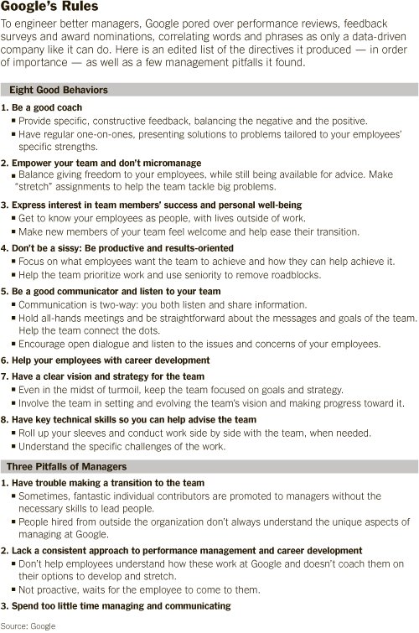**BUDGET MANAGEMENT (BM)**

This part of the module will give you an introduction to the basics of budget management. Depending upon your work situation, you may or may not be responsible for your budget. If you are in charge of a small unit, you may have to manage the budget yourself. If you are in a larger unit, there may be a staff member who is responsible for overseeing the finances. Whatever your situation, it is important to understand your budget and to assert some control over it. If you let someone else control your budget, you may find that they are also making some of the decisions that you should be making, simply by deciding how to spend your resources. When negotiating for a new position, it is appropriate to ask questions about budget, such as: can you see it? Do you have a place at the table when the budget is planned? What control do you have over budget decisions? Fellows should be able to apply the concepts of budget management to the realities experienced or happening at their sites of placement. Going forward they should be able to fill the days log suggesting ways they plan to put the concepts in practice in future.

This section of the module will introduce (or review) a number of issues, such as

* How to plan a budget?
* How to construct an Excel spreadsheet for your budget
* How to present your budget as part of the plans for your administrative unit
* How to monitor expenditures and avoid cost overruns
* How to fix problems with your budget
* Different Budget templates for different organisations ie an NGO, Government department, grant, Cooperative agreement, Project or RFA application (NIH D43,R25,D71,K awards)
* How to prepare a budget justification
* Post award grant budget negotiation (hints)
* Budget shifts redirection (practical clues)
* Best Practices in Grant management
* Audit-Focused Grant Management Strategy

**Learning Objectives:**

1. Fellows will be able to apply basic principles when creating different budgets for different Organisations and RFAs to NIH D43,R25, D71,K awards .
2. Fellows will be able to use excel to create a budget.
3. Fellows will be able to evaluate a budget and select appropriate strategies to manage cost overruns and fix problems.
4. Fellows will be able to outline the steps to constructing a budget
5. Fellows should be able to know what it takes to prepare for a Grant audit
6. Fellows should be able to apply the best practices in Grant Management

# LECTURES ON BUDGET MANAGEMENT

There will be 3 lectures on budget management.

**Lecture 1: General principles of budget management**

This lecture will cover topics such as

* The role of the budget in managing a program
* What you should know about your budget
* Who controls budget decisions
* The budget as a surrogate for program control
* Strategic budget management
* Budget shifts and redirections
* Budget negotiations (post award)

**Learning Objectives:**

1. Fellows will list three roles budgets can play in program management and site examples at their placement sites.
2. Fellows will identify the individuals involved in budget management at their placement sites.
3. Fellows will be able describe and prepare budget shifts if required by program and site examples of cases that need budget shifts at the placement sites

**Lecture 2: How to construct a budget and present it**

This lecture will cover topics such as

* Excel spreadsheet basics
* Pre Budgeting planning
* How to structure your budget
* Different grants different budget templates (NIH D43, R25, D71, K awards)
* 5-year operational budgets formats
* How to justify items in the budget
* How to present the budget as part of your program
* Budgeting for Indirect costs/Overheads

**Learning Objectives:**

1. Fellows will create an excel spreadsheet for the purposes of managing a budget.
2. Fellows will list key considerations when structuring a budget.
3. Fellows will be able to differentiate between different budget templates for different grants and organisations
4. Fellows will create a budget presentation using power point.

**Lecture 3: How to track a budget and trouble shoot budget problems**

This lecture will cover topics such as

* How to set up a tracking system using a budget Tracking tools
* How to control expenditures and their authorization
* How to anticipate cost overruns and make corrections
* How to troubleshoot budget problems
* Budget variance analysis/reports
* Budget and exchange rates/inflation

**Learning Objectives:**

1. Fellows will describe the steps necessary to set up a tracking system.
2. Fellows will list three strategies that will allow them to control budget expenditures.
3. Fellows will list and explain three strategies that will allow them to identify and manage potential budgeting problems.

**Lecture 4: Grant Management Cycles, Tips on Grant Management and Audits**

This lecture will cover topics such as

* What to do after winning a grant
* What PIs need to manage their awards
* Advice for communicating with funders
* The award management cycle (Tracking, Analysis and Reporting)
* Strategies to improve your next Grant audit
* The 3 Common award audit problems

**Learning Objectives:**

1. Fellows will describe the steps necessary to set up a tracking system.
2. Fellows will list three strategies that will allow them to control budget expenditures.
3. Fellows will list and explain three strategies that will allow them to identify and manage potential budgeting problems.

# BUDGET MANAGEMENT CASE STUDIES

NOTE. In some instances there are two case studies (A and B) and in others a single case study.

Budget management case 1A**: How to use Excel, the basics (Given as homework to the fellows to practice before the workshop)**

Excel is the Microsoft Office spreadsheet. You need to have a beginner’s level of competence in Excel to do the case studies that will be presented in this part of the module. If you use Excel and believe that you have reached at least the beginner’s level of competence, you will probably not need to use this tutorial. If you have not used Excel before, we suggest that you go through a beginner’s tutorial before you attempt the homework practice.

Microsoft provides such a tutorial at

* [http://office.microsoft.com/en-us/Excel-help/basic-tasks-in-Excel-2010-HA101829993.aspx?CTT=5&origin=HA010370218](http://office.microsoft.com/en-us/excel-help/basic-tasks-in-excel-2010-HA101829993.aspx?CTT=5&origin=HA010370218)
* which can be accessed in Google by typing in the request box

“basic tasks in Excel 2010”

Another Excel tutorial is

1. [http://people.usd.edu/~bwjames/tut/Excel/](http://people.usd.edu/~bwjames/tut/excel/)

Useful websites for all kinds of Excel templates:

* <http://www.skilledup.com/learn/business-entrepreneurship/best-free-excel-templates-dashboards/>
* <http://www.spreadsheetzone.com/>
* <http://chandoo.org/wp/free-excel-templates-download/>
* <http://spreadsheets.about.com/od/excel-templates/>

Budget Management case 1B: **Developing a budget using Microsoft Excel (Given as homework to the fellows to practice before the workshop)**

You have just been hired to plan and operate a new unit within an NGO that is focused on AIDS prevention. Your unit will work in 4 antenatal clinics in a small city in Tanzania, where your employees will be administering a counselling and testing service for pregnant women coming to the clinic. You have been told that your unit will have an annual budget of $250,000 (aka total costs). You have been requested to develop a plan and budget for your new unit, and to present the budget as an Excel spreadsheet. Your team needs to set up the spreadsheet, and make the decisions what items need to be included in the budget and how much each of them will cost. You will be asked to present the budget, to explain it, to justify it, and to answer any questions that may be asked. The presentation will be made to the Director of the NGO, his senior staff, and the heads of other existing sections in the NGO. You need to prepare a spreadsheet that will be printed out for each member of the review group.

**QUESTIONS**

1. What plans do you need to make for your new unit prior to planning a budget?
2. What components need to be included?
3. How do you decide how much to budget for each one?
4. Can you fit the costs of operating your new unit within the budget total provided?
5. If you think you will need less than the amount suggested, what do you do? If you think you will need more than the amount provided, what do you do?
6. Which cost items need close monitoring and why? Explain the system you would devise to do this monitoring.
7. Would having a petty cash system for minor expenses help reduce the need for multiple approvals?
8. What challenges does a petty cash system generate and what checks/balances would you need to institute to safe guard petty cash pilferage?

Budget Management case 1C**: Train Midwives to Administer and Conduct Neonatal Circumcision (NMC) to generate cost variables and Cost Drivers (in Class Example with your Neighbour)**

Aim 3: To Train midwives to administer and conduct neonatal circumcision (NMC) using appropriate techniques/ devices

**Activities**

3a. Train a cohort of midwives at multiple sites (in knowledge, attitude and technical skills) Methods: This will involve the design of training manuals, testing of the manual and eventual training of a cohort of Midwives on the NMC procedure following the principle of adult learning. Population: the target population is a group of 100 qualified midwives resident within the catchment areas of the PEPFAR partner institution. Outcome variables: training and trainer of trainers manuals, survey of the trainees opinions, performance on knowledge tests and attitude changes of the trained midwives. Analysis: continuous variables performance on knowledge tests will be compared using the paired samples t-test and ANOVA while the categorical and ordinal variables like change in attitude will be subjected to non-parametric tests and qualitative analysis. In all cases results will be interpreted as significant when the tests for significance have a p-value less than 0.05

**With Your Neighbour**

* Use the Pre budget Notes Hand out
* Read the NMC Example
* Use the hand out to Identify and note the Cost drivers under each budget line item
* Indicate any missing information that you might need

Budget management case 2**: Tracking your budget expenditures in real time**

You have been given a green light to launch your new unit described in Budget management case 1B, and you have recruited staff and begun operations. The Director of the NGO, who is your boss, has told you (among other things) that it is your responsibility to be sure that your unit operates within the allocated budget. You need to be able to follow the expenditures of your unit on a regular basis to determine whether you are operating within budget. The budget you need to follow is tabled below:

|  |  |  |  |
| --- | --- | --- | --- |
| **DRAFT BUDGET FOR THE HIV UNIT (ANNUAL)** | | | |
| **GENERAL CATEGORY** | **ITEM** | **BUDGET ($ US)** | **SUBTOTALS** |
| **PERSONNEL: REMUNERATION INCLUDES FRINGE BENEFITS** | **UNIT DIRECTOR** | **40,000** |  |
|  | **COORDINATOR AND DATA MANAGER** | **30,000** |  |
|  | **CASE WORKER AND HIV TESTER** | **25,000** |  |
|  | **CASE WORKER AND HIV TESTER** | **25,000** |  |
|  | **CASE WORKER AND HIV TESTER** | **25,000** |  |
|  | **CASE WORKER AND HIV TESTER** | **25,000** | **170,000** |
|  | **IT CONSULTANT WITHIN NGO** | **0** |  |
|  |  |  |  |
| **CURRENT EXPENSES** | **OFFICE SPACE IN NGO** | **0** |  |
|  | **RENT FOR CONSULTING ROOM IN EACH ANTENATAL CLINIC: 4 @ $1,000** | **4,000** |  |
|  | **TEST KITS FOR HIV DIAGNOSIS: 5000 @ $1** | **5,000** |  |
|  | **ANNUAL RENTAL: LAPTOP COMPUTER FOR EACH ANTENATAL CLINIC AND FOR UNIT OFFICE: 6 @ $500** | **3,000** |  |
|  | **OFFICE EQUIPMENT: ANNUAL RENTAL** | **1,500** |  |
|  | **CELL PHONES FOR ALL STAFF: 6 ANNUAL CONTRACTS @ $500** | **3,000** |  |
|  | **TRAVEL EXPENSES FOR ALL STAFF** | **3,000** | **19,500** |
|  |  |  |  |
| **SUBTOTAL** |  |  | **189,500** |
|  |  |  |  |
| **CONTINGENCY (5% OF SUBTOTAL BUDGET)** |  |  | **9,475** |
|  |  |  |  |
| **GRAND TOTAL** |  |  | **198,975** |

**QUESTIONS**

1. Whom should you consult for advice?
2. Can you set up a system to track the expenditures on a monthly basis? Name the budget monitoring tools you would use.
3. Who in your unit will be responsible for this process?
4. If it appears that there is an over-expenditure in the monthly budget reports, how will you respond?
5. In case the actual budget variance report shows that you have made a saving of $25,000 on personnel because we did not need all the 4 Case worker and HIV testers, Prepare a budget Shift /Redirection Table (whichever is the suitable case) and make justification for your proposed adjustment in the budget.
6. What is the system put in place for budget management at your placement sites? Is it effective? If not what amendments would you propose to ensure improvement.

Budget management case 3A**: Power point presentation of your budget (Given as homework to the fellows to practice before the workshop)**

You have just been hired to plan and operate a new unit within an NGO that is focused on AIDS prevention. Your unit will work in 4 antenatal clinics in a small city in your country, where your employees will be administering a counselling and testing service for pregnant women coming to the clinic. You have been told that your unit will have an annual budget of $250,000. You have been requested to develop a plan and budget for your new unit, and to present the budget as an Excel spreadsheet. Your team needs to set up the spreadsheet, and make the decisions what items need to be included in the budget and how much each of them will cost.

Once you have made a plan for your new unit, you are asked to make a power point presentation of your plans. You will be asked to present the budget, to explain it, to justify it, and to answer any questions that may be asked. The presentation will be made to the Director of the NGO, his senior staff, and the heads of other existing sections in the NGO. You need to prepare a power point presentation that can be completed in 20 minutes with no more than 5 slides. The basis for the power point presentation will be the table shown below.

**QUESTIONS**

This exercise should be presented as a powerpoint within the boundaries described above

1. What are you trying to accomplish in your presentation?
2. What is the sequence of points that you wish to make?
3. What questions do you anticipate? Can you handle these in the presentation?
4. How will you present the budget in a format that can be read on the screen?
5. How will you keep the audience interested? And convinced?

Budget management case 3B**: Fixing a budget problem**

You are a physician and the director for a Government-run ambulatory care clinic that provides primary care to a rural area with about 50,000 inhabitants. Your clinic has facilities for basic care including simple surgery, but for more complicated cases you refer patients to the District hospital which is 50 kilometers away, and is a two hour trip on poorly maintained roads. Your staff includes an administrator who handles many operational issues, including your budget. The rest of your staff consists of 3 nurses, 3 nurse assistants, and one laboratory technician.

The budget for your clinic comes from the Ministry of Health, via the District hospital. Because you are so busy dealing with individual patients and overseeing the rest of the clinic staff, you have left the budget management to your clinic manager.

About half way through your fiscal year, your administrator comes to you with a distraught look on his face and tells you that the clinic is over-expending its budget and he thinks that you will run out of money about 2 months before the end of the year.

**QUESTIONS**

1. Do the facts in the case relate to a similar and real example at your placement site? Who is responsible for budget management at your placement site?
2. What do you do? How do you handle this situation?
3. What information do you need to obtain?
4. What analyses do you need to do?
5. What options do you have?
6. Do you consult anyone for advice? If so, whom?
7. To whom do you report this situation? And when? And how do you verify facts before reporting?
8. Could this situation have been avoided? How?
9. Can you think of some innovative cost cutting measures?

Budget management case 4A**:** **Budget for a grant application (RFA for a D43 Example using SF 424 Research and Related (R&R) forms**

In your Group study the following D43 RFA and answer the questions which follow:

**Title:** **Global Infectious Disease Research Training Program (D43)**

**Program Announcement (PA) Number: PAR-10-260**

NOTICE: Applications submitted in response to this Funding Opportunity Announcement (FOA) for Federal assistance must be submitted electronically through Grants.gov ([http://www.grants.gov](http://www.grants.gov/)) using the SF 424 Research and Related (R&R) forms and the SF 424 (R&R) Application Guide.

**2. Funds Available**  
  
Because the nature and scope of the proposed research training will vary from application to application, it is anticipated that the size and duration of each award will also vary. Although the financial plans of the IC(s) provide support for this program, awards pursuant to this funding opportunity are contingent upon the availability of funds.

The expected amount for individual awards will be up to $ 200,000 per year for new awards and $250,000 per year for renewal awards (total direct costs) for up to ­­­­­­five years.  Facilities and Administrative (F&A) costs requested by consortium participants are not included in the direct cost limitation, see [NOT-OD-05-004](http://grants.nih.gov/grants/guide/notice-files/NOT-OD-05-004.html).  Facilities and administrative costs are limited to 8% for all awards and sub-awards.

The estimated amount of funds available for support of five to six projects awarded as a result of this announcement is $1,200,000 for fiscal year 2011. Future year amounts will depend on annual appropriations.

NIH grants policies as described in the [NIH Grants Policy Statement](http://grants.nih.gov/grants/policy/nihgps_2003/) will apply to the applications submitted and awards made in response to this FOA.

**Allowable Costs**

***Stipends:*** Stipends are provided as a subsistence allowance for trainees to help defray living expenses during the research training experience.  Trainees may be paid a stipend comparable to their professional experience.  Applicants should use an appropriate stipend level and can use the NRSA levels (see[Kirschstein-NRSA stipend schedule](http://grants.nih.gov/training/nrsa.htm),) or grantee institutional policies for trainees involved in medium- or long-term training. Partial stipends for part time long-term trainees should reflect the amount of time they need to be supported for training in the budget and described in the budget justification.

***Tuition and Fees:*** Funds for tuition and academic fees at the U.S. or foreign institution may be requested.  Programs are encouraged to seek cost-sharing arrangements with the grantee institutions in order to provide reduced tuition for trainees. Note that health insurance is not included as part of this budget category, and is now included under Training Related Expenses category. Tuition and fees are excluded from the F&A base. Health insurance is included in the F&A base.

***Trainee Travel:***  Funds may be requested for round-trip economy class airfare on U.S. carriers (to the maximum extent possible).  Funds may be requested for lodging and per diem for short-term trainees. Funds may be requested to support participation in meetings in which current or former trainees will be presenting training-related research results.

***Training-related Expenses:*** Applicants are encouraged to budget adequate professional development opportunities for trainees, including international scientific conference attendance.  Training-related expenses (e.g., books, computers, and courses for software, English language proficiency, etc.) may be included but must be described in the budget justification.  Funds for self-only or family medical insurance may be requested. Include costs for logistics for short- term courses and describe in budget justification.

One-time advanced in-country research training support of up to $15,000 direct costs for mentored research to be undertaken by a long-term trainee in his/her country upon completion of their training.

***Salary for Senior/Key Personnel:*** The salary for the PD, other training faculty and administrative staff must be commensurate with the salary structure and benefits at the institution where they are employed and within the limits described at <http://grants.nih.gov/grants/policy/salcap_summary.htm>.

Collaborators may receive appropriate compensation for their significant activities on the program, such as recruitment and selection activities, as well as other program-related roles.  The administrative, training or teaching responsibilities and time commitment for personnel receiving salary should be thoroughly described. The salary and fringe benefits for the faculty and staff should not exceed 25 percent of total costs.

***Faculty Travel:***Funds may be requested for round-trip economy airfare on U.S. carriers (to the maximum extent possible) and lodging and per diem for the applicant to attend the annual program network meeting, normally in the U.S.  Principal Investigators are expected to attend**.**

***Facilities and Administrative (F&A) Costs:*** F&A costs for the applicant organization and consortium participants will be reimbursed at 8 percent of modified total costs, exclusive of tuition, fees, equipment, and consortia costs in excess of $25,000, per NIH Grants policy for institutional research training grants <http://grants.nih.gov/grants/policy/nihgps_2003/NIHGPS_Part11.htm#_Toc54600212>

NIH grants policies as described in the [NIH Grants Policy Statement](http://grants.nih.gov/grants/policy/nihgps_2003/) will apply to the applications submitted and awards made in response to this FOA.

1. Site all budgeting related instructions and limitations in this RFA
2. Where would you put the justification for your budget.
3. In each allowable cost section list what would be the likely budget drivers/variables
4. Match the budget information from the allowable costs sections above with the fields in the budget related SF 424 Research and Related (R&R) forms below

### 4.7.1 Section A and B

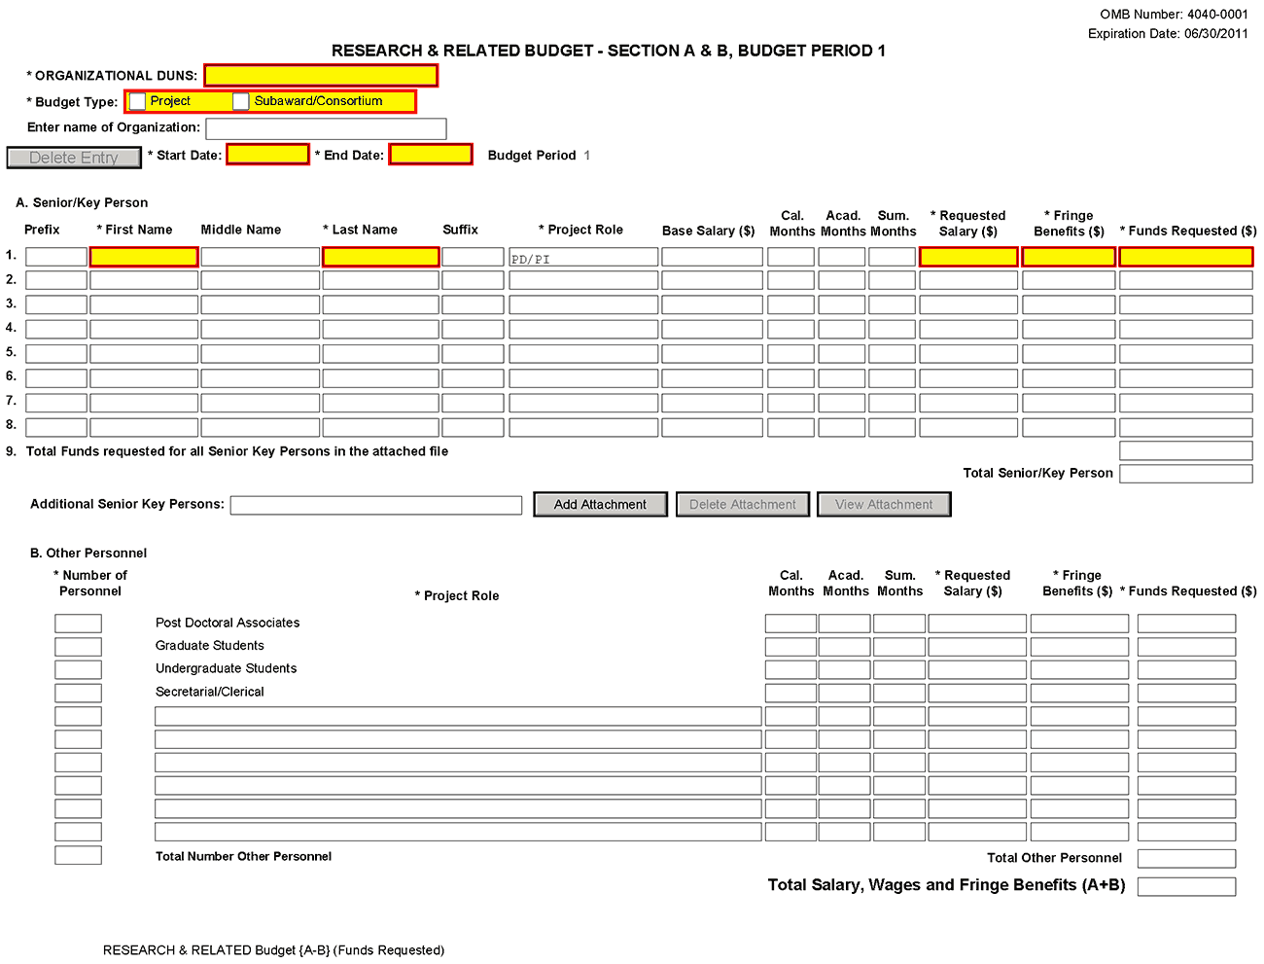

### 4.7.2 Sections C through E

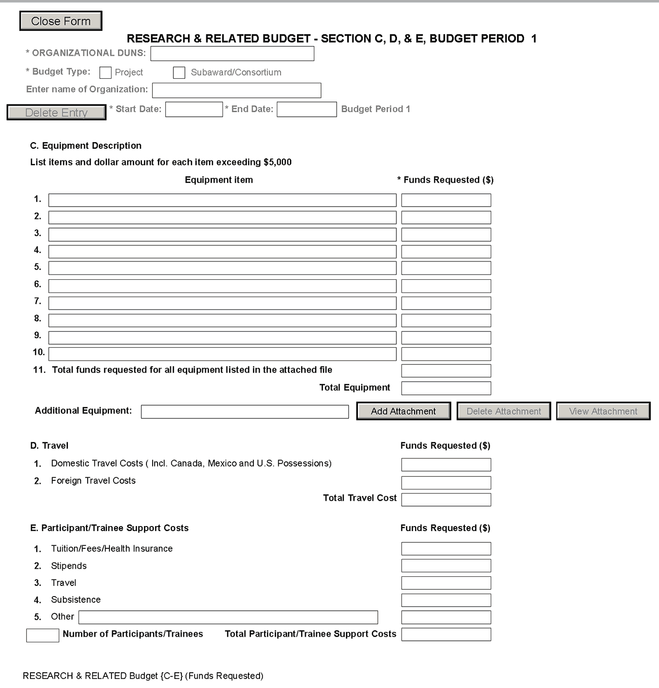

### 4.7.3 Sections F through KResearch & Related Budget, Section F-K

### 4.7.4 Cumulative Budget

All values on this form are calculated automatically. They present the summations of the amounts that you have entered previously, under Sections A through K, for each of the individual budget periods. Therefore, no data entry is allowed or required, in order to complete this “Cumulative Budget” section.

If any of the amounts displayed on this form appears to be incorrect, you may correct it by adjusting one or more of the values that contribute to that total. To make any such adjustments, you will need to revisit the appropriate budget period form(s), to enter corrected values.

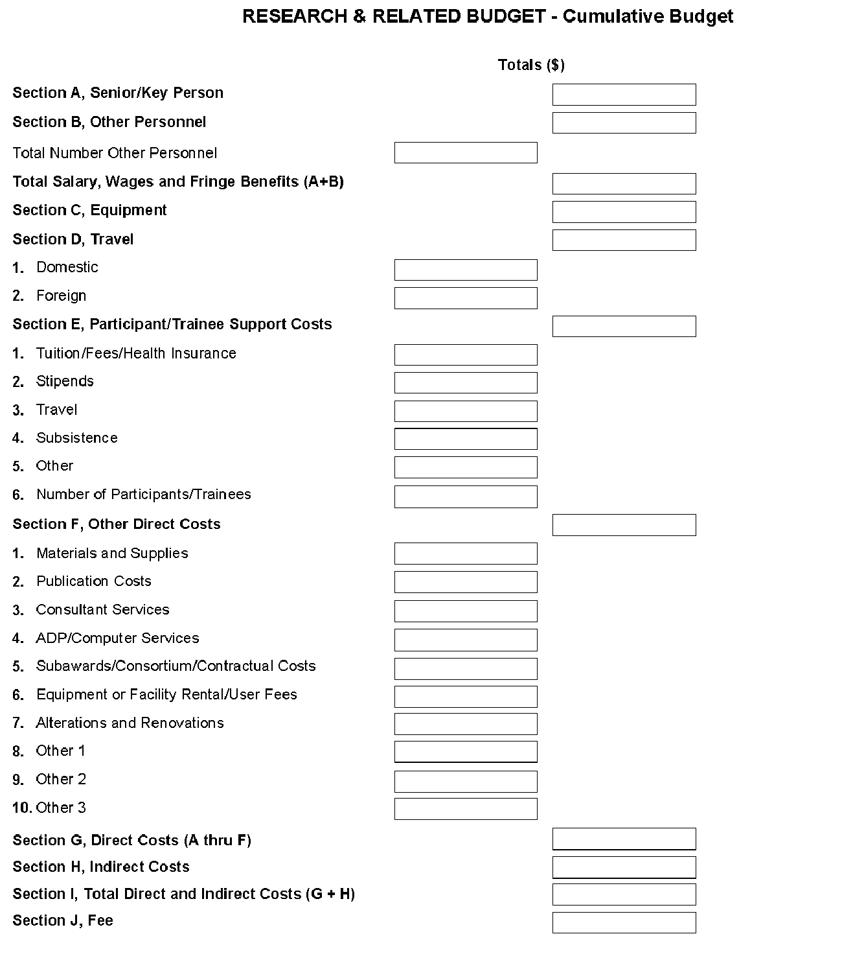

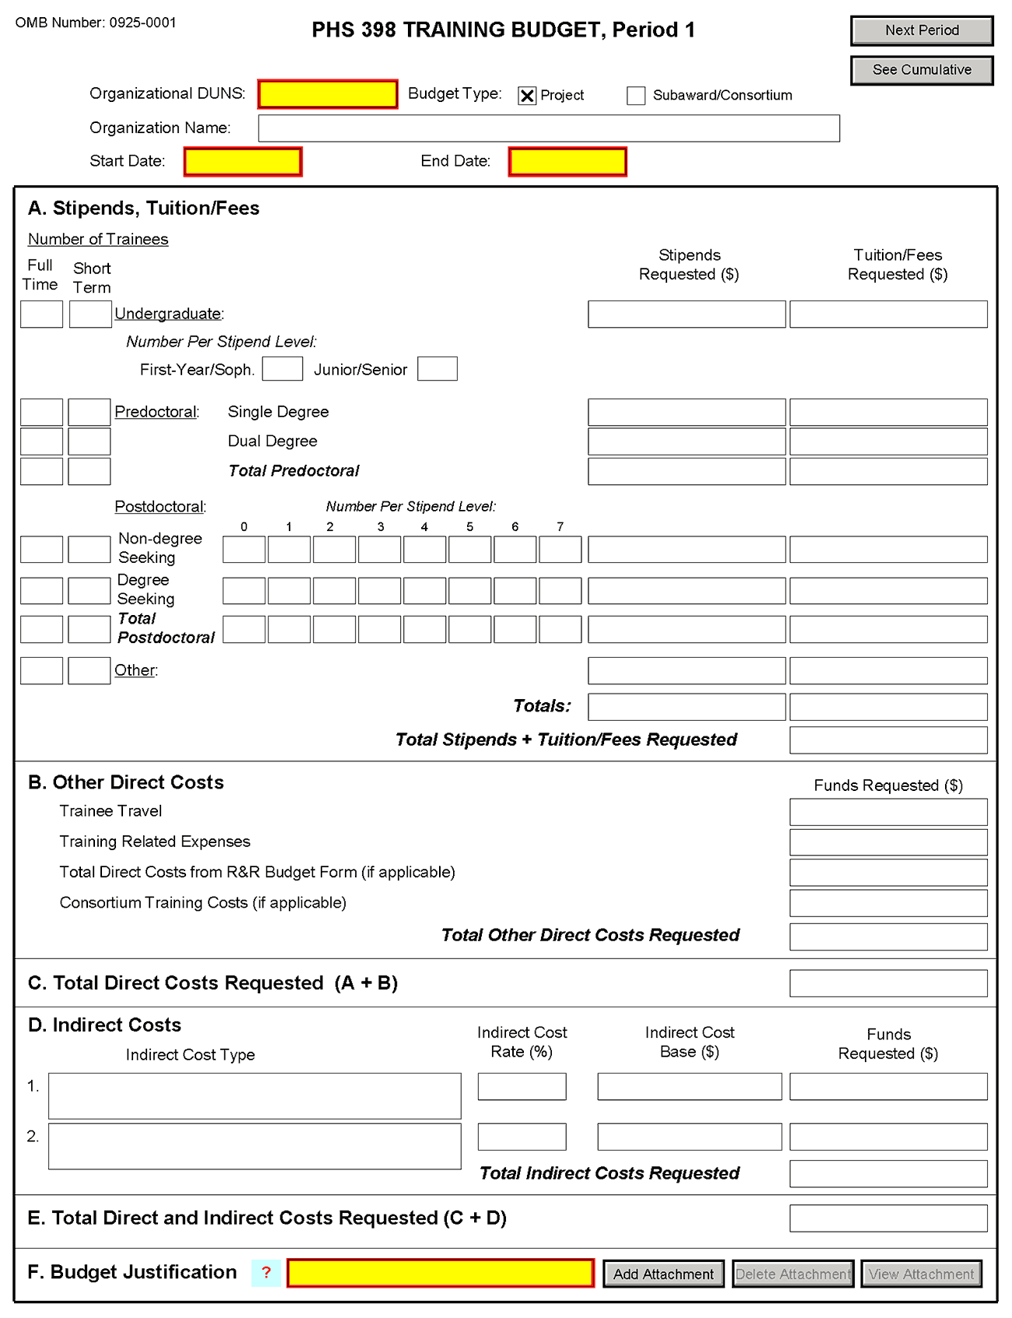

Budget management case 4B**:** **Budget for a grant application (PHS 398 format)**

You are a Professor of Obstetrics and Gynaecology at the major hospital situated in the capital city of your country. The Fogarty International Center of the US National Institutes of Health announces a new grant program to train nurse midwives in Sub Saharan Africa. The application must be submitted by an established African institution, and offers a maximum of US $500,000 per year for up to 5 years. You have long been concerned about reducing maternal mortality in your country and convinced that this could be best accomplished by training nurses as midwives, so you are enthusiastic about this opportunity. You gather together a team of physicians, nurses, public health experts, and plan to submit an application. For a meeting of this team, you have been asked to draft a proposed budget for the application together with a justification of each component. Using the form pages that follow, prepare a budget and justification.

|  |  |  |  |
| --- | --- | --- | --- |
|  |  | | |
|  | | | |
| DETAILED BUDGET FOR INITIAL BUDGET PERIODDIRECT COSTS ONLY | | **FROM** | **THROUGH** |
|  |  |

**List PERSONNEL *(Applicant organization only)***

**Use Cal, Acad, or Summer to Enter Months Devoted to Project**

**Enter Dollar Amounts Requested *(omit cents)* for Salary Requested and Fringe Benefits**

|  |  |  |  |  |  |  |  |  |  |  |
| --- | --- | --- | --- | --- | --- | --- | --- | --- | --- | --- |
| **NAME** | **ROLE ON PROJECT** | **Cal.**  **Mnths** | **Acad.**  **Mnths** | **Summer**  **Mnths** | | **INST.BASE SALARY** | **SALARY REQUESTED** | **FRINGE BENEFITS** | | **TOTAL** |
|  | **PD/PI** |  |  |  | |  |  |  | |  |
|  |  |  |  |  | |  |  |  | |  |
|  |  |  |  |  | |  |  |  | |  |
|  |  |  |  |  | |  |  |  | |  |
|  |  |  |  |  | |  |  |  | |  |
|  |  |  |  |  | |  |  |  | |  |
|  |  |  |  |  | |  |  |  | |  |
| SUBTOTALS | | | | | | |  |  | |  |
| **CONSULTANT COSTS** | | | | | | | | | |  |
| **EQUIPMENT *(Itemize)*** | | | | | | | | | |  |
| **SUPPLIES *(Itemize by category)*** | | | | | | | | | |  |
| **TRAVEL** | | | | | | | | | |  |
| **INPATIENT CARE COSTS** | | | | | | | | | |  |
| **OUTPATIENT CARE COSTS** | | | | | | | | | |  |
| **ALTERATIONS AND RENOVATIONS *(Itemize by category)*** | | | | | | | | | |  |
| **OTHER EXPENSES *(Itemize by category)*** | | | | | | | | | |  |
| **CONSORTIUM/CONTRACTUAL COSTS** | | | | | **DIRECT COSTS** | | | |  | |
| SUBTOTAL DIRECT COSTS FOR INITIAL BUDGET PERIOD *(Item 7a, Face Page)* | | | | | | | | | $ |  |
| **CONSORTIUM/CONTRACTUAL COSTS** | | | | | **FACILITIES AND ADMINISTRATIVE COSTS** | | | |  | |
| TOTAL DIRECT COSTS FOR INITIAL BUDGET PERIOD | | | | | | | | | $ |  |

PHS 398 (Rev. 6/09)

|  |  |  |  |  |  |  |  |  |
| --- | --- | --- | --- | --- | --- | --- | --- | --- |
|  | | |  | | | | | |
|  | | | | | | | | |
| BUDGET FOR ENTIRE PROPOSED PROJECT PERIOD DIRECT COSTS ONLY | | | | | | | | |
| **BUDGET CATEGORY TOTALS** | **INITIAL BUDGET PERIOD *(from Form Page 4)*** | **2nd ADDITIONAL YEAR OF SUPPORT REQUESTED** | | **3rd ADDITIONAL YEAR OF SUPPORT REQUESTED** | **4th ADDITIONAL YEAR OF SUPPORT REQUESTED** | | **5th ADDITIONAL YEAR OF SUPPORT REQUESTED** | |
| **PERSONNEL: *Salary and fringe benefits. Applicant organization only*.** |  |  | |  |  | |  | |
| **CONSULTANT COSTS** |  |  | |  |  | |  | |
| **EQUIPMENT** |  |  | |  |  | |  | |
| **SUPPLIES** |  |  | |  |  | |  | |
| **TRAVEL** |  |  | |  |  | |  | |
| **INPATIENT CARE COSTS** |  |  | |  |  | |  | |
| **OUTPATIENT CARE  COSTS** |  |  | |  |  | |  | |
| **ALTERATIONS AND RENOVATIONS** |  |  | |  |  | |  | |
| **OTHER EXPENSES** |  |  | |  |  | |  | |
| **DIRECT CONSORTIUM/ CONTRACTUAL COSTS** |  |  | |  |  | |  | |
| SUBTOTAL DIRECT COSTS  ***(Sum = Item 8a, Face Page)*** |  |  | |  |  | |  | |
| **F&A CONSORTIUM/ CONTRACTUAL COSTS** |  |  | |  |  | |  | |
| TOTAL DIRECT COSTS |  |  | |  |  | |  | |
| TOTAL DIRECT COSTS FOR ENTIRE PROPOSED PROJECT PERIOD | | | | | | $ | |  |
| **JUSTIFICATION. Follow the budget justification instructions exactly. Use continuation pages as needed.** | | | | | | | | |

PHS 398 (Rev. 6/09)

**Case 5: The Karimojong Senior Citizens Project**

The Following 2 Tables include the summary of a Pre budget worksheet of Tasks Resources needed and the timing of these tasks. These tasks were identified by the project development team of a Senior Citizens Community Outreach Pilot Project in Karamoja district in North Eastern Uganda

The main Project objective is to Ensure that a Minimum of 75 Karimojong speaking senior citizens with Type II Diabates who complete the Project Disease management classes, maintain stabilised blood Sugar levels for three consecutive months.

In order to achieve the objectives for our Senior Karimajong Community Outreach Pilot Project, the project will employ the methods employed below. They have confidence in these methods, as they have been tested and proven successful by two of other non-profit organizations whose client populations are Karimajong speaking Senior Citizens. These are the Health Access for Karimajongs in Mororo Town and the XYZ Senior Citizens Community Clinic in Northern part of the District boardering with Kenya. Representatives of both organizations served as advisers to the Project team as they developed this pilot project. The Project team have also prepared a detailed timeline, which is included in the appendixes to the proposal submitted.

* Use the information in the tables
* To develop a Timeline for the identified Tasks/activities
* To develop a detailed extended 12 months Budget in excel. With monthly totals
* Develop the Budget Notes and Justification which are linked to the main project objective

**Example of a Methods Worksheet for Budget planning**

|  |  |  |  |
| --- | --- | --- | --- |
| **Task Subtasks** | **Person(s) Responsible** | **Resources needed** | **Start and Finish dates** |
| Hire a Program Assistant (PA) and full time bilingual nurse | Executive Director (ED) | Funds for salaries and benefits, recruitment and hiring process, Job description | 1 month of project startup for PA and 2 months of startup for the nurse |
| Establish an outreach Committee | ED and PA | List of potential prospects, meeting space | Within one month of Project startup |
| Adopt the centers current diabetes self management classes to ensure they are linguistically appropriate | Bilingual Nurse and program assistant | Language Consultant specializing in translation, updated materials from worksheet current classes, funds for consultant | Within 3 months of startup |
| Develop the Protocols for testing and tracking Program participants for three consecutive months after completing the classes | Bilingual Nurse and program assistant | Information on best practices for data tracking and collection, computer and software | Within four months of startup |
| Develop a formal referral system and feedback mechanism | Executive Director (ED), outreach Committee, co chairs and program assistants | Information on best practices for referral systems and feedback mechanism | Within 5 months of project startup |
| Organise weekly Karamojong language diabetes self management classes | Bilingual nurse and program assistant | List of potential prospects, meeting space | Within month 2 of Project startup |
| Adopt the centers current diabetes self management classes to ensure they are linguistically appropriate | Bilingual Nurse and program assistant | Meeting space, self management educational materials, refreshments | Within 6 months of startup |
| Track participants progress on a weekly basis for three months following completion of the classes | Bilingual Nurse and program assistant | Filing cabinet, File folders and office supplies, computer, private office for weekly screenings | Starting week 9 of Grant period |

**Example of an Extended / Cost Methods Worksheet**

|  |  |  |  |
| --- | --- | --- | --- |
| **Task Subtasks** | **Resources needed /cost Drivers** | **Quantity, unitcost, cost drivers &frequency** | **Formulae in Excel to generate amount** |
| Hire a Program Assistant (PA) and full time bilingual nurse | Funds for salaries and benefits, recruitment and hiring process, Job description | **1 PA,10 months at $500 from month 3**  **1 BLnurse6 months at $300**  **Recruitment costs for 2 pple at a consolidated cost of $150 each**  **Consultant to develop Job descriptions1day for $50** | =1*10*500    =1*6*300  =2*150  =1*50  **Summation of the 4** |
| Establish an outreach Committee | List of potential prospects, meeting space | **10 seater Board room hired for 1 day at $100**  **Cost of morning snack for 10 each at $2**  **Transport facilitation each at 10 each at $5** | =1*100  =10*2  =10*5  **Summation of the 3** |
| Adopt the centers current diabetes self management classes to ensure they are linguistically appropriate | Language Consultant specializing in translation, updated materials from current classes, funds for consultant | 1 Consultant for 5 days translation at $100 per day.  3 consultants for 15 days to update class materials at $150 per day  Stationary, printing and binding costs 5 subjects each at $500 | =1*5*100  =3*15*150  =5*500  Summation of the 3 |
| Develop the Protocols for testing and tracking Program participants for three consecutive months after completing the classes | Information on best practices for data tracking and collection, computer and software | 3 consultants to develop and document protocols for 5 days at $200 per day  2 computer, printer and accessories at $2,000 | =3*5*200  2*2,000  Summation of the 2 |

**REFERENCES**

Kemp S, Dunbar E. Budgeting for managers. McGraw Hill, New York, 2003. About $15 from amazon.com.

* An introductory primer on all aspects of budget management.

Useful websites:

<http://www.inc.com/articles/2000/01/16379.html>

<http://www.kingcashcow.com/effective-budget-control-techniques/>

<http://www.projectmanagementguru.com/resourceplan.html>

<http://www.referenceforbusiness.com/management/A-Bud/Budgeting.html>

<http://www.flexstudy.com/catalog/schpdf.cfm?coursenum=95075>

**ACKNOWLEDGEMENTS**

*This project was made possible by the Afya Bora Consortium Fellowship, which is supported by the U.S. President’s Emergency Plan for AIDS Relief (PEPFAR) through funding to the University of Washington’s International AIDS Education and Training Center (IAETC) under Cooperative Agreement U91 HA06801 from the Health Resources and Services Administration (HRSA) Global HIV/AIDS Bureau.*

**NOTES**

**NOTES**

**NOTES**

**NOTES**