|  |
| --- |
| AFYA BORA CONSORTIUM GLOBAL HEALTH LEADERSHIP FELLOWSHIP PROGRAM |
| HEALTH INFORMATICS MODULE |
|  |

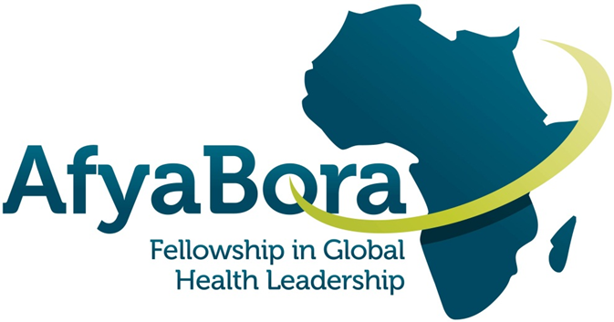

|  |
| --- |
|  |

**AFYA BORA CONSORTIUM**

**HEALTH INFORMATICS MODULE**

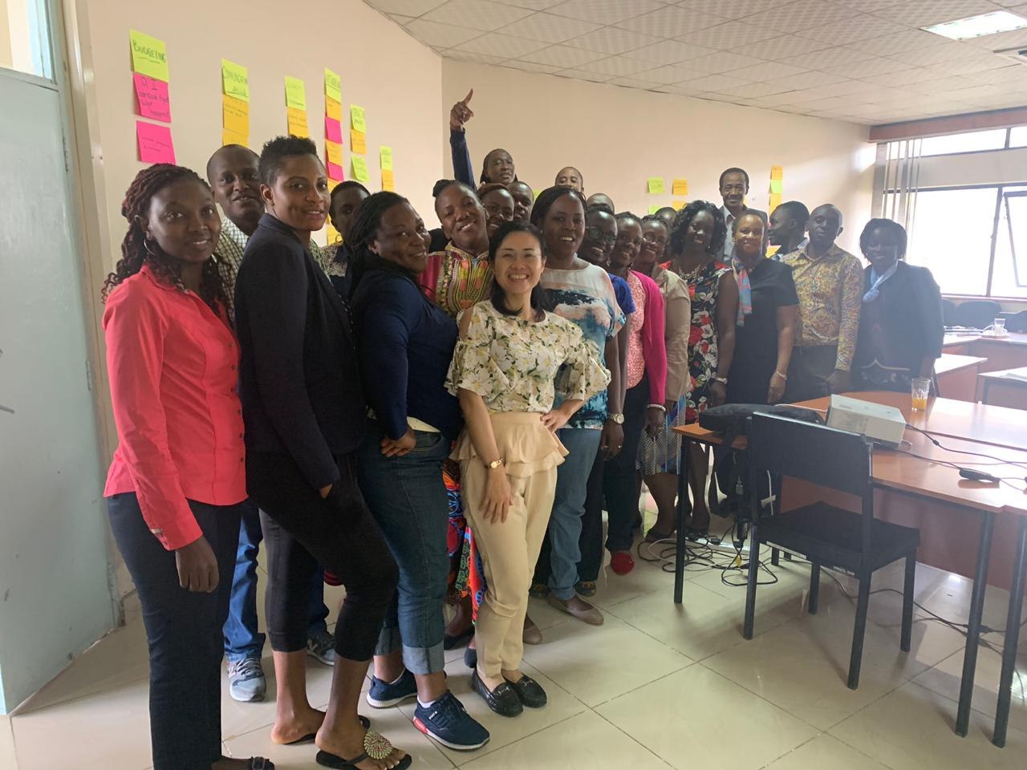

**Guide for Fellows and Instructors**

**Table of Contents**

Introduction 4

Health Informatics Module --- Learning Objectives and Schedule 6

Learning Objectives: 6

MODULE SCHEDULE: Health Informatics 7

Appendix 1. 9

The Afya Bora kwa Wote Public Tertiary Hospital: The Health Information Management Challenge 9

The Story 9

Activity/Exercise 15

Select Readings and Resources 16

WHO Guideline 16

NOTES 17

NOTES 18

Acknowledgments 19

[**Afya Bora Consortium Fellowship in Global Health**](https://sites.google.com/site/afyaborafellowship20111/)

**Health Informatics Concepts and Principles Module**

# Introduction

Information lies at the heart of effective evidence-based health decision-making – throughout the health system. At every level – local, district, county, national and international – health workers require information and data for decision making and they create data and information for use by others.

Just as information and communications technologies (ICT) are transforming the lives of individuals in Africa and across the world there is a growing recognition of the potential of ICT to support and, indeed, transform the access to and delivery of quality health care services.

Health informatics is an academic domain at the intersection of information science, computer science, and health care. It deals with the resources, devices, and methods required to optimize the acquisition, storage, retrieval, and use of information in health and biomedicine. Health informatics tools include not only computers but also information and communication systems.

E-Health is the commonly applied term for the application of ICT in the health sector. According to the World Health Organization (WHO), eHealth is defined as the cost-effective and secure use of Information and Communications Technologies (ICT) in support of health and health-related fields, including health-care services, health surveillance, health literature, and health education, knowledge and research. The definition introduces a range of services such as electronic health records to ensure continuity of patient care across time, mobile health services (mHealth), telemedicine, health research, consumer health informatics to support individuals in health decision-making, and e-learning by health workers. In practical terms, eHealth is a means of ensuring that the right health information is provided to the right person at the right place and time in a secure, electronic form for the purpose of optimizing the quality and efficiency of health care delivery and disease prevention programs.

Digital health, or the use of digital technologies for health, has become a salient field of practice for employing routine and innovative forms of information and communications technology ([ICT](https://www.ncbi.nlm.nih.gov/books/n/who311941/abb/def-item/abbreviations.gl1-d9/)) to address health needs. The term digital health is rooted in eHealth, which is defined as “the use of information and communications technology in support of health and health-related fields”. Mobile health ([mHealth](https://www.ncbi.nlm.nih.gov/books/n/who311941/abb/def-item/abbreviations.gl1-d14/)) is a subset of eHealth and is defined as “the use of mobile wireless technologies for health”. More recently, the term digital health was introduced as “a broad umbrella term encompassing eHealth (which includes mHealth), as well as emerging areas, such as the use of advanced computing sciences in ‘big data’, genomics and artificial intelligence”.

Currently, members of the health workforce often lack knowledge and skills in key informatics competencies, including the ability to find, evaluate, manage and apply information and data to quality decision-making. This lack of knowledge and skills leads to poorly-designed information systems that frequently do not meet their intended needs, do not allow for sharing of information among systems in organizations, and results in barriers to sharing data and information with health information systems both inside and outside the organization.

Health workers and healthcare leaders need an understanding and awareness of how to identify, evaluate and apply data and information for quality decision-making. They must also appreciate how to adapt their health programs to take advantage of the benefits of these new information and communications technologies for improving the quality and speed of information and data sharing. Technical specialists are needed who can help define health worker information needs, acquire, and implement new information and communications systems, and assure that they produce information and data that positively affects health.

The purpose of this 3-day course is to provide participants with an understanding of the principles of health informatics and strategies for finding, evaluating and using health information and data as well as designing health information strategies, systems and tools for quality decision-making.

# Health Informatics Module --- Learning Objectives and Schedule

## Learning Objectives:

Fellows will be able to:

* Gain an understanding of the fundamentals of digital health
* Describe organizational factors affecting uptake and utilization of health informatics with a focus on digital health governance
* Understand and apply the principles for digital development
* Explore approaches and methods for implementing digital health
* Explore digital health global goods: What are they and how can you use them?
* Digital health innovation and future trends

## MODULE SCHEDULE: Health Informatics

|  |  |  |
| --- | --- | --- |
| **Day 1** | | |
| **Time** | **Activity** | **Presenters** |
| 8:30 – 9:30 | Welcome and Introductions: Prior Experiences with ICT in Healthcare Learning Expectations | Wanyee |
| 9:30 – 10:30 | Introduction to Digital Health | Wanyee |
| 10:30 – 10:45 | Break | |
| 10.50 – 13:00 | Implementing Digital Health | Wanyee |
| 13:00 – 13:45 | Lunch |  |
| 13.50 – 14:30 | Introduce and discuss case study | |
| 14:30 – 16:00 | Case study Exercise | Wanyee |
| 16.00 – 16.15 | Break |  |
| 16:20 – 17:00 | Presentations | Groups |
| 17:00 | End of Day |  |

|  |  |  |
| --- | --- | --- |
| **Day 2** |  |  |
| **Time** | **Activity** | **Presenter** |
| 8:30 – 9:00 | Introduction and recap | Designate |
| 9:00 – 9:45 | Principles for Digital Development | Wanyee |
| 9:45 – 10:15 | Break | |
| 10:15 – 11:00 | Introduction to digital health global goods | Wanyee |
| 11:00 – 12:00 | Country case studies of digital health solution investments | Team Work |
| 12:00 – 1:00 | Lunch Break | |
| 1:00 – 2:00 | Afya Bora Kwa Wote – Team work | Team Work |
| 2:00 – 3:30 | Afya Bora Kwa Wote -Team Presentations  Lessons learned | Team Presentations |
| 3:30 - 4:00 | Break |  |

|  |  |  |
| --- | --- | --- |
| **Day 3** |  |  |
| **Time** | **Title** | **Presenter(s)** |
| 8:30 – 9:30 | Recap | Designate |
| 9:30 – 10:30 | Investing in interoperability: Establishment of a Health Information Exchange | Wanyee |
| 10:30 – 10:45 | Break | |
| 10:45 – 12:00 | Digital Health Innovation and Trends | Wanyee |
| 12:00 – 1:00 | Lunch Break | |
| 1:00 – 2:00 | Farewells, and Course Evaluation |  |

# Appendix 1.

# The Afya Bora kwa Wote Public Tertiary Hospital: The Health Information Management Challenge

**Teaching Purposes/Objectives:**

* Fundamentals of health informatics
* How does health informatics affect me? How do I determine how and when to use it?
* Making wise investment decisions in health informatics
* Key and important considerations in health informatics (including mechanics of health informatics)
* Implementing health informatics interventions
* Determining impact of health informatics interventions
* Trends and innovations in health informatics

## The Story

You have just accepted a new position as the Chief Medical Information Officer (CMIO) for a large public tertiary hospital, Afya Bora Kwa Wote (ABKW) with responsibility for planning a new and comprehensive digital health system to support acceleration towards Universal Health Coverage (UHC). This being the largest health facility means that it is critical to the Government’s mission to achieve quality and affordable health care for all its citizens. The experience and investments at this facility will provide an insightful indicator to the Ministry of Health (MOH) about the practical reality of enabling the Government to achieve UHC within the projected 5 years of the current administration.

You will be reporting to the Hospital Director, Dr. Mdosi, a physician with many years of experience treating patients and managing health facilities in Sub-Saharan Africa. Dr. Mdosi, himself does not use computers but the Board of Directors that provides strategic leadership for the hospital has directed him to create this new position and to develop a comprehensive digital health systems plan for hospital management, patient care management and for reporting to the national MOH and, to its financial and technical support partners. The Board is very committed to evidence-based practice and Dr. Mdosi is as well.

The Afya Bora Kwa Wote is a Public Tertiary Referral hospital that is owned and supported by the MOH. Its mission is to provide innovative and consistently high quality, low cost, high quality healthcare in the safest possible way. It was started in 1965 as a Family Planning Clinic.

In the early 1980s it ran vertical clinics of Family Planning (FP), Antenatal Care (ANC) and Baby Clinic. It started integrating these services gradually and in 1992 there was one clinic called the Maternal and Child Health/Family Planning (MCH/FP). In the year 2001 it added HIV/AIDS services and became MCH/FP /HIV/AIDS and added TB in 2005 to become MCH/FP /HIV/AIDS /TB. By 2006 this facility was running a fully-fledged and well integrated CCC offering Prevention of Mother-to-Child Transmission (PMCT), HIV/AIDS, TB, FP, Exposed Baby Programme, STI/drug addiction, dental services and ophthalmology services.

In addition to its primary mandate to provide specialized health-care services to patients on referral from sub-national level hospitals, the Hospital facilitates medical training and research and participates in national health-care planning. The specialized health-care services provided by the Hospital include; Radiotherapy, heart surgery, neurosurgery, renal dialysis and kidney transplant operations, plastic and reconstructive surgery, orthopedic surgery, and burns management among others. With the current focus on UHC, the hospital has invested heavily to provide Primary Health Care services with a focus on the patient. These services include treatment and management of Non-Communicable Diseases (NCDs) including hypertension, diabetes, cancer, among others. It also offers blood transfusion services as part of the MOH country-wide network of Blood Transfusion Services (BTS)

In its efforts to improve the structure and functioning of Afya Bora Kwa Wote public tertiary hospital, the Government commissioned an independent evaluation of the hospital on its overall performance of service delivery. The evaluation assessed the level of efficiency at which the Hospital delivers its statutory mandate as a national referral hospital particularly for specialized healthcare services. One of the specific objectives of the evaluation included an objective to assess the average length of waiting-time experienced by patients seeking treatment services in each of the Hospital’s main specialized healthcare departments namely, the Cardiology Department, the Cancer Treatment Centre and the Renal Unit, as well as in the Accident and Emergency Centre. Other key objectives included; cost efficiency and healthcare outcomes.

Below is a summary of the evaluation findings which focus on waiting times to receive service as an indication of service delivery efficiencies;

**Waiting-time for cancer patients**

Examination of samples and batches of data on the operations of the Hospital revealed that patients experience long delays before they receive treatment in any of its specialized departments and units: The data revealed that new patients at the Cancer Treatment Centre wait for an average of 63 days (over two months) to see a clinical specialist for the first time. Those booked for radiotherapy sessions wait for four months before they attend the first session while those due for chemotherapy wait for one and a half months. Patients due for brachytherapy (treatment for cervical cancer) wait for an average of five months before they access treatment services for the first time. Among the cancer patients booked for chemotherapy, only one out of every two received the service on schedule. The Hospital promises to release results on medical tests carried out on cancer patients at the Histology Laboratory within seven (7) days. However, the evaluation revealed that on average, the results are released after twenty-two (22) days.

**Waiting-time for heart patients**.

Records in the Cardiology Department revealed that patients wait for an average of 34 days (one month) to consult a specialist doctor for the first time and 112 days (three and-a-half- months) to appear before a multi-disciplinary committee that recommends the mode of treatment for each patient. Further, the patients wait for an average of 207 days (seven months) before they are admitted into the Ward to prepare for heart surgery. Upon admission, patients stay in the Ward for an average of 22 days (three weeks) before surgery. On average, the multi-disciplinary committee deliberates on 23 cardiac patients every month. Of the 17 patients booked for surgery during the month, only 6 (six) are operated on. In view of the delays that precede surgical operations in the Cardiology Department, at least 132 patients on the waiting-list at the end of the year are carried forward to the following year.

**Waiting-time for kidney patients**.

International guidelines on renal therapy require patients to be dialyzed for at least four (4) hours, three times every week, or a total 12 hours in each week. The Hospital’s target is to put renal patients on dialysis for at least eight (8) hours each week. However, most patients are dialyzed only once per week (4 hours) and some only once in two weeks. On average, the patients wait for eight (8) days from one dialysis session to another contrary to the recommended waiting time of three (3) days. Effects of long delays in delivery of specialized health care services. Long waiting times before serious illnesses are treated prolong suffering and heighten anxiety of the sick and increase the risk of failure of any belated treatment that may eventually be provided to them. Further, patients who have their treatment regimes delayed may later on require more rigorous treatment which may result in side effects detrimental to their well-being, not to mention the inevitable increase in financial costs of treatment. Reasons for delays in delivery of the specialized services. Afya Bora Kwa Wote Hospital’s failure to provide services efficiently is mainly caused by lack of sufficient numbers of healthcare workers, and variety of medical equipments and specialist staff to cater for the very large number of patients who come to the Hospital for treatment. The resource constraints faced by the Hospital are caused by lack of sufficient funds with which to buy acquire and maintain the resources. In addition to resource constraints, management systems and practices applied by the Hospital, for example, its weak management information system and ineffective revenue management practices hinder timely delivery of services. Too many patients seek treatment at the Hospital because the national health-care referral system does not function as well as intended.

Records on hospital attendance indicated that on average, the Afya Bora Kwa Wote (ABKW) hospital receives more than 2,000 in-patients and 1,500 outpatients each day. The majority of the patients (at least 60%) suffer from common illnesses, even though the Hospital’s mandate is to provide specialized health-care services. This influx of patients is a result of the national-health-care referral system failing to function as intended. Too many patients come to ABKW because primary and other lower-tier health-care institutions face operational constraints and do not therefore provide services in a manner that meets the expectations of the patients. In addition, unlike other regions, the region where the ABKW hospital is located lacks a regional-level public hospital. Further, the ABKW is the only public health-care institution in that country that provides the full range of specialized health-care services. The Hospital lacks sufficient numbers of functional specialized medical equipment’s. The specialized medical equipment’s used by the Hospital to are few and mostly, quite old. Therefore, the equipment’s are not only constrained in the range of services they may provide but also break down frequently. For example, the Renal Unit has only 14 out of the 23 machines it requires to provide dialysis services efficiently. Only eight (8) of the 14 machines were in good working condition at the time of the audit. Similarly, the Cancer Treatment Centre has only two radiotherapy machines. One of the two machines, the Cobalt T780, is 50 years old, breaks down often, and thus disrupts delivery of services at the Centre. In the Cardiology Department, the Hospital’s only closed-heart surgery machine was purchased in the year 1973. It was put out of service in early 1990 after it broke down. The Hospital lacks sufficient space for all the patients that it admits. The management has set the Hospital’s bed-capacity at 1,410. However, at the time of the evaluation, there were 1,876 beds (133 % of the recommended capacity) in all of the Hospital’s wards but these were still not sufficient to cater for all patients in need of admission at the time. The Critical Care Unit, which provides both emergency as well elective surgeries, has 21 beds only. Scheduled surgical operations are cancelled often due to lack of bed-space. The Acute Room at the Accident and Emergency Centre has only five (5) beds, which are not sufficient to serve the many critically ill patients received at the Centre. The Ward which admits orthopedic patients, registers occupancy rates of up to 180% causing congestion and an uncomfortable environment for the patients as well as the medical personnel who work there. The Hospital has too few of the specialists it requires to deliver its unique mandate effectively. The number of doctors and other experts employed in the Hospital’s specialized units are too few relative to the patients. For example, the Cancer Treatment Centre has only four (4) oncologists- (specialists trained to treat cancer) even though it receives between 50 and 60 new patients each week. The Centre has only two nurses trained in handling cancer patients and two medical physicists instead of the required ten and eighteen radiographers instead of the thirty-six (36) required. In addition, the Hospital does not meet the required nurse patient ratio of 1:1, which the World Health Organization (WHO) recommends for critical-care services. There are occasional stock-outs of important medical supplies 19. Occasionally, the Hospital lacks vital and essential drugs required in the Critical Care Unit, surgical theatres as well as in the resuscitation and burns units. Medical workers at the Hospital blame the stock-outs on poor procurement practices applied by the procurement unit and refusal by some suppliers to honor purchase orders when the Hospital fails to pay for previous deliveries in due time. **The Hospital’s Management Information System does not support efficient delivery of services. The Hospital’s management information system does not gather, analyze, store and control clinical, administrative and financial information in a complete and integrated manner. Key data and information required to plan and guide daily operations are not available to management fast enough and in a format that would support efficient delivery of services**. Efficiency standards and guidelines on the Hospital’s key operations are not fully developed. The Hospital has not established and documented important operational standards and guidelines essential for efficient delivery of its services. Among the missing operational standards are those on waiting-time as well as policies and guidelines on admission and discharge of patients. In the absence of measurable targets for efficient service delivery, the management of the Hospital cannot effectively monitor, evaluate and control performance of the specialized health-care and other departments or units of the Hospital. 23. In addition, ABKW has no documented policies on how to acquire, maintain, and replace organizational assets. Therefore, the Hospital is unable to manage its assets in a manner that supports efficient delivery of its services. The Hospital’s expenditures often exceed its revenues.

The Hospital lacks sufficient financial resources to buy and maintain all the equipment and the human expertise it requires to deliver on its specialized health-care mandate. During the period under review, the actual financial allocations made to the Hospital by the Treasury were below what the Hospital had estimated and presented in its annual budgets by an annual average of about 16.84%. Further, revenue collection under the cost-sharing programme was below the budgeted levels by 27% during the period.

The Hospital’s private wing levies fees to patients but does not collect as much revenue as expected. For instance, it reported annual financial losses totaling to MPS:35 million (MPS = Mapesa) during the 2004/05 financial year and MPS.66.1 million in 2008/09. Over the same period, the Hospital incurred 71% of its total expenditure on personal emoluments.

The management explained that patients who fail to pay for the services provided to them by the Hospital are the main cause for the revenue shortfalls. Outstanding debts owed to the Hospital by patients as at 30 June 2009 amounted to MPS.1,446billion out of which, a balance of MPS 1,256billion (86%) was owed by those categorized by the Hospital as poor and therefore not likely to repay their debts. However, the evaluation revealed that the Hospital does not manage its debtors well mainly because it lacks a documented credit control policy. It recovered only 20% of the financial credit granted to patients during the period under review.

## Activity/Exercise

1. Review the case and identify opportunities where a comprehensive and hospital wide digital health solution can support ABKW hospital fix those challenges it is grappling with.
2. Develop a digital health investment and implementation plan for the Afya Bora Kwa Wote public tertiary hospital that will;
   1. Address the challenges and weaknesses uncovered by the evaluation.
   2. Contribute to the national agenda for UHC
3. Present the plan to the President’s appointed special Committee on UHC for funding.
4. Develop an evaluation plan: How will you know you succeeded and measure impact of this digital health intervention?

As you conduct the exercise above, pay special attention to;

* Setting: Where, type of facility, environment and environmental factors
* Decision makers/main actor/other actors (including those not mentioned in case)
* Issues/problems/interests
* Constraints/opportunities
* Sources of information/data for planning purposes (Do literature search for relevant articles regarding hospital clinic information systems planning – from print to electronic information systems)
* Your Theory of Change...

Planned Site Visit, 28th October 2019 (*this will form the basis for report back)*

1. What digital health solution is in use at the hospital? This could be an EMR, Lab information system, Pharmacy information system, mHealth application, etc.
2. Why did the hospital invest in it? What was the justification for this investment? Was it a specific pain point/challenge? If yes, seek to further understand that pain point(s)/problem(s).
3. What approach did the hospital take? How was the digital health solution implemented?
4. What impact has that investment in the digital health solution had and on what specifically? Is the solution sustainable and if yes, how?
5. *Seek for any other information*

## Select Readings and Resources

* Principles for digital development, <https://digitalprinciples.org/>
* Classification of digital health solutions, <https://apps.who.int/iris/bitstream/handle/10665/260480/WHO-RHR-18.06-eng.pdf>

# WHO Guideline: recommendations on digital interventions for health system strengthening

* ,<https://www.who.int/reproductivehealth/publications/digital-interventions-health-system-strengthening/en/>
* National eHealth Strategy Toolkit, <https://www.who.int/ehealth/publications/overview.pdf>
* **Monitoring and Evaluating Digital Health Interventions,** [**https://www.who.int/reproductivehealth/publications/mhealth/digital-health-interventions/en/**](https://www.who.int/reproductivehealth/publications/mhealth/digital-health-interventions/en/)
* WHO Health Metrics Network Framework and Standards for Health Information Systems Strengthening 2nd ed. 2009 <http://www.who.int/healthmetrics/documents/hmn_framework200803.pdf>
* The MAPs Toolkit, <https://apps.who.int/iris/bitstream/handle/10665/185238/9789241509510_eng.pdf?sequence=1>

# NOTES

# NOTES

**ACKNOWLEDGMENTS**

**Content developed by:**

|  |  |
| --- | --- |
| Steven Wanyee, MSc, (*PhD student in health informatics*) | IntelliSOFT Consulting Limited & Kenya Health Informatics Association  Rose Avenue Off Argwings Kodhek Road, Hurlingham,  Office: +254 711 466 263,  Email: [swanyee@intellsoftkenya.com](mailto:samkanga@gmail.com) |
| Brandon Guthrie, Ph.D.  Assistant Professor | Departments of Global Health and Epidemiology  University of Washington  Email: [brguth@u.washington.edu](mailto:sfuller@uw.edu) |

*This project was made possible by the Afya Bora Consortium Fellowship, which is supported by the U.S. President’s Emergency Plan for AIDS Relief (PEPFAR) through funding to the University of Washington’s International AIDS Education and Training Center (IAETC) under Cooperative Agreement U91 HA06801 from the Health Resources and Services Administration (HRSA) Global HIV/AIDS Bureau.*