**Last Updated: August 2019**

|  |
| --- |
| AFYA BORA CONSORTIUM GLOBAL HEALTH LEADERSHIP FELLOWSHIP PROGRAM |
| PROJECT MANAGEMENT MODULE |
|  |

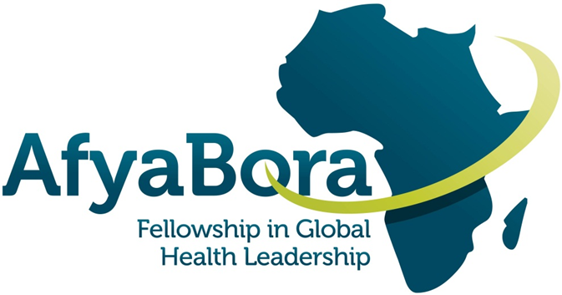

**AFYA BORA CONSORTIUM**

**PROJECT MANAGEMENT MODULE**

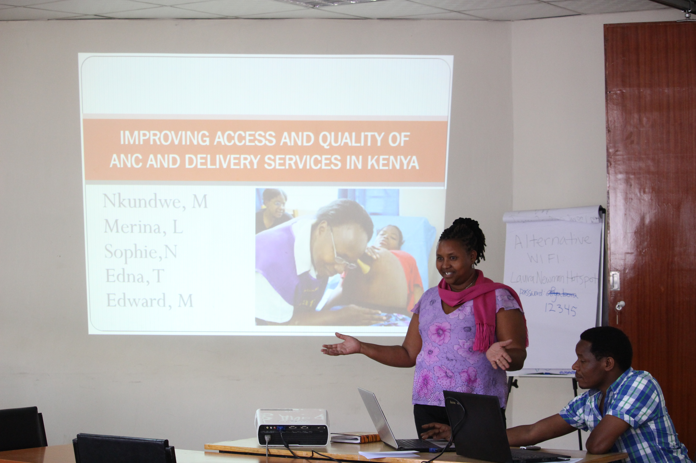

**Guide for Fellows and Instructors**

Lectures courtesy of:

* Susan Chapman, PhD, RN Professor, Department of Social & Behavioural Sciences, School of Nursing, University of California, San Francisco
* Kenneth Ngure MPH, MSc, PhD College of Health Sciences, Jomo Kenyatta University of Agriculture and Technology, Nairobi, Kenya

Table of Contents

Course Overview 4

Goals of the Module 4

Learning Objectives: 4

Teaching Methods: 5

Module Schedule 5

Suggested Readings 6

Acknowledgements 6

# Course Overview

A critical component of implementing a research study or project is Project Management. A Project Manager is responsible for a multitude of duties/tasks, including preparing and managing grants and project budgets, complying with government regulations, preparing project reports and regulatory submissions, creating data collection forms, managing project data, managing human resources, conducting regular project team meetings, preparing and managing the project timeline, and producing the project deliverables. Sometimes a project manager may need to focus on improving processes when administrative, clinical, or research problems occur. Many professionals who have taken on the role as project manager know all too well the difficulties of learning all these tasks “on-the job”. This module focuses on the skill set required for effective project management.

# Goals of the Module

Project management is an essential skill for success in any organization. In today’s complex health care delivery and research environment, a project-based team approach is becoming common and necessary. In order to implement successful projects in this environment, one must pay great attention to planning. This includes developing and managing timelines, budgets, scope of work, risks, unforeseen problems, clients, stakeholders, and fellow team members.

Effective project management ensures cost effective use of valuable resources such as people and funds.

The skill set required for effective project management is not necessarily the same set of skills needed for success as a clinician or researcher. Many clinical staff in health care have not been taught project management skills. Project management has too often been seen as an unnecessary add-on or something that just will happen automatically.

This workshop will assist you to develop the range of skills appropriate for effective project management in a health care or research setting.

# Learning Objectives:

The objective of this module is to provide fellows with the foundational skills necessary to be successful in Project Management. At the end of the course fellows should be able to:

1. Explain (Understand) what is meant by the meaning of “project” and provide examples of different types of projects.
2. Describe the concepts used in project management, project planning and development of project plan, and development and monitoring of project timeline and deliverables.
3. Participate in group discussions of issues in project management in field placements and problem solve with discussion group members.

# Teaching Methods:

The course is taught in a distance-learning format with two recorded lectures, two discussion posts, and two required discussion groups. Weekly discussion posts assess knowledge of concepts and application of project management tools. Discussion posts are due every Sunday. If you chooses to attend, please bring any questions that may have surfaced during the lectures.

# Module Schedule

|  |  |  |  |
| --- | --- | --- | --- |
| **Week** | **Topic** | **Discussion Groups** | **Discussion Post Due Date** |
| WEEK 1 | The Project Life Cycle | Day 3  6:30pm WAT/7:30pm CAT/8:30pm EAT | Day 7  by 11:59pm EAT |
| WEEK 2 | Timelines, Deliverables, Metrics | Day 10  6:30pm WAT/7:30pm CAT/8:30pm EAT | Day 14  by 11:59pm EAT |

# Suggested Readings

Carroll-Barefield, A. & Smith, S.P., (2001). Case Study: Incorporating Project Management Skills in the Design of a Clinical Research Patient Management System, *Health Care Manager*, (1), 70–76.

De Wit, A. (1988). Measurement of project success. *International journal of project management*, *6*(3), 164-170.

Dwyer, J., Stanton, P., & Thiessen, V. (2004). *Project Management in Health and Community Services: Getting good ideas to work*. Psychology Press.

Institute for Healthcare Improvement: PDSA Worksheet. Review website

<http://www.ihi.org/knowledge/Pages/Tools/PlanDoStudyActWorksheet.aspx>

NHS Institute for Innovation and Improvement, Quality and Service Improvement Tools, PDSA, 2008.

Klein, G. (2007). Performing a project premortem.  *Harvard Business Review*,*85*(9), 18-19.

Munns, A. K., & Bjeirmi, B. F. (1996). The role of project management in achieving project success. *International Journal of Project Management*, *14*(2), 81-87.

Payne JM, France KE, Henley N, D’Antoine HA, Bartu AE, Elliott EJ and Bower C, (2011). Researchers’ experience with project management in health and medical research: Results from a post-project review, *BMC Public Health*, 11:424.

# Acknowledgements

*This project was made possible by the Afya Bora Consortium Fellowship, which is supported by the U.S. President’s Emergency Plan for AIDS Relief (PEPFAR) through funding to the University of Washington’s International AIDS Education and Training Center (IAETC) under Cooperative Agreement U91 HA06801 from the Health Resources and Services Administration (HRSA) Global HIV/AIDS Bureau.*