RESEARCH METHODS MODULE

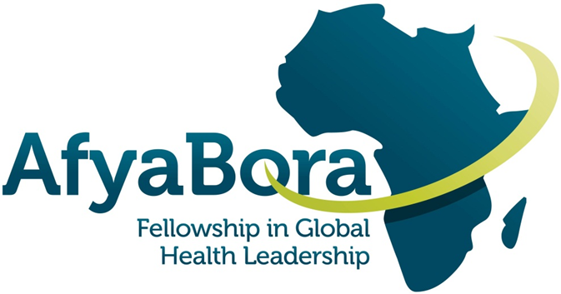

Table of Contents
Course Overview 3
Instructors 3
Expectations and Grading 3
Textbook and Course Materials 4
Topic Outline 4
Time/Deadlines in Canvas 4
Quiz and Conference Schedule 5
Acknowledgements 6

Course Overview

Research Methods provides an orientation to the fields of epidemiology and biostatistics for those seeking to conduct research or work on research studies in a global health context. The objective of this course is to provide participants with an understanding of how epidemiologic methods are used to understand the distribution of disease within populations and what factors affect the risk of disease. Through this course, participants will become familiar with the concepts and terminology used to describe disease risk, the common study designs used in epidemiology, the concepts of bias and confounding, and the importance of appropriate measurement in epidemiologic research.

Instructors

Dr. Brandon Guthrie, PhD, is an epidemiologist and Assistant Professor of Global Health and Epidemiology at the University of Washington. His specific research interests focus on improving engagement in care among people living with HIV. Dr. Guthrie has NIH-funded research projects based in Nairobi, Kenya that are evaluating interventions to improve linkage and retention in HIV/AIDS care, expedite treatment initiation, and reduce mortality. His research includes both randomized intervention trials as well as mixed methods and implementation science approaches to evaluate interventions that are tailored to achieve both high effectiveness and acceptability.

Jarim Omogi is an epidemiologist and a lecturer of Epidemiology and Biostatistics at Amref International University. He is also the Monitoring and Evaluation Coordinator for the Afya Bora Fellowship. His research interests are in maternal, newborn and child health. He is currently on a research project on the optimization of breastfeeding in Kisii and Nairobi Counties in Kenya.

Expectations and Grading
To be successful in the course you will need to watch the weekly video lectures, read the recommended readings, and complete the weekly quiz. You will need to complete the final exam by the 6th April 2020 due date. In order to pass the course, you much have a final score of 70% or higher. Your final score will be calculated as follows:
- Quizzes (40%): You will have two attempts on each weekly quiz. Your score will be averaged across the 10 quizzes.
- Final exam (40%): The final exam at the end of the course will include multiple-choice questions randomly selected from each topic area and will have 20 questions.
- Writing assignments (15%)
- Discussion forum participation (5%)
For example, if you average 80% on the quizzes and 90% on the final exam and complete all writing and discussion board assignments, your final score will be 88%. If you average 60% on the quizzes and 90% on the final exam and complete all writing and discussion board assignments, your final score will be 80%.

Textbook and Course Materials

Recommended Text
Recommended (not required) readings will be drawn from the following texts.
Principles of Epidemiology in Public Health Practice, 3rd Edition. An Introduction to Applied Epidemiology and Biostatistics.

Cancer Epidemiology: Principles and Methods. Isabel dos Santos Silva. International Agency for Research on Cancer. Lyon. 1999.

Topic Outline
Week 1: Introduction to Epidemiologic Methods and Quantitative Research
Week 2: Introduction to Statistical Decision Making
Week 3: Epidemiologic Study Designs
Week 4: Causation, Bias, and Confounding
Week 5: Measurement, Classification, and Misclassification
Week 6: Interpretation of Epidemiologic Studies and Decision Making
Week 7: Multiple Variable Regression Models in Epidemiology
Week 8: Data Management Practices in Health Research
Week 9: Qualitative Research Methods
Week 10: Analyzing Qualitative Data and Public Health Applications

Time/Deadlines in Canvas
Please note that the course has been set to East Africa Time (Nairobi). If you are in a different time zone (or you have your Canvas time set to another time zone), Canvas will show you your local time and the time the course is set to when you hover over a deadline anywhere in Canvas. We'd like for you to adhere to deadlines as close as possible so we can move together through the course, but we do not plan on penalizing for late submissions. If you would like to set your Canvas time in a different time zone, here are the instructions to do so:
https://guides.instructure.com/m/4214/l/218818-how-do-i-set-a-time-zone-in-my-user-account

Quiz and Conference Schedule

Course instructor and TA will be available via Canvas Conference bi-weekly to discuss the previous week’s content and quiz. We have split your cohort into three groups, as listed below; please attend the conference day that corresponds to your group.
*Conference Session dates are subject to change.

Week | Lecture | Quiz Due Date | Conference Session (Group 1) | Conference Session (Group 2) | Conference Session (Group 3)
1 | Introduction Epidemiologic Methods and Quantitative Research | Day 8 | Day 16 | Day 17 | Day 18
2 | Introduction to Statistical Decision Making | Day 15
3 | Epidemiologic Study Designs | Day 22 | Day 30 | Day 31 | Day 32
4 | Causation, Bias, and Confounding | Day 29
5 | Measurement, Classification, and Misclassification | Day 36 | Day 44 | Day 45 | Day 46
6 | Interpretation of Epidemiologic Studies and Decision Making | Day 43
7 | Multiple Variable Regression Models in Epidemiology | Day 50 | Day 58 | Day 59 | Day 60
8 | Data Management Practices in Health Research | Day 57
9 | Qualitative Research Methods | Day 64 | Group 1 and 2 Combined  Day 72 |  | Day 73
10 | Analyzing Qualitative Data and Public Health Applications | Day 71
 | FINAL EXAM DUE | Day 78

Acknowledgements

This project was made possible by the Afya Bora Consortium Fellowship, which is supported by the U.S. President’s Emergency Plan for AIDS Relief (PEPFAR) through funding to the University of Washington’s International AIDS Education and Training Center (IAETC) under Cooperative Agreement U91 HA06801 from the Health Resources and Services Administration (HRSA) Global HIV/AIDS Bureau.

Content created by: Dr. Brandon Guthrie (brguth@uw.edu)

