|  |
| --- |
| AFYA BORA CONSORTIUM GLOBAL HEALTH LEADERSHIP FELLOWSHIP PROGRAM |
| HIV/AIDS as a Global Health Challenge |
| Distance Learning |

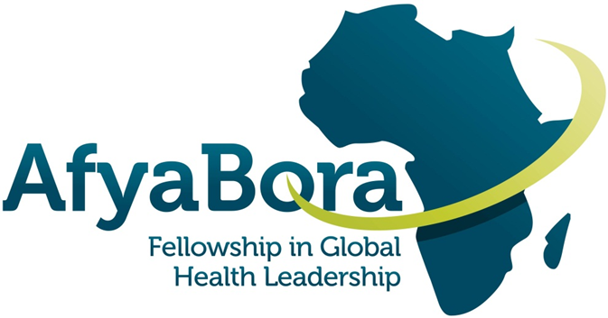**AFYA BORA CONSORTIUM**

**HIV/AIDs as a Global Health Challenge**

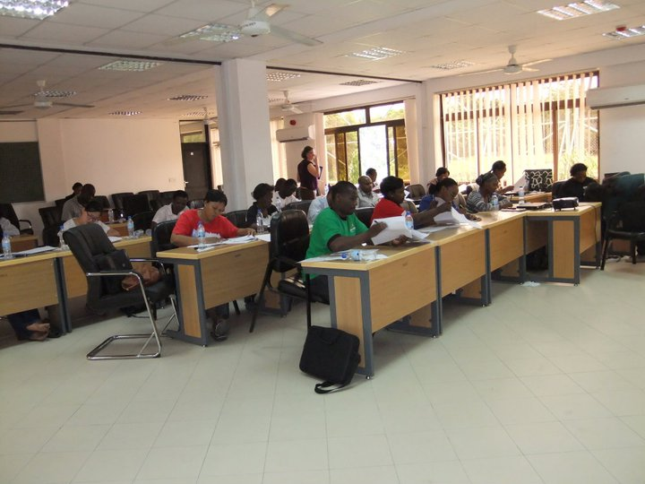

Table of Contents

Course Description: For Fellows, Working Group Members, and Facilitators 3

Course Guidelines 4

Course Format 4

Table 1. 4

Speaker Biographies 5

# Course Description: For Fellows, Working Group Members, and Facilitators

This module is one of the Afya Bora Consortium Fellowship’s distance learning modules. This module will provide Fellows with information on several critical HIV/AIDS topics in care, prevention, and policy. It is a thought-provoking update rather than a comprehensive overview of the global HIV/AIDS epidemic.

The purpose of this module is to provide you with information on HIV/AIDS topics through lectures from experts in the field and current journal articles, and to create the opportunity for you to engage with your Afya Bora colleagues to synthesize and discuss these issues.

Fellows will view the lectures, read the assigned articles on their own, and participate in a dialogue via a web-based discussion board in order to expand their understanding of issues raised by the presentations.

**Learning Objectives**

1. Be able to discuss current topics in HIV/AIDS in an informed manner

2. Increase your ability to critically read journal articles

## Course Guidelines

We have selected 10 of the most relevant lectures recorded at the University of Washington Principles of HIV and STI course held in July 2018 (http://pshrcourse.org/). **These lectures are available on the UW Canvas website** (<https://canvas.uw.edu/courses/1351798>) to which each of you should have access using your UW NetID. You can also access the lectures on YouTube (<https://www.youtube.com/playlist?list=PL3tx3vGOaICkvhrCxG4xKk8u3bDuVnaBR>) and the USB thumb drive you received.

## Course Format

**The recommended format for conducting this course is as follows:**

* Each fellow will be distributed a thumb drive.
* Fellows will be responsible for viewing talks during the weeks indicated on the table below.
* Fellows will be required to participate in a discussion board by responding to the original question and to a colleague’s post for each lecture by Friday each week. Dates are listed below and on the website.
* We will be tracking responses. All 10 lectures must be viewed and discussion board entries must be completed on time for course credit.

Table 1. **HIV/AIDS talks, presenters, viewing dates and deadline for discussion board entries**

|  |  |  |
| --- | --- | --- |
|  | **Presenters and Lecture Titles** | **Discussion Board Entry Due Date** |
| **Week 1** | Martina Morris: “Sexual Networks and HIV: Opportunities for HIV Prevention” | **Day 7** |
|  | Grace John-Stewart: "Prevention of Mother-to-Child Transmission of HIV" |  |
| **Week 2** | Jane Simoni: "Mental Health and HIV" | **Day 14** |
|  | Jared Baeten: “Pre-exposure Prophylaxis (PrEP) for HIV Prevention" |  |
| **Week 3** | Robert Harrington: “Anti-retroviral Therapy” | **Day 21** |
|  | Corey Casper: “HIV-Associated Cancers: Epidemiology and Pathogenesis” |  |
| **Week 4** | David Horne: "HIV & Mycobacterium tuberculosis Co-Infection" | **Day 28** |
|  | Joanne Stekler: "HIV Testing Strategies" |  |
| **Week 5** | Matthew Golden: "Partner Services for HIV/STD" | **Day 35** |
|  | Taraneh Shafii: "STI/HIV Research in Adolescent and Young Adult Populations" |  |

**Speaker Biographies**

**Martina Morris, MA, PhD**

Martina is a sociologist with interests in the analysis of social structure and population dynamics. Her research is interdisciplinary, intersecting with demography, economics, epidemiology and public health, and statistics. Examples from her current projects include the study of partnership networks in the spread of HIV/AIDS, the impact of economic restructuring on inequality and mobility, and the development of Relative Distribution methods for statistical analysis. Martina joined the faculty at the University of Washington in September 2000.

**Grace John-Stewart, MD, PhD**

Dr. Grace John-Stewart is a Professor of Global Health, Medicine, Epidemiology, and Pediatrics at the University of Washington. Her interests include prevention of mother-to-child transmission of HIV (PMTCT), improving outcomes for children with HIV, and addressing relevant co-infections that affect women and children with HIV (including TB, pneumonia, diarrhea, CMV). Dr. John-Stewart has published over 275 peer-reviewed articles. Her research is based in Kenya and includes molecular epidemiologic studies, clinical trials, implementation science studies, and program evaluations focused on HIV and maternal child health. She received the Elizabeth Glaser Scientist Award for research on mother-to-child transmission of HIV. Dr. John-Stewart has mentored numerous trainees, received a K24 Mentorship Award, and received a UW School of Medicine mentorship award. She is the Director of the UW CFAR International Core and the UW Global Center for Integrated Health of Women, Adolescents and Children (Global WACh).

**Jane M. Simoni, PhD**

Jane M. Simoni, Ph.D. is a clinical psychologist and a Professor in the Department of Psychology at the University of Washington in Seattle. Co-Director of the Program on Global Mental Health, she is active in the UW CFAR’s Socio-behavioral and Prevention Research Core and is the Associate Director of its Substance Use Working Group. She co-chairs HANC’s Behavioral Science Consultative Group. Her research has focused on behavioral aspects of HIV treatment, with NIMH-funded intervention studies in New York City, Seattle, the U.S.-Mexico border, China, and Kenya. The Chinese government has recognized her with a “High-End Foreign Expert” Award for 20015-2018. She has over 170 publications, and two of her medication adherence intervention strategies (peer support and electronic reminders) are included among those with “Good Evidence” in the CDC’s DEBI program for adherence interventions. Her collaborations include HIV treatment and other behavioral studies in the U.S. as well as Kenya, Rwanda, and South Africa. Formerly funded by a K24 award from NIMH, she is an active mentor of doctoral students and early career scientists, serving as primary mentor on several NRSA pre-doctoral and K series awards. Her current work aims to employ computer technology to enhance intervention impact and dissemination.

**Jared Baeten, MD, PhD**

Dr. Baeten is a professor in the Departments of Global Health and Medicine and an adjunct professor in the Department of Epidemiology at the University of Washington. His research focuses on epidemiologic and biologic risk factors for HIV-1 and other sexually transmitted diseases, and clinical trials of novel interventions for prevention of HIV-1 transmission. He co-chaired the Partners PrEP Study, a phase III, randomized clinical trial among ~4700 HIV-1 uninfected heterosexual men and women in Kenya and Uganda that demonstrated pre-exposure prophylaxis (PrEP) provided protection against HIV-1 acquisition. Linked projects included a large observational study of PrEP adherence and laboratory analyses of innate and adaptive immune responses related to PrEP use. Other current projects include a) a multinational phase III trial of dapivirine vaginal ring for HIV-1 prevention in women (MTN-020/ASPIRE, through the NIH Microbicides Trials Network, for which he serves as protocol chair), b) implementation studies of combination HIV-1 prevention in South Africa and Uganda, c) epidemiologic studies exploring use of hormonal contraception as a risk factor for HIV-1, and d) demonstration projects to deliver antiretroviral treatment and PrEP for HIV-1 prevention in African HIV-1 serodiscordant couples.

**Robert Harrington, MD**

Robert Harrington received his medical degree from Tufts University, completed residency at the University of Chicago and then infectious diseases training at the University of Washington. He is currently professor of medicine at the University of Washington, medical director of the Harborview Medical Center HIV clinic, section chief of infectious diseases at Harborview Medical Center and director of the clinical research core of the UW Center for AIDS Research. His career interests center on patient care, teaching, general infectious diseases and clinical HIV. He has published over 70 manuscripts and book chapters on a variety of HIV and infectious diseases topics.

**Corey Casper, MD, MPH**

Dr. Corey Casper is the head of the Program in Global Oncology at the Fred Hutchinson Cancer Research Center in Seattle and a Professor of Medicine, Epidemiology and Global Health at the University of Washington. He is also the Associate Director of the UW/FHCRC Center for AIDS Research. Dr. Casper divides his time among research, teaching and patient care. He focuses on infection-related cancers, particularly those caused by the human gamma herpes viruses (Kaposi sarcoma caused by, human herpesvirus-8, or HHV-8, and lymphoma related to the Epstein Barr Virus, or EBV). In 2004, Dr. Casper founded a novel collaboration with the Uganda Cancer Institute to study infection related cancers and develop strategies to reduce the cancer burden in low- and middle-income countries. This collaboration has resulted in the training of local healthcare workers and researchers, the development of new treatment strategies for the most common pediatric and adult cancers, and more than two dozen research projects. Dr. Casper’s scientific achievements have been published in more than 60 peer-reviewed publications and several books.

**David Horne, MD, MPH**

David Horne, MD, MPH is an Associate Professor in the Division of Pulmonary and Critical Care Medicine and Adjunct Associate Professor of Global Health at the University of Washington. He is also a staff physician in the TB Control Program, Public Health – Seattle & King County. Dr. Horne’s broad research interests are in various aspects of tuberculosis and latent tuberculosis infection, including epidemiology, genetic epidemiology, diagnosis, and dissemination of best practices. He is particularly interested in TB prevention in low- and high-resource settings. Dr. Horne is the PI of a study to evaluate TB screening among people living with HIV in Kenya and co-PI with the U.S. CDC TB Epidemiologic Studies Consortium (TBESC).

**Joanne Steckler, MD, MPH**

Dr. Stekler is working to expand routine HIV antibody testing and diagnosis of acute HIV infection. She leads several studies investigating novel methods to diagnose acute and early HIV infection; comparisons of rapid HIV tests; and home, self-testing for HIV infection. Her other interests in HIV prevention include use of technology for education and research recruitment. She has been involved with several domestic PrEP projects and started the first community-based PrEP clinic in Seattle at Gay City Health Project in 2013. Dr. Stekler also works at the University of Washington Primary Infection Clinic within the clinical core of the Seattle Primary Infection Program (SeaPIP), a collaboration of local and national virologists, immunologists, and clinicians. Since 1992, the Primary Infection Clinic has enrolled and followed over 300 persons with acute and early HIV infection. Dr. Stekler's interests include interdisciplinary research to understand factors associated with HIV transmission, consequences of transmitted drug resistance, viral dynamics following HIV acquisition, and clinical outcomes of antiretroviral therapy during primary HIV infection.

**Matthew Golden, MD, MPH**

Dr. Matthew Golden is the Director of the Public Health – Seattle & King County HIV/STD Program, a professor of medicine at the University of Washington (UW) School of Medicine, and the Director of the UW Public Health Capacity Building Center. He received his BA in history from Grinnell College, his MD and MPH from Johns Hopkins University, and completed a residency in internal medicine and a fellowship in infectious diseases at the University of Washington. Dr. Golden's research seeks to integrate public health practice with operational research in the area of HIV/STD prevention. Much of his work has related to the implementation of expedited partner services for gonorrhea and chlamydial infection, HIV partner services, and the use of field outreach to improve the HIV care continuum.

**Taraneh Shafii, MD, MPH**

Taraneh Shafii is Associate Professor of Pediatrics in the Division of Adolescent Medicine in the Department of Pediatrics at the University Of Washington School Of Medicine. She is an attending physician at Seattle Children’s Hospital and serves as Director of Teen Health Services at Harborview Medical Center. Her research focus is to promote sexual health and to reduce STD/HIV and unintended pregnancy in adolescents and young adults through primary prevention, as in standardized comprehensive sexual education, and secondary interventions such as patient-centered risk reduction behavioral interventions.

**Acknowledgments**

Content developed by:

**Dr. Carey Farquhar**

[**cfarq@u.washington.edu**](mailto:cfarq@u.washington.edu)

**Dr. Damalie Nakanjako**

[**dnakanjako@gmail.com**](mailto:dnakanjako@gmail.com)

*This project was made possible by the Afya Bora Consortium Fellowship, which is supported by the U.S. President’s Emergency Plan for AIDS Relief (PEPFAR) through funding to the University of Washington’s International AIDS Education and Training Center (IAETC) under Cooperative Agreement U91 HA06801 from the Health Resources and Services Administration (HRSA) Global HIV/AIDS Bureau.*