NITROGEN-FIXATION PROJECTS

**Nitrogen Fixation in Poplar**

* A variety of nitrogen-fixing endophytes were identified in poplar and willow growing in a natural riparian setting
* Ph.D. graduate student, Jenny Knoth, studied the impacts of inoculations on bioenergy crops as part of the UW NSF IGERT program, “Bioresource-Based Energy for Sustainable Societies.” Her project is funded by the NSF Energy for Sustainability program. A goal is to quantify nitrogen fixation within poplar.
* Ph.D. graduate student, Amy Baum, is studying the impact of N-fixing endophytes on plantation-grown poplar as part of the large UW AFRI project on bioenergy. She is also using fluorescent microscopy to study the colonization process.
* Project Status: A lot is unknown about how endophytes fix nitrogen within plants. There are many N-fixing endophytes yet to be characterized. Advanced projects could explore the role of quorum sensing, mechanisms for the prevention of oxygen interference on the nitrogenase enzyme, the role of uncultured endophytes on nitrogen fixation in poplar and willow, or the signaling between poplar/willow and the endophytes that result in an effective symbiosis.

Doty, S. L., Oakley, B., Xin, G., Kang, J. W., Singleton, G., Khan, Z., Vajzovic, A., and Staley, J. T. 2009. Diazotrophic endophytes of native black cottonwood and willow.  *Symbiosis* Vol 47: 23-33.

Xin, G., Kang, J. W., Zhang, G., Staley, J. T., and **Doty, S. L.** 2009. A diazotrophic, indole-3-acetic acid producing endophyte from wild cottonwood. *Biology and Fertility of Soils* 45:669-674.

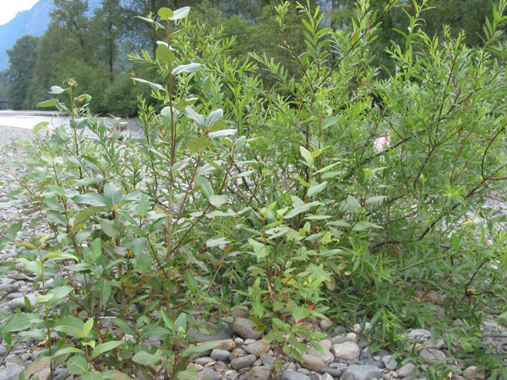

**Nitrogen Fixation in Crop Plants and Grasses**

* Endophytes from wild poplar and willow are able to colonize some crop and grass cultivars
* Research Scientist III, Zareen Khan, demonstrated dramatic improvements in plant growth upon inoculation of turfgrasses, bell pepper, and tomato with the endophytes of wild poplar and willow.
* Undergraduate researchers demonstrated that inoculation of specific grass lines with the N-fixing endophytes resulted in increased N content as well as increased growth, suggesting that the endophytes are able to fix nitrogen within the plants and benefit the host directly. There was also increased drought tolerance in the inoculated plants versus the uninoculated controls.
* Project status: We have new funding from NIFA to study the impacts of using N-fixing endophytes on corn, rice and Douglas-fir for climate change mitigation.

Knoth, J., Kim, S.H., Ettl, G., and Doty, S. L. 2012. Effects of cross host species inoculation of nitrogen-fixing endophytes on growth and leaf physiology of maize. *GCB Bioenergy* (in press).

Khan, Z., Guelich, G., Phan, H., Redman, R., and Doty, S. L. 2012. Bacterial and yeast endophytes from poplar and willow promote growth in crop plants and grasses. *Agronomy* (in press)

Figures: Grasses and bell pepper that were inoculated (left) with endophytes from poplar and willow grew better than uninoculated controls in nutrient-limited soil.

UNINOCULATED

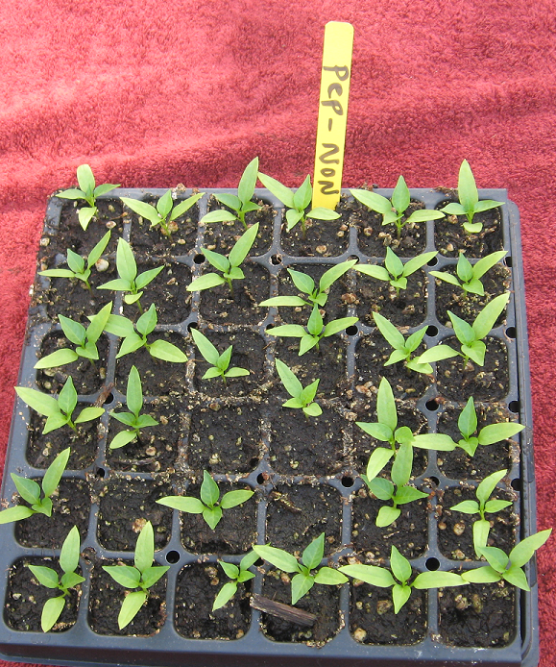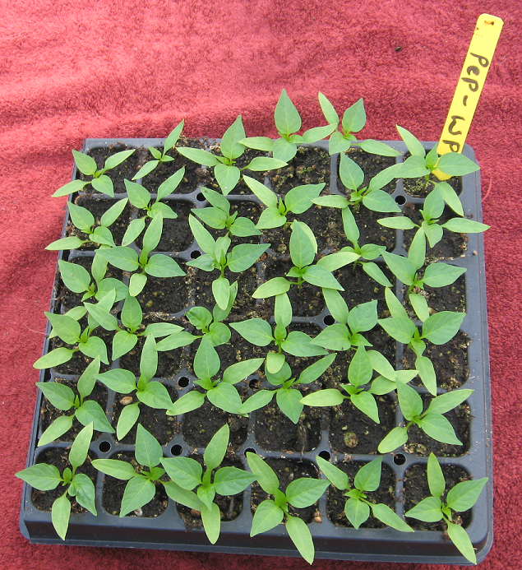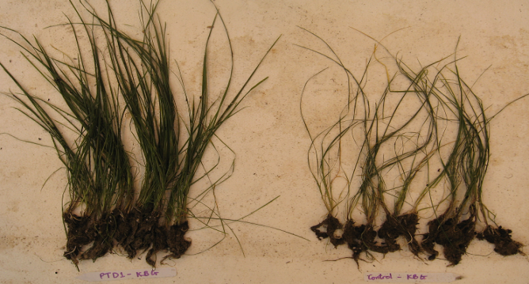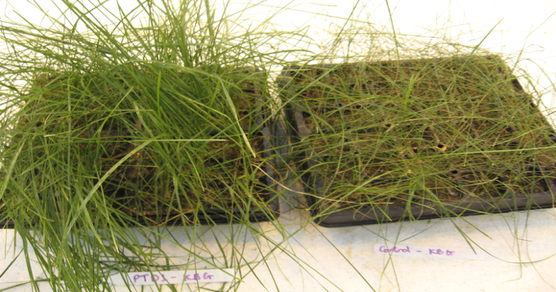

**Nitrogen Fixation in Conifers**

* Pioneer plant species colonize newly available land following volcanic eruptions, glacial retreats, flooding, and severe fires. Although some are legumes with N-fixing root nodules, little research has been done to explain the presence of pioneer species that do not have root nodules. Endophyte research is fairly new and has not yet been done to address this phenomenon. It may be that all such plants, like wild poplar and willow, are able to colonize new land due to superior partnerships with endophytes.
* It was recently discovered that lodgepole pine and western red cedar have N-fixing endophytes that provide this essential nutrient. Research on the N-fixing endophytes of Douglas-fir is an exciting new project in the lab with enormous forestry benefits.

