University of Washington / Fred Hutch
Center for AIDS Research (CFAR)

2024 Request for Applications (RFA)

International Infrastructure Grants

Key Deadlines | Date
RFA Release Date | March 25, 2024
Applications Due | June 18, 2024

See the following pages for a description of the award program and application process.

International Infrastructure Awards

Purpose
Infrastructure awards are designed to build capacity for UW/Fred Hutch CFAR international HIV research activities. The awards generally benefit multiple studies and/or investigators within a single research site. They can be used to renovate facilities and purchase supplies and equipment that contribute to the execution, efficiency and development of research projects.

Eligibility
Applicants must:
    - Be a UW/Fred Hutch CFAR member
    - Have an MD or PhD or equivalent terminal degree (includes an MBChB).
3) Have an appropriate affiliation, as follows:
        - Be appointed at, or being recruited to, a UW/Fred Hutch CFAR affiliate institution (University of Washington, Fred Hutch, Access to Advanced Health Institute, Seattle Children’s, University of Hawai’i at Manoa), OR
        - Be a citizen or permanent resident of an Eligible Low or Middle Income Country, and have a primary mentor appointed at a US-based UW/Fred Hutch CFAR affiliate (University of Washington, Fred Hutch, Access to Advanced Health Institute, Seattle Children’s, University of Hawai’i at Manoa).

CFAR values diversity and encourages individuals from underrepresented groups to apply.

Types of Projects
We encourage applications for items that are not readily purchased on a typical research grant and that promote collaborative and innovative HIV research. Past awards have included a back-up generator at a research clinic, classroom renovations and security improvements, statistical software, IT equipment for distance learning, laboratory equipment and data management supplies. Priority will be given to projects that can demonstrate local institutional support, either through matching funds or in-kind support. All projects must be completed within one year of approval.

Examples of past awards can be found here.

Funding Available
Direct costs: Up to $10,000 per project. Per revised NIH guidelines, funding for minor alterations and renovations at international sites is allowable. Funding cannot be applied to new construction or activities that would change the "footprint" of an existing facility (e.g., relocation of existing exterior walls, roofs, or floors, attachment of fire escapes), indirect costs/F&A, salary support or computers.

Review Criteria
- Value added to existing research projects
- Need (and lack of other sources to fund the request)
- Collaborative benefit for multiple projects
- Relationship to UW/Fred Hutch CFAR affiliate institution (University of Washington, Fred Hutch, Access to Advanced Health Institute, Seattle Children’s, University of Hawai’i at Manoa)
- Relevance to underserved populations
- Potential for new collaborations & research projects
- Local institutional support

Improvements that would support multidisciplinary projects are encouraged and are defined as improving infrastructure for 2 or more investigators that have differing areas of expertise or different research focuses.

Pre-Award Requirements

Per NIH policy, UW/Fred Hutch CFAR may not release funds for international awards until awardees complete the NIH administrative clearance process. This process often takes more than one month, so please consider it in your timeline. More information on NIH requirements for international studies can be found at: https://grants.nih.gov/grants/foreign/index.htm

**Projects that are unable to complete the NIH clearance process within one year of award date are at risk of losing funding**

Post-Award Requirements
All recipients must provide a one-page report detailing how their grant was applied. Photographs of the item in use are required. All manuscripts or publications resulting from CFAR support should acknowledge CFAR. See here for suggested wording.

Application Instructions
Complete the CFAR IIA Application Submission Form by June 18, 2024 using the application template below. Individual application sections may be expanded, but the overall proposal should not be more than 3 pages in length. Applicants are required to also submit their biosketch and quotes from vendors to support the requested amounts in the budget.

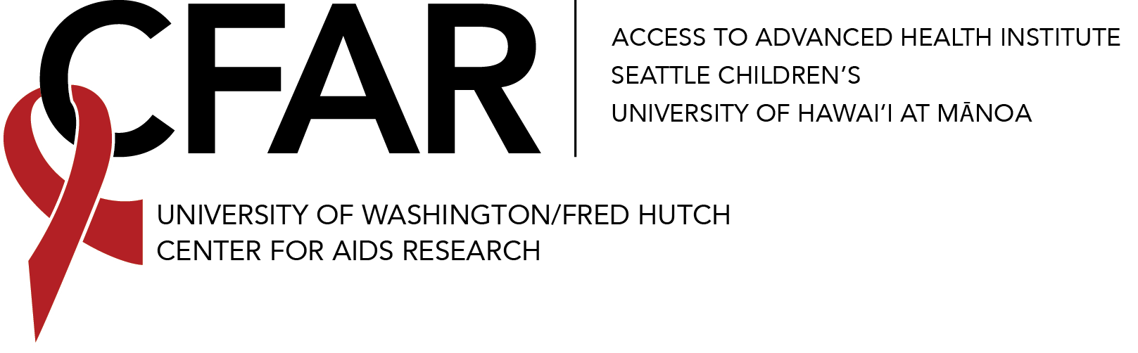
UW/Fred Hutch Center for AIDS Research
2024 International Infrastructure Award Application Form

Principal Investigator
Name:
Academic Title:
Primary Institution/Organization:
Address:
City: | State: |  |  | Zip:
Phone: | Fax: |  |  |  | Email:

UW/FH CFAR Faculty Partner (if external applicant)
Name and Title:
Organization:
Address:
City: | State: | Zip:
Phone: | Fax: |  | Email:

Please describe the site and circumstance necessitating the proposed activities:

Detailed Description of Proposed Actions, including information on local institutional support:

How will the activities impact the international site?

Please list UW/Fred Hutch CFAR linked projects and researchers that will utilize the infrastructure:
PI | Title | Grant Number | Grant Source  (NIH, etc)

What are other potential funding sources for your project? If none, please explain briefly.

Budget:
Item | US Dollar Amount
Total

**Attach a copy of your biosketch and vendor quotes to support your budget.**

Submit your application using the CFAR IIA Application Submission Form by June 18, 2024 at 11:59pm PDT. Please be prepared to provide the following information:

- Upload Application (single PDF (preferred) or MS Word file), including biosketch and vendor quotes to support your budget.

- Principal Investigator Name (Last, First)

- Email

- CFAR Membership Status
  - I am a CFAR member.
  - I have completed the CFAR membership form and am awaiting confirmation.

- Optional Investigator Demographic Information section. To facilitate completing the online form, we list the included questions below for your information.

  - PI Name (used solely to compare aggregate applicant pool and awardee pool data)
  - Gender identity(ies) (Indicate or DECLINE TO STATE)
  - Racial category(ies) (Indicate or DECLINE TO STATE)
  - Ethnic category(ies) (Indicate or DECLINE TO STATE)
  - NIH disabled? (YES/ NO/ DECLINE TO STATE)
  - NIH disadvantaged? (YES/ NO/ DECLINE TO STATE)

NOTE: The demographic information provided is confidential and will not affect consideration of your grant application or access to services. Reporting the requested information is voluntary. Additionally, as part of UW/FH CFAR’s commitment to diversity and inclusion, this form enables applicants to describe their gender(s) beyond the binary options provided by our funders.

