Description | Primary Student Activities | Materials | Objectives | Assessments | EALRs Addressed:  History/Social Studies
This lesson is designed to develop a deeper understanding of what it means to be a part of the documentation and creation of history. Students will understand what the Chicano Movement was, and also how those involved impacted the movement through their art. | Students will:  - Engage in group discussions  - Analyze a piece of art (primary source)  - Understand different perspectives  - Draw conclusions  - Create works of art | - Projector  - Copies/Photos of the mural  - Copies of the poem excerpt  - Mural making materials:  (paper, pencils, wood, paint, brushes) | a. Students will understand the role of art in history.  b. Students will be able to draw connections between Latinos and other historically repressed groups. (middle/high School)  c. Students will understand outlets for protest and resistance. | a. Students will demonstrate their understanding of the role of art in history by creating their own pieces of art to reflect a current event/theme.  b. Students will demonstrate their ability to connect Latinos and other historically repressed groups by participating in small group discussions with prompting questions.  c. Students will demonstrate their understanding of protest outlets by answering questions after the narratives. | 4.2.1 Understands and analyzes how individuals caused change in Washington State history.  4.2.2 Understands and analyzes how cultures and cultural groups contributed to Washington Stat  4.3.1 Analyzes and interprets historical materials from a variety of perspectives.  1.4.1 Understands civic involvement.

UW Chicano Mural:
Targeted Length: Three 30-Minute class periods

Created by Danielle Woods (ELTEP) and Gonzalo Guzman (EDLPS)
www.civilrights.washington.edu

Introduction for teachers:

The Chicana/o Movement in Washington State or the Latina/o Civil Rights Movement in many ways mirrored the hub of Chicana/o activism located in the Southwest United States. Chicanos/as or Mexican American activists in Washington State rallied for reforms in education in both the secondary and higher education front, labor rights(especially concerning agricultural work), and combined their movement with the national arts and United Farm Workers movement of the time. A cultural expression explosion accompanied the political movement of the time. Nothing displayed the cultural component of the Chicano/a Movement more so than the muralist movement.

The Chicano Art Movement was centered in Seattle and the movement is clearly visible through the number of murals on the University of Washington campus. The art movement in Washington State was centered on the work of Chicano/a youth. Like much of the Civil Rights movements of the period, by the end of the 1970s much of the activism and art of the Chicano/a Movement, encountered setbacks and lost much of its original energy. The Chicano Art Murals are a vivid reminder of the power youths had in enacting change both on political and cultural front in a short time span.

For more background teachers should read “The Chicano Movement in Washington State 1967-2006” by Oscar Rosales: http://depts.washington.edu/civilr/Chicanomovement_part1.htm

Instructor
Students will go to the “Chicano Cultural Awakening: The Chicano Art Movement in Pacific Northwest” section: http://depts.washington.edu/civilr/Chicanomovement_part2.htm

Steps:

1. Hook
a. Activate prior knowledge of mural: “A mural is a large piece of art that an artist will display in a public place, like on the side of a building, inside a school or hospital, somewhere where lots of people will get to see it. The artist usually has a story to tell, something important they want the world do know about.”

b. Teacher shows students a photo of NW Mural: Show students the three images of the mural “Aztlan” (1971) by Emilio Aguayo: http://depts.washington.edu/civilr/mecha_photos.htm
(See Appendix A)

c. Initiates large group discussion
“What do you think is going on here? What does the artist want to say? Why? What makes you say that? What do you see that tells you that?”
Students view oral history video of Emilio Aguayo (http://depts.washington.edu/civilr/aguayo.htm)

2. Mini-Lesson/Lecture
a. Teacher describes historical context in a narrative, describe a Mexican American student in Seattle during the late 1960s/70s

Narrative:
- Before reading review vocabulary: immigrant
- This is not to be simply read to students. This is an example of information you could use to build a character that would be relatable to your students. Use visuals to enhance it, use music…make it creative and work for your classroom!

Elementary Example:
My name is Gloria; my parents are immigrants from Latin America. When I watch TV I see lots of people like me marching around in the streets saying “We need better schools!” My classroom has lots of kids, so many that sometimes I share my desk with my friends. My teacher says we have to be careful with our books because lots of pages are missing and we have no money for new ones. My mom says that it’s too dangerous for me to go march in the streets but I wish everyone knew that my school needs help. I wish I could show them and tell them.
(Class Discussion: “How could Juan let lots of people know his school needs help?” Teacher elicits responses, leads toward idea of using large scale art, like the UW Mural as a possibility.)

High school example 1:
Imagine you are a Mexican American student at the University of Washington during the late 1960s. You are part of the first class of Mexican Americans to ever go to the University of Washington. All over the media (TV and newspapers) you see students just like you in the streets protesting for access to better education and to support farm workers. However, most of the protests you see are not in Washington State, they are in California. Many of the same issues your people (friends and family) are protesting against are the same problems you see in Washington State and on the UW campus. But you don’t have the same numbers or the support that many of the people in California do. You feel like you can’t protests against many of the injustices you see the same way as those in California, however, you still feel the need to protest.[What creative could you express your frustration with the injustices you see in Washington State?]

High School Example 2
Read an excerpt from “Yo Soy Joaquín” by Rodolfo Corky Gonzales (last stanza)
…  I have endured in the rugged mountains  Of our country  I have survived the toils and slavery of the fields.  I have existed  In the barrios of the city  In the suburbs of bigotry  In the mines of social snobbery  In the prisons of dejection  In the muck of exploitation  And  In the fierce heat of racial hatred.  And now the trumpet sounds,  The music of the people stirs the  Revolution.  Like a sleeping giant it slowly  Rears its head  To the sound of  Tramping feet  Clamoring voices  Mariachi strains  Fiery tequila explosions  The smell of chile verde and  Soft brown eyes of expectation for a  Better life. | And in all the fertile farmlands,  the barren plains,  the mountain villages,  smoke-smeared cities,  we start to MOVE.  La raza!  Méjicano!  Español!  Latino!  Chicano!  Or whatever I call myself,  I look the same  I feel the same  I cry  And  Sing the same.  I am the masses of my people and  I refuse to be absorbed.  I am Joaquín.  The odds are great  But my spirit is strong,  My faith unbreakable,  My blood is pure.  I am Aztec prince and Christian Christ.  I SHALL ENDURE!  I WILL ENDURE!

Class Discussion:
(“What does this poem reveal about this time in history? What does Joaquin’s story reveal? How does he feel?” Why?”)

3. Follow up Assessment
a. Elementary: “Draw a picture and write a sentence describing how Gloria feels.”
(Scaffold the writing portion by giving them sentence prompts appropriate to grade level)

b. Middle/High School: In small groups, come up with answers to the following questions;
1. “From the poem or from the student description, tell me what the key themes are. Be specific! (What are the authors asking for, what are they demanding? For example, better schools etc…)
2. “What similarities or differences do you see between the Chicano Movement and the Black Civil Rights Movement?”
3. “Whose voices are not being heard in this narrative?” (Women, Lesbian Gay Bisexual Transgender Queer (LGBTQ))

4. Large group debrief
a. “Now what do you think this mural can tell us?”

5. Assignment: Choose one
- Students choose a topic of protest for which to build a class mural about
(See information about building a class mural below)
- Teachers may want to select a topic or offer a selection of topics to choose from, thinking of themes that are important to your classroom/school’s culture
- Class maps out a mural to create in chalk (on the playground)
- Have students work in small groups or independently to create their own mural ideas on paper
- Students do an excursion to the University of Washington and find the murals listed in the “Chicano Cultural Awakening: The Chicano Art Movement in the Pacific Northwest”. The majority of the murals can be found in the Ethnic Cultural Center on the UW campus. Have students visit the sites and write a response to the following question: “What do you think the artist was trying to tell us about the Chicana/o Movement?”
(This can be done as a whole class brainstorming activity for younger grades)

* All assignments should have a writing component.
A possible prompt could be “We chose to make a mural about…because…” Or “Our mural is similar to Emilio Aguayo’s mural because…”

Making a Class Mural
Why:
Build community (this goes for your class, and for the space in which you display your mural!)
Increase confidence of individuals and the class
Expand the understanding of history and who makes it
Enact social action in your classroom
Link creativity and art to history
How:
Find a location
(This can be done on a large sheet of butcher paper, or a piece of wood to be hung afterwards, if no direct wall space is available)
Create a theme/decide on a topic
Students draw ideas
Teacher helps mix and match ideas
Create master blueprint (put all ideas together)
Teacher sketches out on the final space
Students fill it in (like a coloring book!)
Seal the paint and display!

Appendix A: “Aztlan” (1971) by Emilio Aguayo, Ethnic Cultural Center, University of Washington
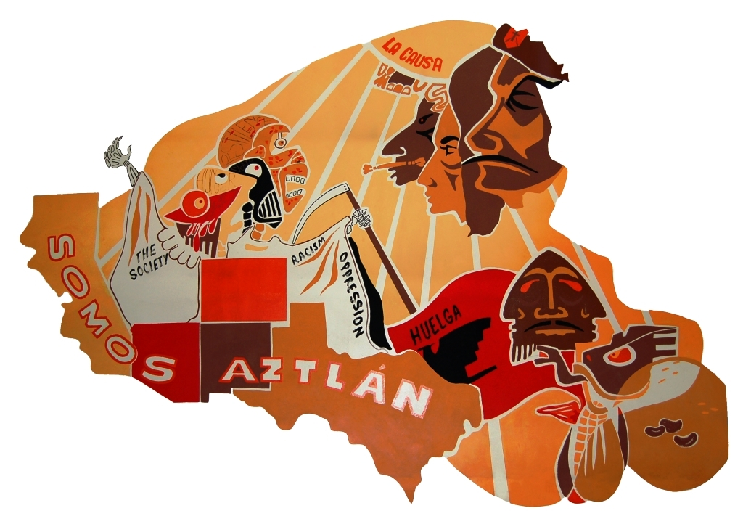
Name_____________________________

Draw a picture of how Gloria feels.

I think Gloria feels____________________ because ________________________________________________________________________________________________________

Name_______________________

1. Key themes of “Yo Soy Joaquín”
__________________________
__________________________
__________________________
__________________________
__________________________
__________________________

2. Similarities/differences between Chicano/a Movement and Black Civil Rights Movement
Similarities | Differences

3. Is anyone not represented?
____________________________________________________________________________________________________________________________________________________________________________________________________________________________________________________________________________________________________________________________________________
__________________________________________________________________________________

Gonzalez, R. “I am Joaquin.” http://www.latinamericanstudies.org/latinos/joaquin.htm
Adapted from Osumi, T. 2004. Murals/Art Projects. “Making Murals, Making History a Mural Making Guide for K-12 Teachers.” http://www.kuidaosumi.com/murals/muralguide.html

