Non-Example #1
For most of its history Seattle was a segregated city, as committed to white supremacy as any location in America. People of color were excluded from most jobs, most neighborhoods, and many stores, restaurants, and other commercial establishments. As in other western states, the system of severe racial discrimination in Seattle targeted not just African Americans but also Native Americans, Asian Americans, Pacific Islanders, people of Mexican ancestry, and also, at times, Jews.
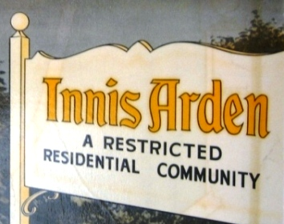
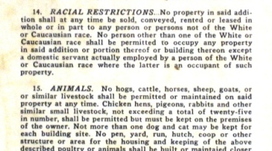
Non-Example #2

“Before AIM (American Indian Movement), Indians were dispirited, defeated, and culturally dissolving. People were ashamed of being Indians. You didn’t see the young people wearing brands or chokers or ribbon shirts in those days. Hell, I didn’t wear ‘em. People didn’t Sun Dance, they didn’t sweat, they were losing their languages.”

Quote by Russell Means

Source: Menkart, M., Murry, A., & View, J. (Eds.). (2004). Putting the movement back into civil rights teaching: A resource guide for K-12 classrooms, p. 195. Washington, D.C.: Teaching for Change

Non-Example #3

“I grew up my early years going from labor camp to labor camp. We would work in Washington cutting asparagus and then go and eventually we bought our own truck. [Then we would] get [in] our truck and drive down to Oregon to Willamette Valley and pick beans and then drive down to California and pick cotton with the big companies in California during the winter and then come back in the spring and follow the same routine. So as a child I grew up going from school to school, and the first grade I think I started while I was here in Washington in the spring and I flunked the first grade ‘cause I didn’t know any English, and there were no programs or anything to make up for the fact that you couldn’t understand what they were saying…
Most of the work- at least the stoop labor - was either by piece rate, like in the asparagus, or by the hour, and the wage never was more than the minimum wage. It was just the minimum wage all the time. There were no benefits and at that time farm workers didn’t have any unemployment or at least, in Washington, very few social services. So people worked, pooled their resources [and] tried to save money for periods when there was no employment. And it was hard work and there were a lot of indignities, because you could be fired at any time. There were no toilets in the fields or water provided for the workers. The worker basically had no say. So that’s the background—a lot of hard work [and] very low pay. If the grower didn’t like the work you were doing, he wouldn’t pay you and you’d be fired.”
-Interview with Guadalupe Gamboa

Source: http://depts.washington.edu/pcls/ufw/interviews.htm

Non-example #4

In the weeks following the signing of Executive Order 9066 on February 19, 1942, the U.S. Army issued exclusion orders requiring "all persons of Japanese ancestry" to vacate their communities. They had only days to prepare to leave their homes. The state fairgrounds had been converted to an "assembly center" surrounded by barbed wire and guarded by armed soldiers. Many houses formerly owned by Japanese-Americans were vandalized and defaced.

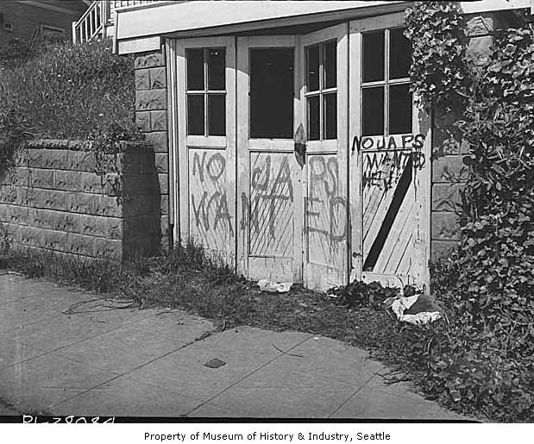

Source: http://depts.washington.edu/civilr/after_internment.htm

