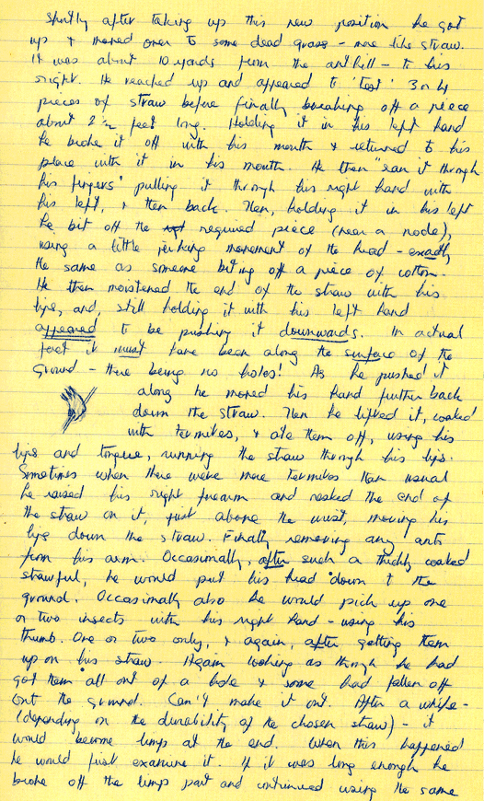



**Reference**

The Jane Goodall Institute. (2015). *Gombe Street View*. Retrieved April 17 from

http://www.rootsandshoots.org/streetview