**From:** York, Tammy <[Tammy.York@seattlechildrens.org](mailto:Tammy.York@seattlechildrens.org)>   
**Sent:** Friday, September 11, 2020 9:55 AM  
**Subject:** EPIC: Go Live instructions: Telehealth provider instructions

Hello,

Here is a resource for this group to support the learning of the telehealth information for GO Live. There is patients in the playground for practice and then specific instructions for Oct 3 and after.

1. Telehealth patients in PLY all have middle name ‘telehealth’.  Search ‘telehealth’ in name field  
   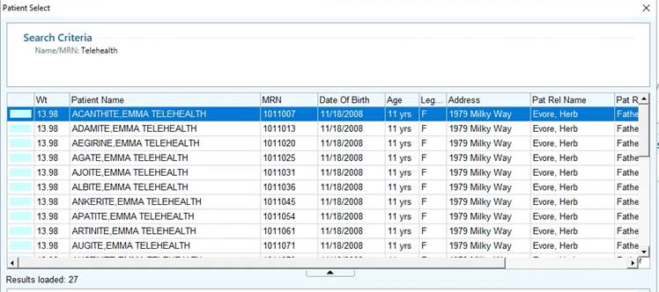  
   or via the PULSOU schedule  
   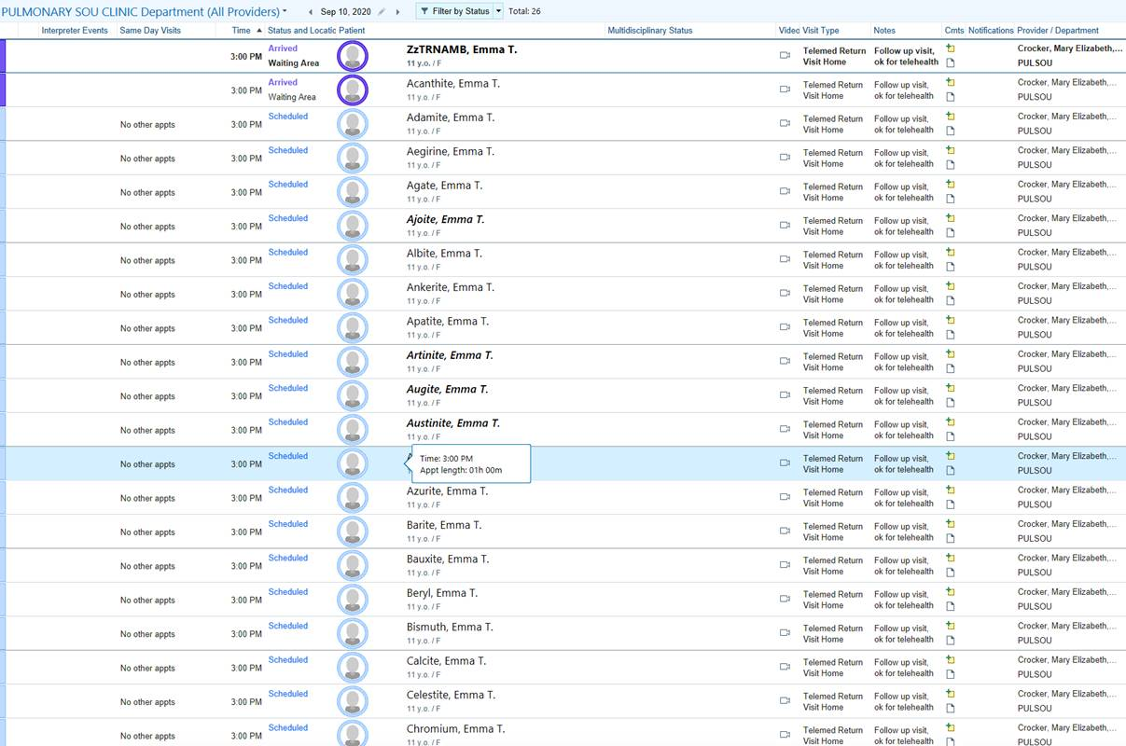
2. We have identified an issue in the PLY environment where the “Connect” button is not working.  The Epic Team is working on this and will let us know when it is fixed, but it will not be available on Saturday.
3. I will be your contact/resource this weekend.  How should I connect?  Is there a Webex you all are using?

# Following is a snippet from the future state Provider Training Document that illustrates how to launch the visit from Hyperspace.  I thought it would be helpful to provide this so you at least have a visual of what the experience would look like even if you are unable to launch from the button.

# Connecting to a Video Visit

1. LaunchEpic Hyperspace from the desktop.

**If you are not at Seattle Children’s or are using a personal device at a Seattle Children’s location**,Epic can be launched from the Favorites or Apps tab of the Citrix receiver/workspace.

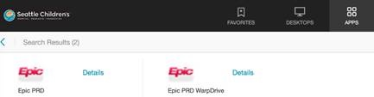

1. Navigate to your Epic schedule
2. Identify the telehealth home video visit appointment on your Epic Schedule

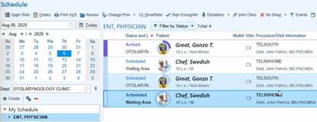

1. Double-click the video icon  in the video column to launch the video visit. The video icon will turn green when the patient has entered the virtual waiting room.

**If you would like to review the patient’s chart before the video visit,** double-click the patient’s row on the schedule.

1. When you are ready to connect, click on the Telemedicine tab. 

If you do not see the Telemedicine tab, click on the three dots and select Telemedicine from the drop down.

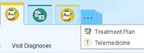

On the Telemedicine tab, it will show the users that are connected via Zoom and if the Telemedicine Consent has been signed.

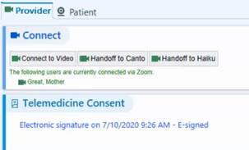

1. Click **Connect to Video** to launch the video visit.**To send the video visit to an iPad,** click **Handoff to Canto. To send the video visit to your mobile phone,** click **Handoff to Haiku.** Group video visits can not be handed off to a mobile device.

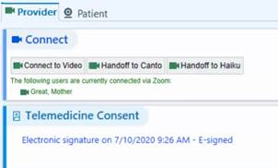

If the**patient** is having difficulty connecting at the time of the video visit.  The Patient video visit link can be sent to the patient by clicking on the Patient tab.  Then click **Copy patient link.**

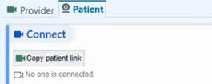

When the link is copied, the **Link copied to Clipboard** window will appear.  Click OK, then paste the link into an email to the patient.

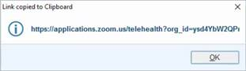

1. Click **open Zoom.us** when prompted to launch the Zoom app

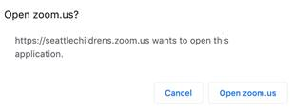

1. The Join Audio window will display.  Select **Join with Computer Audio**.  Check the Automatically join audio by computer when joining a meeting box to set the audio setting for future visits.

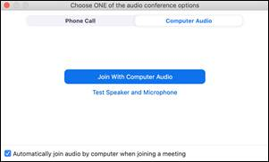

1. Once the patient has entered the waiting room, they can be admitted in one of the following ways:
   1. Clicking the blue Admit button that appears over the Participants icon

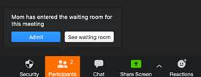

* 1. Clicking the Admit button in the Participants window on the right-hand side

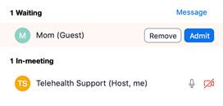

1. When the video visit connects, the patient will appear in the visit window.

|  |  |
| --- | --- |
| **Provider View When Connected** | **Patient View When Connected** |
|  |  |

1. Once all participants (patient/parents/legal guardian) have joined, the visit should be locked by clicking on the Security icon and selecting **Lock Meeting**.  This will not prevent other providers from joining a session.

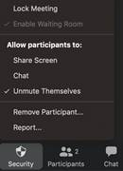

Participants attempting to join will receive the following message after the meeting is locked.  Other providers joining from Epic will still be able to join the video visit.

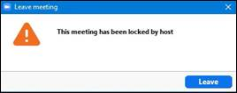

1. If the visit needs to be placed on hold, click More in the Participants window and select **Put in waiting room**.

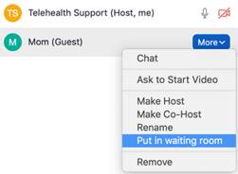

1. The patient will appear as waiting.  Click **Admit** to have them rejoin the visit.

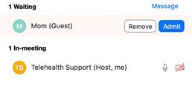

1. If for any reason a participant must be kicked out of a session, the host should click **More** in the Participants window and select **Remove.**

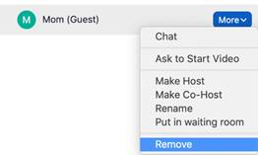

1. If a provider is the active host and must leave, he/she can transfer the host to another provider or other clinical staff in the session. Click **More** in the Participants window and select **Make Host.**  
   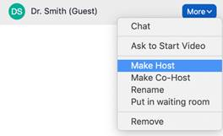

Then click on End and select **Leave Meeting**

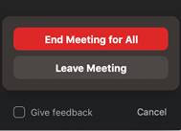

1. Once the video visit is complete, Click End and select **End Meeting for All**

