Today’s piece was prepared by Abby Koff, MD, based on a New York Times article Keeping the Fun in Children’s Sports.
The article begins by citing a new clinical report from the AAP, which summarizes many of the benefits of organized sports including gross motor skill development, development of life skills and positive social interactions, and encouraging physical activity. Given the increasing rates of childhood obesity and popularity of static pastimes such as video games, many parents and providers may assume that a child enrolled in a sport would be getting the physical activity needed, but according to an article on physical activity during youth sports practices, up to 43% of witnessed sports practice was inactive, and children were significantly more active during free play than during organized activity.
Regardless, the established benefits of organized sports, both as a tool for development and encouraging physical activity, cannot be overstated. However, the increasingly competitive nature of organized sports (both at the professional level and increasingly trickling down into the level of children’s sports), must also be cautioned against. The article emphasizes that it is the “fun” of the sport that keeps children engaged rather than “winning,” and cautioned that a balance of various forms of physical activity, as opposed to focusing solely on one sport/skill in particular was more beneficial to the child’s development, and less likely to result in “over-use” injuries and burnout.
As Pediatricians we can educate parents on both the benefits and potential pitfalls of organized sports, and emphasize that the more fun the child is having, the more likely the child is to continue reaping the many benefits sports have to offer.
RESOURCES FOR PARENTS ON SPORTS:
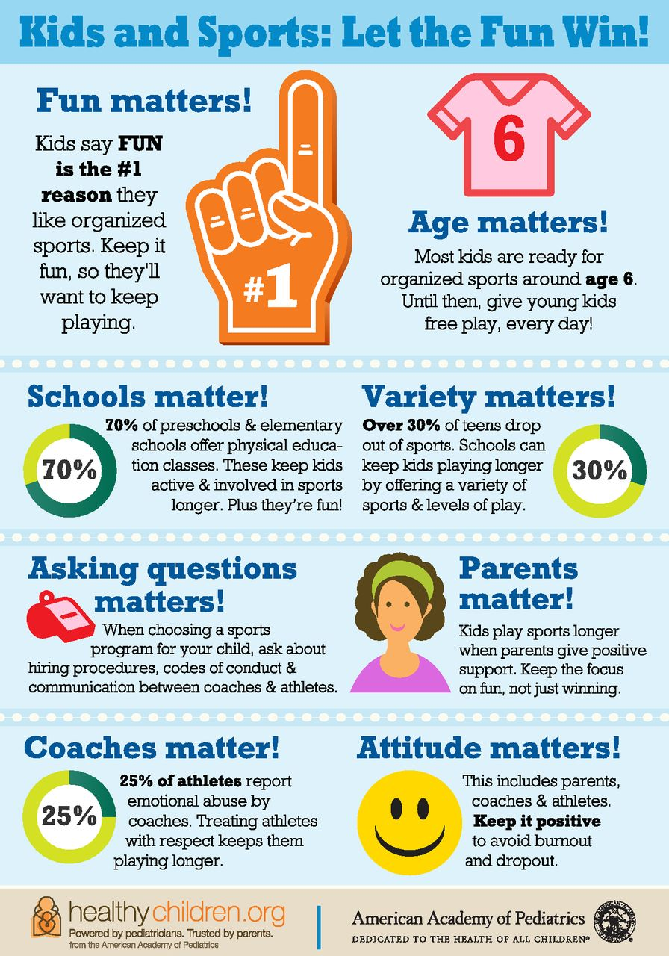
Kids and Sports: Let the Fun Win Infographic created by HealthyChildren.org, from the AAP, highlighting ways to keep children engaged in sports.(shown to the right)
Healthy Sports Index Tool developed to identify relative benefits and risks of participating in different sports, analyzing Physical Activity, Safety, and Psychosocial effects.
Parent Checklist American Academy of Pediatrics site, providing “Parent Checklist” to aid in creating a safe environment to prevent abuse in youth sports.

And that’s today’s Developmental & Behavioral Pediatrics: IN THE NEWS!

