Source: http://www.economist.com/node/21556230

Schumpeter

In praise of misfits

Why business needs people with Asperger’s syndrome, attention-deficit disorder and dyslexia
Jun 2nd 2012 | from the print edition
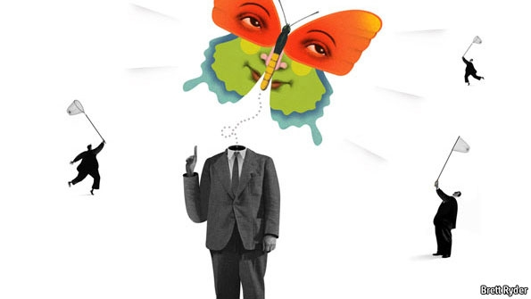
IN 1956 William Whyte argued in his bestseller, “The Organisation Man”, that companies were so in love with “well-rounded” executives that they fought a “fight against genius”. Today many suffer from the opposite prejudice. Software firms gobble up anti-social geeks. Hedge funds hoover up equally oddball quants. Hollywood bends over backwards to accommodate the whims of creatives. And policymakers look to rule-breaking entrepreneurs to create jobs. Unlike the school playground, the marketplace is kind to misfits.
Recruiters have noticed that the mental qualities that make a good computer programmer resemble those that might get you diagnosed with Asperger’s syndrome: an obsessive interest in narrow subjects; a passion for numbers, patterns and machines; an addiction to repetitive tasks; and a lack of sensitivity to social cues. Some joke that the internet was invented by and for people who are “on the spectrum”, as they put it in the Valley. Online, you can communicate without the ordeal of meeting people.
Wired magazine once called it “the Geek Syndrome”. Speaking of internet firms founded in the past decade, Peter Thiel, an early Facebook investor, told the New Yorker that: “The people who run them are sort of autistic.” Yishan Wong, an ex-Facebooker, wrote that Mark Zuckerberg, the founder, has “a touch of Asperger’s”, in that “he does not provide much active feedback or confirmation that he is listening to you.” Craig Newmark, the founder of Craigslist, says he finds the symptoms of Asperger’s “uncomfortably familiar” when he hears them listed.
Similar traits are common in the upper reaches of finance. The quants have taken over from the preppies. The hero of Michael Lewis’s book “The Big Short”, Michael Burry, a hedge-fund manager, is a loner who wrote a stockmarket blog as a hobby while he was studying to be a doctor. He attracted so much attention from money managers that he quit medicine to start his own hedge fund, Scion Capital. After noticing that there was something awry with the mortgage market, he made a killing betting that it would crash. “The one guy that I could trust in the middle of this crisis,” Mr Lewis told National Public Radio, “was this fellow with Asperger’s and a glass eye.”
Entrepreneurs also display a striking number of mental oddities. Julie Login of Cass Business School surveyed a group of entrepreneurs and found that 35% of them said that they suffered from dyslexia, compared with 10% of the population as a whole and 1% of professional managers. Prominent dyslexics include the founders of Ford, General Electric, IBM and IKEA, not to mention more recent successes such as Charles Schwab (the founder of a stockbroker), Richard Branson (the Virgin Group), John Chambers (Cisco) and Steve Jobs (Apple). There are many possible explanations for this. Dyslexics learn how to delegate tasks early (getting other people to do their homework, for example). They gravitate to activities that require few formal qualifications and demand little reading or writing.
Attention-deficit disorder (ADD) is another entrepreneur-friendly affliction: people who cannot focus on one thing for long can be disastrous employees but founts of new ideas. Some studies suggest that people with ADD are six times more likely than average to end up running their own businesses. David Neeleman, the founder of JetBlue, a budget airline, says: “My ADD brain naturally searches for better ways of doing things. With the disorganisation, procrastination, inability to focus and all the other bad things that come with ADD, there also come creativity and the ability to take risks.” Paul Orfalea, the founder of Kinko’s and a hotch-potch of businesses since, has both ADD and dyslexia. “I get bored easily; that is a great motivator,” he once said. “I think everybody should have dyslexia and ADD.”
Where does that leave the old-fashioned organisation man? He will do just fine. The more companies hire brilliant mavericks, the more they need sensible managers to keep the company grounded. Someone has to ensure that dull but necessary tasks are done. Someone has to charm customers (and perhaps lawmakers). This task is best done by those who don’t give the impression that they think normal people are stupid. (Sheryl Sandberg, Mr Zuckerberg’s deputy, does this rather well for Facebook.) Many start-ups are saved from disaster only by replacing the founders with professional managers. Those managers, of course, must learn to work with geeks.
Geekery in the genes
The clustering of people with unusual minds is causing new problems. People who work for brainy companies tend to marry other brainy people. Simon Baron-Cohen of Cambridge University argues that when two hyper-systematisers meet and mate, they are more likely to have children who suffer from Asperger’s or its more severe cousin, autism. He has shown that children in Eindhoven, a technology hub in the Netherlands, are two to four times more likely to be diagnosed with autism than children in two other Dutch towns of similar size. He has also shown that Cambridge students who study mathematics, physics and engineering are more likely to have autistic relatives than students studying English literature. Most employers are leery of hiring severely autistic people, but not all. Specialist People, a Danish firm, matches autistic workers with jobs that require a good memory or a high tolerance for repetition.
More broadly, the replacement of organisation man with disorganisation man is changing the balance of power. Those square pegs may not have an easy time in school. They may be mocked by jocks and ignored at parties. But these days no serious organisation can prosper without them. As Kiran Malhotra, a Silicon Valley networker, puts it: “It’s actually cool to be a geek.”

