Anesthesia Web Reports

Anesthesia reports for individual staff, for general operation and for administrators are now available on the [web](https://depts.washington.edu/docusys/Reports.html). Most reports are available for both UWMC and HMC. Report contents are:

# Reports for Individual Anesthesia Staff

These reports are accessible by all Anesthesiology staff, and show only cases for the user logged in.

MY CASES

My Current Issues: records that need attention in AIMS – open or suspended cases from previous days that should be closed, and overlapping cases where resident and CRNA should revise duty times.

My PeriOp Documentation: records that need attention in ORCA are on top - cases missing post-op notes, echocardiogram notes, or AIMS intra-op records. Includes all cases started 1 to 3 days ago.

My Costs: costs for bolus medications, infusions and inhalation agents by case.

My Cases Today: status, duty times, patient and procedure for cases started or still open today.

My Case Log: duty times, patient and procedure for cases from previous days.

My CVC Cases: central venous line placement cases from the last two years, for attendings.

MY QUALITY MEASURES

My Beta Blockers: for residents - success rate for documenting Beta Blockers, and list of failures.

My Antibiotics: on-time antibiotic administration for all cases, by month.

My Missed Antibiotics: just cases missing documentation of effective antibiotic administration.

My PONV: success at giving anti-nausea treatment appropriate for risk, and list of failed cases.

# Anesthesia Operational Reports

These reports are accessible by all Anesthesiology staff, but are not limited to your cases.

BILLING

**Professional Fee:** Checklist of all cases closed yesterday (or earlier, if you change the date).

**Facilities Billing:** Checklist of all cases closed or suspended yesterday (or earlier).

CASE ISSUES

**Monitor Summary:** cases from yesterday that are suspended, open, or have unassigned patient or attending.

**Staff Overlaps:** cases with one resident or CRNA signed in to two cases at the same time.

**Closing Delays:** Bar chart of records not closed within 48 hours, or within 7 days, by attending.

**PeriOp Doc Count:** Percent of cases with pre- and post-op notes by location for the last 6 months.

OR EVENTS

**OR Times by Day:** patient in & out of room, anesthesia start & end, procedure start & end, case delays.

**OR by Week:** OR times for a range of dates (one week’s worth by default).

**OR Time Lines:** Graphic display of OR times for a day, plotted on time lines.

# Reports for Administrators

These reports show all cases, and are accessible by the chiefs of Anesthesiology and other managers at each site.

PERI-OP DOCUMENTATION

**Missing Documentation:** cases where ORCA has no pre-op or post-op note, or no AIMS record.

**Yesterday’s cases:** cases missing documentation are shown on top. Missing echocardiogram notes from the last 30 days are listed first (usually only applies to UWMC). Then, for cases started yesterday, cases missing both the intra-operative record and post-operative note are listed, followed by those missing one or the other, followed by those which have both forms of documentation. The date of each case’s most recent pre-op note, if any, is shown.

**Missing Post-Op notes:** Only those cases from yesterday missing post-operative notes.

**Last 3 days cases:** cases from 1 to 3 days ago, with cases missing documentation listed first.

QUALITY MEASURES

**Monthly Staff Ranking:** Rank all staff by medication safety measures.

**Beta Blockers:** rate of Beta Blocker documentation success & list of failures for each resident, by month.

**Antibiotics, all cases:** overall and individual staff success rates (cases with on-time antibiotics / total cases) for first attending, residents and CRNA, plus antibiotic administration for each case for each first attending, by month.

**Missed Antibiotics:** just cases with missing on-time antibiotics documentation, by month.

**Antibiotics, 1 provider:** success rate and list of all cases for one staff member or for all members of a group (all attendings, all residents, or all CRNAs) by month.

**PONV Case Reports:** risks, treatments, outcome, medications and inhalation agents by case.

**Faculty Report:** counts of cases started and closed, and documentation success rate for anitibiotics, beta blockers, CVC precautions, induction and emergence sequence, close within 24 hours and no amendments after 24 hours.

**OR Dashboard:** quality measure success rates by month and division.

CASE LISTS

**Duty Hours and Case Logs:** duty start and end times and duration for each day, and each case, for 1 provider or a group of providers (e.g. all attendings), by month.

**Today’s Case List:** cases started today and cases not yet closed, by provider.

**Solo Duty Hours:** duty and solo duty start and end times and duration, for each case and for each day, for 1 attending or all attendings, by month.

**Duty Hours as Excel:** duty start and end times for each day, and each case, by provider by month, formatted for export as an Excel spreadsheet.

**CVC Cases:** count and list of central venous line placement cases over the last 2 years, by provider.

ANESTHESIA COSTS  
 Monthly Costs by Staff: costs of bolus medications, infusions, and inhalation agents by provider.

The Special Reports link has more reports for managers and IT support staff, including the Ad Hoc Reports tool for counting or listing cases by criteria of your own choosing.

.

# Access to Reports

# Browser Choices:

We used to recommend [**Firefox**](http://www.mozilla.org/en-US/firefox/new/) since it will properly ask for AMC user ID and password authentication from any computer, including Macs. However, Firefox does not work on the new SSRS server (as of Dec. 2019) so we now suggest **Chrome,** **Safari**, or **Internet Explorer (IE).** IE offers a “Print” button; in other browsers you would need to export the report to a file using the floppy disk icon, and print that. These **browsers** will properly ask for authentication when you run from an AIMS workstation (blue or grey desktop background). They will also work if you are logged on to another machine with your AMC user ID. But on kiosks (purple), personal machines, or offsite, you will have to use [SSLVPN](https://sslvpn.medical.washington.edu/) and go to the web site as below.

**For all browsers, you’ll need active scripting enabled to view reports.**

# Getting to the Site

From AMC machines, you can access the reports list through the Reports tab of the AIMS Support Website, or go directly to <https://depts.washington.edu/docusys/Reports.html>.

For non-AMC devices, you need to use [SSLVPN](https://sslvpn.medical.washington.edu/). Log in with your AMC username and password and click your Anesthesia Reports bookmark if you have one. The first time, you will need to add a bookmark: click the + sign in the “Web Bookmarks” header:

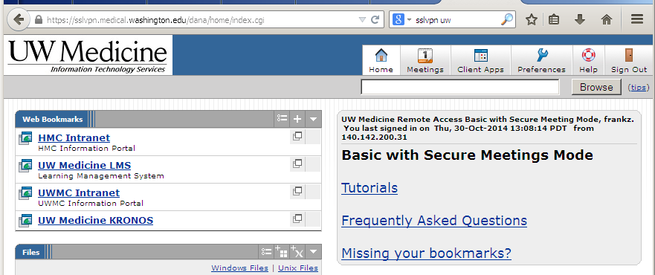

Fill in Bookmark Name as “Anesthesia Reports”, description (optional), and URL as <https://depts.washington.edu/docusys/Reports.html>. Then click the “Add Bookmark” button.

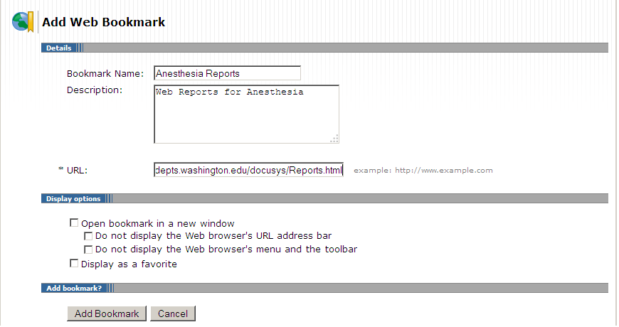

This adds the Anesthesia Bookmark permanently to your SSLVPN Web Bookmarks list. Click this link:

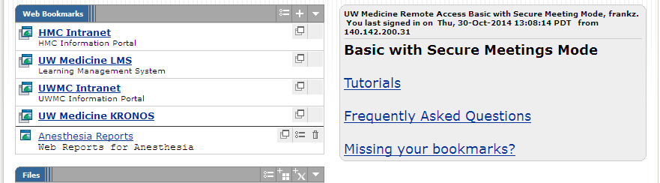

# Viewing the Reports

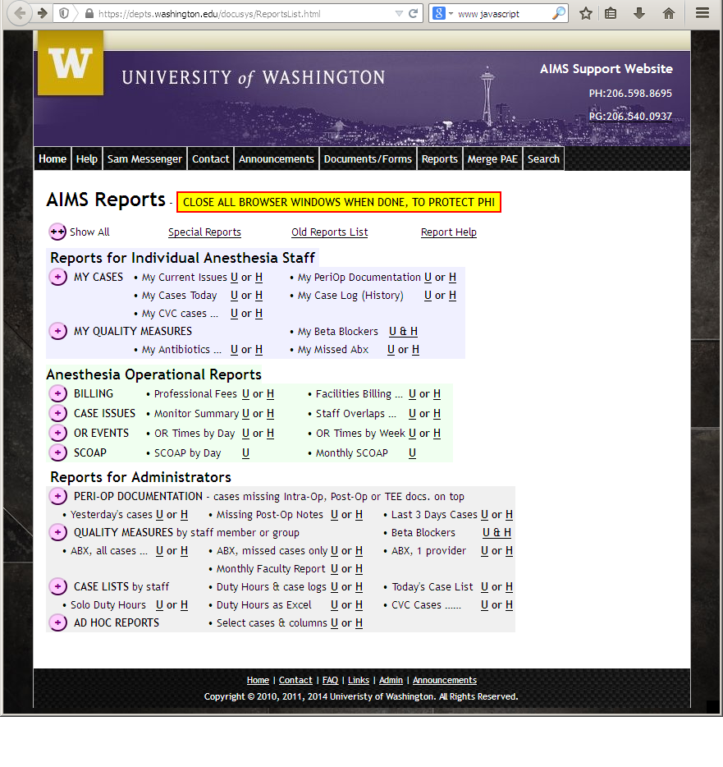 Click on the site initial (**U** or **H**) to view reports for UWMC or HMC. To show one-line descriptions for each report, click the **(++) Show All** button near the top, or click the individual (+) buttons in each section. The buttons will change to **(--) Hide All** and (**-**) as needed. The fully expanded list (Show All) looks like:

# 

# Special Reports

The Special Reports link brings up a page of reports with narrow audiences, e.g. for Teaching Concurrency, Nursing Concurrency, Residents Case List, CQI, Infection Control, and AIMS Support.

# Protecting Patient Privacy

All reports require AMC username and password login, either directly or from your workstation login. Once you have entered your credentials, the browser will remember them for the rest of the session – that is, until all instances of that browser have been closed on your workstation. Many reports include PHI, so it is important to follow the message displayed on the Reports list page:

**CLOSE ALL BROWSER WINDOWS WHEN DONE, TO PROTECT PHI**

This is especially important if you are not on a secure workstation, e.g. on a phone or laptop, but it is best to get into the habit of closing all browser windows when done so you don’t forget.

# Report Controls: date selection, page turning, printing

All reports have a header with controls to turn pages, print, and export reports to files; many reports also have a date or date range you can set:

|  |
| --- |
|  |

Many reports start off showing cases for the previous day or month. You can change the date or date range with fields on the upper left, then click “View Report” on the upper right to display cases for the new date(s).

For reports with many pages, use the arrows or number field in the lower left corner of the header.

Use the file icon in the lower center of the header to export the report as a PDF or Excel file.  
On Internet Explorer, the printer icon button prints the report legibly, though not in PDF format.

The “Back to Anes. Reports List” button takes you back to the full list of reports. Note that you might need to scroll back up to the top of a page to see this button, if you’ve scrolled down.

# Ad Hoc Reports

These reports allow you to select which fields to filter, show and sort, to construct your own reports.

You can count the number of cases in selected categories, then list those selected. Both “Count Selected Cases” and “List Selected Cases” have instructions followed by parameters for selecting columns to show or filter:

|  |
| --- |
|  |

By default, “Count Selected Cases” counts all cases in the year ending at the end of the previous month, giving you one row with an annual case count (~18,000). “List Selected Cases” starts off listing patient name, medical record number (MRN), date and time of service for just yesterday’s cases. For both reports, you can:  
 **1) Select a different date range  
 2) Select fields to show or to filter** (see below for details) **3) Press the “View Reports” button on the right.**

Remember you may have to press the “View Report” button **several times**, to run the report.

To see the top of the actual report, you may have to   
 - hide the instructions by clicking on the “Hide Instructions” link *e.g.* at the center top, or   
 - hide the fields using the small arrow in the center of the darker blue horizontal line just below the fields, or   
 - scroll down using the inner scroll bar.   
Both the “Count” and “List” reports include a button linking to the other report, so you can get a list of cases once you’ve got the count small enough. These buttons have the effect of shrinking the parameter fields list; you can expand it back up using the small arrow in the center of the horizontal bar above the report.

**Details on field selection:**

In “Count Selected Cases”, for all columns except Date, Age and ASA Class, your options are:

**<hide>** meaning do not include this column in the report at all;

**<SHOW>** meaning include this column, sort on it, and for “Count Selected Cases”, use it to group cases.  
 All cases with the same value in the shown columns are counted together.

Any other value in the selection list acts as a filter on this column; only cases with that value are included.  
 For Procedure Text, cases with the entered text anywhere in the Free Text Description are included.

**Do NOT filter by both Proc. Code and Proc. Type; filter on one and show the other if you want both.   
Each Proc. Type has a unique Proc. Code, so you don’t need to filter on both.  
Also, you risk filtering out all cases if you pick the wrong Proc Code for the Proc Type.**

For Age and ASA Class, the Min field controls whether the column is hidden, shown or filtered. If a value other than <hide> or <SHOW> is selected, then the Max field sets the upper bound of the range.

The “List Selected Cases” report has the same options as above. In addition, you can choose which patient information to show: none, just name, just MRN, or name and MRN. You can similarly choose to hide or show anesthesia start and end times.

Later versions of this report may include sorting control by clicking the column header. For now, you can export the report to Excel and sort there.

-- □ --