

**Key Populations Service Provision Training**

Blended Learning Course

**Workbook and Resources**

**August 2023**

**Name:** Click or tap here to enter text.

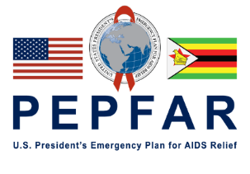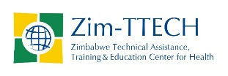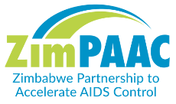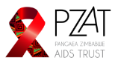

# Table of Contents

Table of Contents 3

Key Populations Service Provision Training Course Overview 4

Session One: Introduction to Providing KP-Friendly Services 6

Session Two: Providing KP-Friendly Services for MSM 9

Session Three: Providing KP-Friendly Services for TG Clients 13

Session Four: Providing KP-Friendly Services for PWID 17

Resources and Tools 21

The Genderbread Person 22

Tips for Building Rapport with Transgender Clients 23

Best Practices for Communicating with Transgender Clients 24

# Key Populations Service Provision Training Course Overview

Welcome to this course on service provision for key populations (KP). This course consists of a set of sessions and resources to support you in being a skilled, compassionate, and non-judgemental healthcare worker (HCW) who works with KPs.

UNAIDS reported in *The Path That Ends AIDS 2023, UNAIDS Global AIDS Update* that:

People from key populations face much higher risks of acquiring HIV than other members of society, including in regions where HIV prevalence is also high in the general population. In 2022, compared with adults in the general population (aged 15–49 years), HIV prevalence was 11 times higher among gay men and other men who have sex with men, 4 times higher among sex workers, 7 times higher among people who inject drugs, and 14 times higher among transgender people.

KPs include men who have sex with men (MSM), transgender individuals, sex workers, people who inject drugs (PWID), and people in prisons (PIP) and other closed settings. Due to specific higher-risk behaviours, these populations are at increased risk for HIV, irrespective of epidemic type or local context.

Zimbabwe has a history of marginalising KP groups. However, great strides have been made in ensuring equitable access to HIV and other health-related services in line with Government of Zimbabwe and Ministry of Health and Child Care (MoHCC) policies and guidelines.

To foster the creation of an enabling environment in which KPs can freely access services, it is of paramount importance that HCWs are equipped with the skills and knowledge about what comprises KP-friendly services, and are familiarised with the many facets of KP health, such as sexual health, HIV treatment and prevention, and mental health.

ZimPAAC has been working with MoHCC to address the stigma and discrimination that affect the provision of comprehensive, quality, and client-centred HIV prevention, care, and treatment services. Although training in providing KP-friendly services is already available, the need for development of additional skills has been identified.

This training will provide you with the skills and knowledge you need to apply theoretical learning and concepts in your work. This training is not meant to replace other trainings; rather, it is complementary and will help you make practical use of what you have learned. This course consists of an initial session that covers general KP practices that can be used with any of the groups discussed, plus sessions that are specifically designed to address some of the unique needs of MSM, transgender individuals, and PWID.

This KP Service Provision training has been organised into four short, practical sessions with content that you can directly use in your work. It will provide you with tips and actionable steps to take when working with KPs. It will also help you take complex issues and break them down into information that will support you in providing services for KPs.

These are user-friendly materials, developed with the recognition that HCWs have many roles and responsibilities. We hope that this will be an enjoyable learning experience for you!

**How to Use this Workbook**

This workbook is intended to accompany the Key Populations Service Provision Training self-study eLearning course; it provides pages to write notes as well as structured spaces for you to respond to questions and activities throughout the training.

Each eLearning session includes pre- and post-session assessments, and activities with written responses. Use the corresponding pages in this workbook to write responses to questions during the session and to jot down any notes or questions you have. Tools introduced through the training have been included as resources for you to use.

**Course Aim and Objectives**

The aim of this course is to build your skills to help you successfully provide care and treatment to KP clients.

By the end of this course, you will be able to:

* Have increased confidence to provide quality, non-judgemental healthcare to KPs.
* Become more sensitive about issues of stigma and discrimination as they relate to KPs.
* Be able to ensure that the human rights of KPs are being protected.

**Session Outline**

Session 1: Introduction to Providing KP-Friendly Services

Session 2: Providing KP-Friendly Services for MSM

Session 3: Providing KP-Friendly Services for Transgender Clients

Session 4: Providing KP-Friendly Services for PWID

**Course Material and Structure**

All of the learning materials for this course have been already loaded on your device, so you will not need an internet connection to access them. You will also be provided with a hard copy workbook to write down answers and take notes. If you were not given a workbook, it is available to download and print from the tablet. If you prefer an electronic version, you can access the word document in the resources. Additional resources are included at the end of each session, as well as in the Resources section of the course.

You will need about 1–2 hours to complete all of the learning activities for each session. Each session includes short pre- and post-tests. These are for your use only; you will not be turning them in. However, you can use the tests to identify content areas that you may need to review further.

Remember to have your workbook and a pen or pencil handy as you go through the session activities.

**Key Populations Content Experts and Contributors**

Throughout the training you will hear from experienced HCW, who will share information, tips and inspiration. We would like to thank all of these individuals for providing their wisdom and motivation. We would also like to give a special thanks to the PZAT Community Facilitators for their help in developing this material. Additionally, we would like to thank the I-TECH Trinidad team for sharing their knowledge and materials from the Key Populations Preceptorship training programme.

# Session One: Introduction to Providing KP-Friendly Services

|  |  |
| --- | --- |
|  | **Session Activities and Notes** |

**Pre-session assessment:** Use the space below to write your responses to questions as instructed in the quiz. After responding, click the “Show Feedback” button to score your response. Track your score for each question and take note of any content areas that you answered incorrectly. For multiple-choice and true/false questions, you don’t need to write your response in the workbook; it’s fine to just track your score.

1. Which of the following is **true** of KPs?

**Score**

1. Gender identity is outwardly visible.

**Score**

1. Why is it important to understand stigma in the KP context?

**Score**

1. Appropriate services for KPs at a public health facility include which of the following?

**Score**

**Session 1 Pre-session assessment Total Score**

**Reflecting on Values**

Looking at how you responded to the statements above, think about how you felt as you were reading them. Take a few minutes to jot down your thoughts using the following questions as a guide:

* What feelings came up for you while answering the questions?
* Did any of the statements make you feel uncomfortable?
* Did any of the statements have you questioning your own beliefs and attitudes?
* How do these attitudes affect us as health workers?

Click or tap here to enter text.

**Stigma We Have Experienced in Our Lives**

Think about a time in your life when you felt lonely or rejected for being seen to be different from others. It does not need to be related to HIV or key populations; it can be any form of stigmatisation for being seen to be different. If you cannot think of a personal experience, think about when you may have witnessed stigmatising behaviour towards people living with HIV, and imagine how they felt.

Think about what happened and how it felt. Answer the following questions:

* How did it feel to be stigmatised?
* How did it affect your life?

Click or tap here to enter text.

**Providing Healthcare Services for KPs: Reflection**

Take a moment to think about the facility you work in:

* Is it an environment that is welcoming and enabling to KPs?
* What can you do to help make it friendlier?

Click or tap here to enter text.

**Case Study: Mercy and Chiedza**

1. How should Chiedza handle the clerk’s disrespectful behaviour?
2. What can Chiedza do to help Mercy feel more comfortable?
3. What healthcare and screening needs may sex workers have?
4. In providing risk reduction counselling with sex workers, what should be covered?

Click or tap here to enter text.

**ACTION PLAN**

List 2-3 skills that you will do differently in your job from what you have learned this session.

|  |  |  |
| --- | --- | --- |
| **Skill I will change** | **What I am doing now** | **How I will improve** |
| Click or tap here to enter text. | Click or tap here to enter text. | Click or tap here to enter text. |
| Click or tap here to enter text. | Click or tap here to enter text. | Click or tap here to enter text. |
| Click or tap here to enter text. | Click or tap here to enter text. | Click or tap here to enter text. |
| Click or tap here to enter text. | Click or tap here to enter text. | Click or tap here to enter text. |

**Post-session assessment:** Use the space below to write your responses to questions as instructed in the quiz. Track your score for each question and take note of any content areas that you answered incorrectly. If you found that you had some gaps in your knowledge or understanding, think about what you can do to fill in those gaps for yourself, and what resources you can access.

1. Which of the following is **true** of KPs?

**Score**

1. Gender identity is outwardly visible.

**Score**

1. Why is it important to understand stigma in the KP context?

**Score**

1. Appropriate services for KPs at a public health facility include which of the following?

**Score**

**Session 1 Post-session assessment Total Score**

# Session Two: Providing KP-Friendly Services for MSM

|  |  |
| --- | --- |
|  | **Session Activities and Notes** |

**Pre-session assessment:** Use the space below to write your responses to questions as instructed in the quiz. After responding, click the “Show Feedback” button to score your response. Track your score for each question and take note of any content areas that you answered incorrectly. For multiple-choice and true/false questions, you don’t need to write your response in the workbook; it’s fine to just track your score.

1. Men who have sex with men are all homosexuals.

**Score**

1. Which of the following are considered psychological issues that impact MSM?

**Score**

1. What are some components of providing effective care for MSM?

**Score**

1. List at least three reasons why MSM are at greater risk of contracting STIs.

Click or tap here to enter text.

**Score**

1. Which of the following are key health issues that should be considered when working with MSM clients?

**Score**

**Session 2 Pre-session assessment Total Score**

**Munya: Reflection**

Think about what services for MSM look like in your facility. Write down two or three areas that can be improved for better service.

Click or tap here to enter text.

**Myths about MSM: Reflection**

Did you write down any of the same myths that were listed? Have you heard some of these myths and misconceptions before? Take a few minutes to think about your experience with how you have handled the situation when you have heard others say things that you know are not based in reality. If you have not experienced it directly with statements about MSM or gay people, how have you handled hearing myths about people living with HIV or other highly stigmatised health issues?

* Did you stay quiet?
* Did you speak up?
* Did you try to educate?
* How might you handle it differently now that you have more information?

Click or tap here to enter text.

**Case Study: Walter**

1. How do you deal with stigma related to same-sex behaviors in this client?

Click or tap here to enter text.

1. What is the strategy for providing this client with good clinical care given the limits he has set?

Click or tap here to enter text.

**ACTION PLAN**

Look back at the reflection activity from earlier in this session where you identified some areas that need improvement to deliver more effective health services to MSM.

List actions that you will take to help make improvements. Additionally, list any resources you will need and who will help and set a goal date for the change to be implemented.

|  |  |  |
| --- | --- | --- |
| **Service to Improve** | **How I will make improvements** | **Resources needed** |
| Click or tap here to enter text. | Click or tap here to enter text. | Click or tap here to enter text. |
| Click or tap here to enter text. | Click or tap here to enter text. | Click or tap here to enter text. |
| Click or tap here to enter text. | Click or tap here to enter text. | Click or tap here to enter text. |
| Click or tap here to enter text. | Click or tap here to enter text. | Click or tap here to enter text. |

**Post-session assessment:** Use the space below to write your responses to questions as instructed in the quiz. Track your score for each question and take note of any content areas that you answered incorrectly. If you found that you had some gaps in your knowledge or understanding, think about what you can do to fill in those gaps for yourself, and what resources you can access.

1. Men who have sex with men are all homosexuals.

**Score**

1. Which of the following are considered psychological issues that impact MSM?

**Score**

1. What are some components of providing effective care for MSM?

**Score**

1. List at least three reasons why MSM are at greater risk of contracting STIs.

Click or tap here to enter text.

**Score**

1. Which of the following are key health issues that should be considered when working with MSM clients?

**Score**

**Session 2 Post-session assessment Total Score**

# Session Three: Providing KP-Friendly Services for TG Clients

|  |  |
| --- | --- |
|  | **Session Activities and Notes** |

**Pre-session assessment:** Use the space below to write your responses to questions as instructed in the quiz. After responding, click the “Show Feedback” button to score your response. Track your score for each question and take note of any content areas that you answered incorrectly. For multiple-choice and true/false questions, you don’t need to write your response in the workbook; it’s fine to just track your score.

1. People of transgender experience are:

**Score**

1. Why are trans people at greater risk of acquiring HIV than the general population?

**Score**

1. True or False.
   1. A trans woman is a person who was assigned male at birth and identifies as female.
   2. Trans women may avoid seeking health services due to fear of discrimination and unease about the physical exam.
   3. All trans people are gay.

**Score**

1. Which of the following terms are appropriate to use in association with ‘transgender’?

**Score**

1. Which of the following are considered transgender health issues?

**Score**

**Session 3 Pre-test assessment Total Score**

**Thinking about Gender**

Take a moment to think back to your own childhood. Answer the following questions:

* What is an early message that you received about gender?
* Where did you hear this message?
* How did it affect you?

Click or tap here to enter text.

**Barriers Faced by Transgender Clients**

What barriers do you think transgender clients face in accessing healthcare? Write your thoughts below.

Click or tap here to enter text.

**Understanding Trans Identities and Issues: Reflection**

After watching this presentation, list two concepts shared in the presentation that you will incorporate into your work.

Click or tap here to enter text.

**Case Study: Sly**

1. What should the SIC do when she hears about how Sly was treated at the facility?
2. In a situation where a client like Sly feels mistreated by facility staff, what course of action do they have?
3. What can facilities do to make services more friendly to transgender persons?

Click or tap here to enter text.

1. When Sly shares about the abuse she is experiencing, what should the SIC do?
2. What measures can help in improving staff attitudes when working with transgender persons and other key population groups?

**Strategies to Overcome Barriers that Transgender Clients Face**

Earlier in the session we identified a number of barriers that transgender clients may face when accessing healthcare services.

List three strategies that you can employ to overcome some of the barriers mentioned (such as avoiding seeking primary healthcare services because of fear of discrimination or stigma, unease about the physical exam, lack of legal protection, and mental health issues such as depression, trauma, and substance use).

Click or tap here to enter text.

**ACTION PLAN**

List actions (at least two or three) that you will take to improve how you provide services for transgender clients. Additionally, list any resources you will need and who will help, and set a goal date for the change to be implemented.

|  |  |  |
| --- | --- | --- |
| **Actions for Improvement** | **Resources needed** | **Goal date** |
| Click or tap here to enter text. | Click or tap here to enter text. | Click or tap here to enter text. |
| Click or tap here to enter text. | Click or tap here to enter text. | Click or tap here to enter text. |
| Click or tap here to enter text. | Click or tap here to enter text. | Click or tap here to enter text. |
| Click or tap here to enter text. | Click or tap here to enter text. | Click or tap here to enter text. |

**Post-session Self-assessment:** Use the space below to write your responses to questions as instructed in the quiz. Track your score for each question and take note of any content areas that you answered incorrectly. If you found that you had some gaps in your knowledge or understanding, think about what you can do to fill in those gaps for yourself, and what resources you can access.

1. People of transgender experience are:

**Score**

1. Why are trans people at greater risk of acquiring HIV than the general population?

**Score**

1. True or False.
   1. A trans woman is a person who was assigned male at birth and identifies as female.
   2. Trans women may avoid seeking health services due to fear of discrimination and unease about the physical exam.
   3. All trans people are gay.

**Score**

1. Which of the following terms are appropriate to use in association with ‘transgender’?

**Score**

1. Which of the following are considered transgender health issues?

**Score**

**Session 3 Post-test assessment Total Score**

# Session Four: Providing KP-Friendly Services for PWID

|  |  |
| --- | --- |
|  | **Session Activities and Notes** |

**Pre-session assessment:** Use the space below to write your responses to questions as instructed in the quiz. After responding, click the “Show Feedback” button to score your response. Track your score for each question and take note of any content areas that you answered incorrectly. For multiple-choice and true/false questions, you don’t need to write your response in the workbook; it’s fine to just track your score.

1. Which of the following are potential health issues faced by PWID?

**Score**

1. Sharing syringes is the riskiest behaviour for getting HIV.

**Score**

1. A harm-reduction approach to reducing the HIV risk for PWID could include which of the following?

**Score**

1. Which of the following are basic principles of harm reduction?

**Score**

1. Why are PWID at greater risk of acquiring HIV or STIs?

**Score**

**Session 4 Pre-test assessment Total Score**

**Self-Reflection: Working with PWID**

What do you think are some of the consequences of strict laws against drug users?

Click or tap here to enter text.

**Providing Healthcare Services to PWID: Self-Reflection**

After watching the video presentation, answer the questions below:

* What has been your experience working with PWID?
* What did you find challenging about the experience?
* If you haven’t worked with any PWID, what is your biggest concern about providing services to this population?
* What will you be able to incorporate from the presentation into your practice to strengthen your skills in working with PWID?

Click or tap here to enter text.

**PWID and HIV**

Think about the relationship between HIV and PWID. Why are PWID at such great risk for HIV? Write your response below.

Click or tap here to enter text.

**Case Study: Quality**

1. What could Clara do to get Quality to begin sharing more information?
2. What needs to be included in the screening to determine PrEP eligibility?
3. What key messages do you think are appropriate for an injecting drug user at a public health facility where drug use is outlawed and no services specifically target this population? Write 2–4 messages below.

Click or tap here to enter text.

**ACTION PLAN**

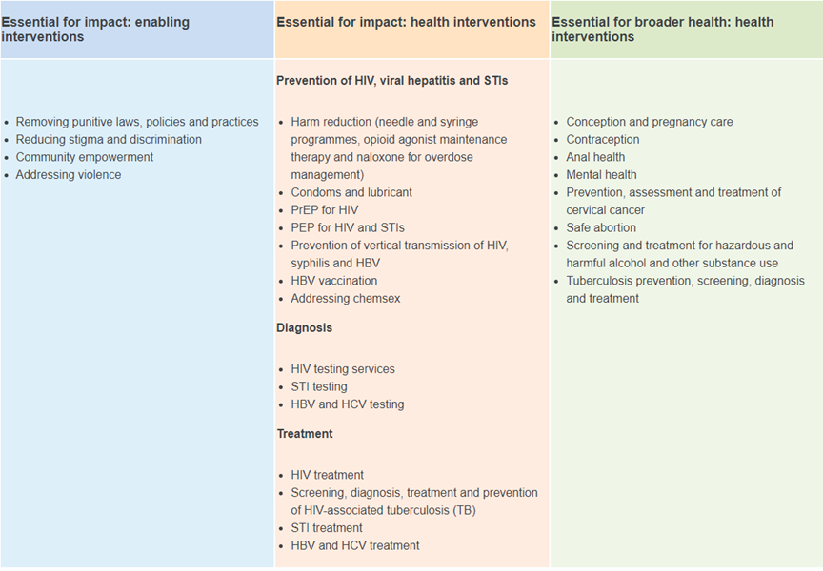

Looking at the WHO-recommended comprehensive package above, pick out a few items that you will work towards implementing in your facility. In your workbook, list the action you will take, a timeframe for doing it, and what support you will need.

|  |  |  |
| --- | --- | --- |
| **Action** | **Timeframe** | **Support needed** |
| Click or tap here to enter text. | Click or tap here to enter text. | Click or tap here to enter text. |
| Click or tap here to enter text. | Click or tap here to enter text. | Click or tap here to enter text. |
| Click or tap here to enter text. | Click or tap here to enter text. | Click or tap here to enter text. |
| Click or tap here to enter text. | Click or tap here to enter text. | Click or tap here to enter text. |

**Post-session Self-assessment:** Use the space below to write your responses to questions as instructed in the quiz. Track your score for each question and take note of any content areas that you answered incorrectly. If you found that you had some gaps in your knowledge or understanding, think about what you can do to fill in those gaps for yourself, and what resources you can access.

1. Which of the following are potential health issues faced by PWID?

**Score**

1. Sharing syringes is the riskiest behaviour for getting HIV.

**Score**

1. A harm-reduction approach to reducing the HIV risk for PWID could include which of the following?

**Score**

1. Which of the following are basic principles of harm reduction?

**Score**

1. Why are PWID at greater risk of acquiring HIV or STIs?

**Score**

**Session 4 Post-test assessment Total Score**

# Resources* and Tools

*Note: National documents are loaded into the application or can be accessed online.

The Genderbread Person 22

Tips for Building Rapport with Transgender Clients 23

Best Practices for Communicating with Trangender Clients Cheat Sheet 24

# **The Genderbread Person**

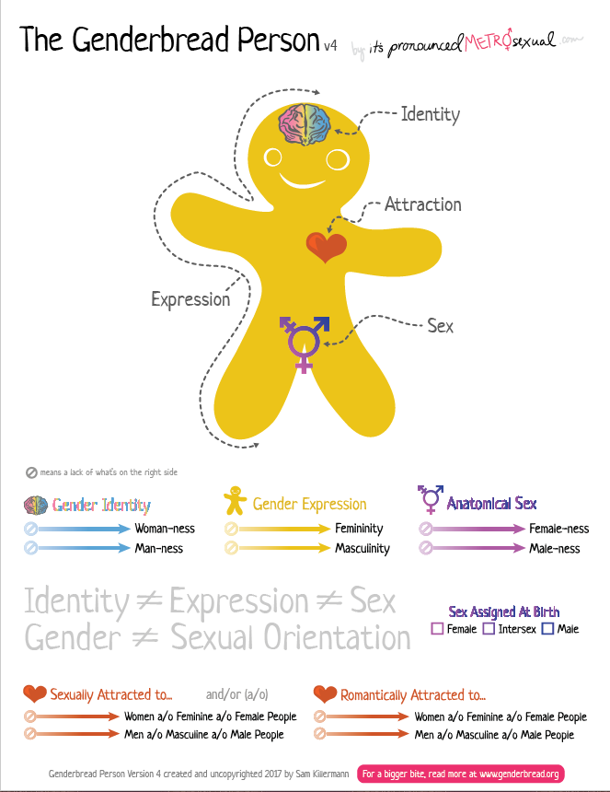

# Tips for Building Rapport with Transgender Clients

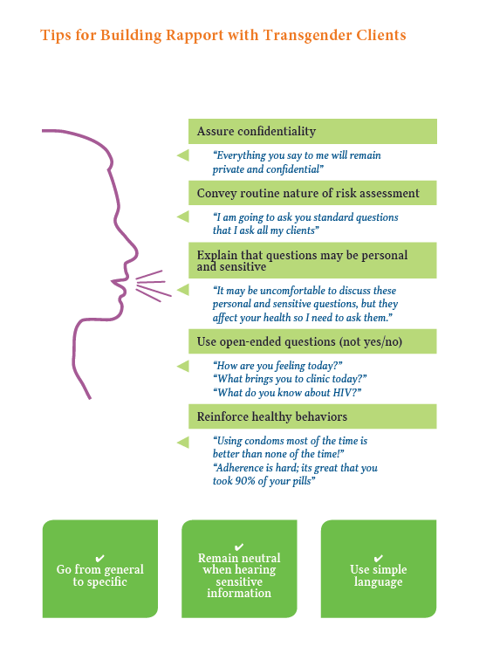

# **Best Practices for Communicating with Transgender Clients**

