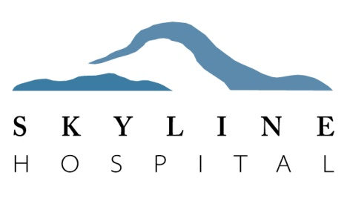

Medical students seeking to complete a clinical rotation at Skyline Hospital are required to provide the following information prior to starting their rotation:

- CV or resume
- Letter from school, university or program director stating “Good Standing”, with dates of rotation and documentation of universal precautions training, HIPAA training, and declaration of malpractice insurance coverage
- Copy of immunization records
- State Patrol Background Check forms (attached)
- Waiver, Release and Hold Harmless Agreement (attached)

University, school or program will forward all required documentation as a complete packet for each student participating in a clinical rotation to the contact below:

Attn: Jessie Ramos, Human Resources Department
P.O. Box 99
White Salmon, WA 98672
PH: (509) 637-2923
Fax: (509) 493-5114
jessieramos@skylinehospital.org

