Details
CENTRAL WASHINGTON FAMILY MEDICINE
1806 West Lincoln Avenue
Yakima, Washington 98902
SITE DIRECTOR: Katina Rue, DO; katina.rue@chcw.org
SITE COORDINATOR: Verna Red Bear; Verna.redbear@chcw.org; 509-573-6210
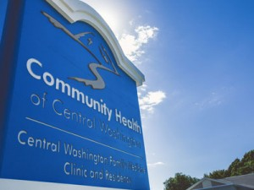
Thirty residents and twelve family medicine faculty with a full complement of other health professionals including four Integrated Behavioral Health Consultants at the Central Washington Family Medicine (CWFM) clinic. The clinic and residency program are services of Community Health of Central Washington (CHCW), a Federally Qualified Health Center that receives federal funding to provide care to Medicaid and Medicare populations. The residency is a federally designated and funded Teaching Health Center and is dually accredited by the ACGME and the AOA.
Clerkship Site Director in Yakima: Katina Rue, DO.
Other faculty physicians who participate in student teaching include: Taj Heer MD; Joel Pearson MD; Debra Gould MD, MPH; Portia Jones MD, MPH; Maria Verduzco MD; Russell Maier MD; Brandon Isaacs DO; Meg Mac Leod MD; Judy Harvey MD; Brent Herr MD; and Patrick Moran DO.
Ancillary faculty who may work with the students include our pediatricians Melissa Lemp DO, and Stephen Pearson MD; our Pharmacist Louise Achey, PharmD; and our Behavioral Health Consultants Kirk Strosahl, PhD; Bridget Beachy PsyD; David Bauman PsyD; and Michael Aquilino MS. Students also work with Senior residents in both the inpatient and outpatient settings.

Satellites
Central Washington Family Medicine, Community Health of Central Washington

Community
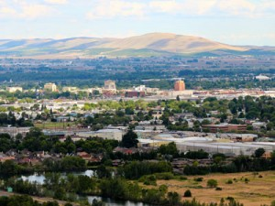
Yakima is located 2 1/2 hours east of Seattle in the foothills of the Cascades and enjoys 300 days of sunshine per year. Recreational activities easily accessible include hiking, fishing, biking, camping, and skiing. Yakima Valley wines are award winning and winery tours are popular as are the many festivals and the local Farmers’ Market.

Duties
The student spends the majority of time in the clinic including visits with BHCs and osteopathic manipulation medicine, but also is involved in OB visits at a satellite clinic and hospital care at two community hospitals. Call averages once per week and includes emergency room evaluations, OB triage and admissions. Educational activities include hospital-based lectures, procedures in the clinic, nursing home visits and residency didactics.

Patients
The clinic is located in a health provider shortage area with a diverse population including significant Hispanic and American Indian populations. The mission of the clinic is to serve the needs of these underserved and rural populations and offer full spectrum family medicine.

Housing
Two-bedroom apartment with sleeper-couch in the living room. Pool and laundry facilities on site. The building is next to the clinic. Crib not provided. No pets. Wi-Fi provided.
Car required. Some travel can easily be done by bike, especially in better weather.

Other
PATHWAYS: This clerkship fulfills the Hispanic Pathway Core Clerkship Requirement.

Some facts about the weather in Yakima
- July is the average warmest month.
- The highest recorded temperature was 110°F in 1971.
- On average, the coolest month is December.
- The lowest recorded temperature was -25°F in 1950.
- The maximum average precipitation occurs in December.

Features
Underserved Pathway

